TRIVENTURE FILMS IN ASSOCIATION WITH BURNT HOUSE PRODUCTIONS AND DAWN POWER PRESENTS “DEADLY DOULA”
BROOKE BURFITT JASON BURKEY LAUREN BUGLIOLI GINA HIRAIZUMI POPPY GEORGE
SOUND
DESIGNER
c IAN FISHER ROBERTO HERRADOR eALEXANDER L. SMITH gANDREW KIRKPATRICK vARABELLA BURFITT-DONS
EXECUTIVE
PRODUCERS
jBROOKE WILLIAMS AND FIONA WILLIAMS RORY GORMAN RHYS WILLIAMS a CLARK PHILLIPS-JANSSEN k RYAN DEWAR

COPYRIGHT © 2021 TRIVENTURE FILMS LIMITED. ALL RIGHTS RESERVED

Billing block image

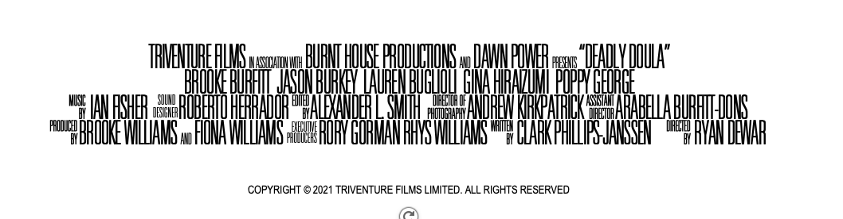

Text

TRIVENTURE FILMS IN ASSOCIATION WITH BURNT HOUSE PRODUCTIONS AND DAWN POWER PRESENTS “DEADLY DOULA”
BROOKE BURFITT JASON BURKEY LAUREN BUGLIOLI GINA HIRAIZUMI POPPY GEORGE
MUSIC BY IAN FISHER SOUND DESIGNER ROBERTO HERRADOR EDITED BY ALEXANDER L. SMITH DIRECTOR OF PHOTOGRAPHY ANDREW KIRKPATRICK ASSISTANT DIRECTOR ARABELLA BURFITT-DONS
PRODUCED BY BROOKE WILLIAMS AND FIONA WILLIAMS EXECUTIVE PRODUCERS RORY GORMAN RHYS WILLIAMS WRITTEN BY CLARK PHILLIPS-JANSSEN DIRECTED BY RYAN DEWAR

COPYRIGHT © 2021 TRIVENTURE FILMS LIMITED. ALL RIGHTS RESERVED

