We are looking for a flyer design which is casual but not fancy, structured but not consisting of sqares, it should somehow feel like a personal message to the reader.

The following flyer should give you an idea about the design, but at the same time we are not looking for an exact copy.

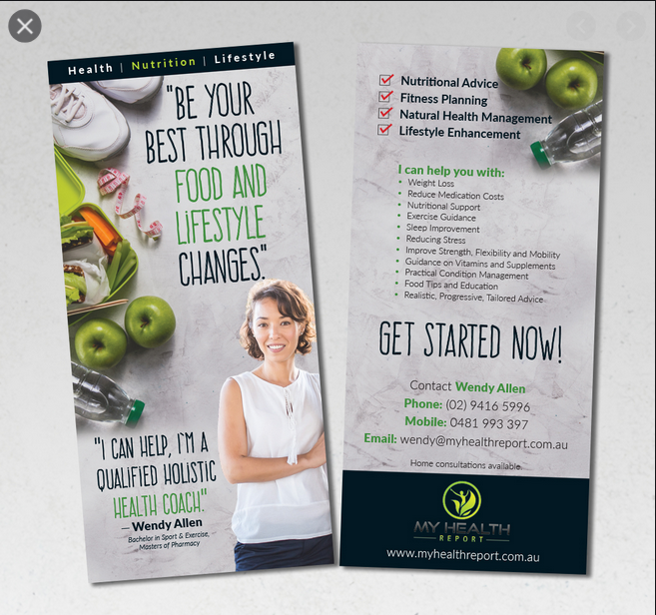

Since there is never only one design, please feel free to present other ideas that match our constraints.

Essential and to be placed in a prominent position:
----------------------
Wellbeing – life quality – health

Increase in quality of live based on Nutrition is my Motto.
------------------

Essential:
-----------------------------
About me
Dr. Svenja Stein, Diplom-Ökotrophologin
Starting at my childhood, nutrition started to play a major role in my life.
I was fascinated, on how much potential our daily life food has on our health. This knowledge I have gained during my career is what I would like to pass on to as many people as possible to profit from the enormous profits of a healthy diet.
--------------------

Essential and to be placed in a prominent position:
---------------------
I advise you on
- Questions about a healthy diet
- Your aim to lose weight
- Nutrition during pregnancy
- Nutrition during nursing
- Preparation of beneficial dishes for the whole family
- Intestinal health
--------------------

Essential:
-------------------
Information on my coaching offers, the process as well as pricing can be found on my homepage: www.ernaehrung.blog
Dr. Svenja Stein
kontakt@ernaehrung.blog
06202 7606559
(Mo-Fr 9.00-12.00 Uhr)
www.ernaehrung.blog

Essential, but may be rephrased or presented in a bullet point style.:
--------------------
My aim is, to perfectly support you to achieve your aims.

I offer personal as well as online coaching. We could meet at your place, in a café, at my place or online via multiple channels. As your personal coach I will be available to answer your questions or solve your questions in a responsible and binding manner.

One of the most effective ways you can take to improve your health is to increase your energy level and to prevent chronical diseases, is to alter to a healthy and nutrition diet.

Whenever there is a desire to change the current condition, coaching can support you on boost this desire for a change to the better. Using suitable questions and tools, we will define your aims and define measures to achieve your goals. You will understand, on what can be changed in your nutrition in order to make the change sustainable. My holistic nutrition coaching is fully tailored to your needs and circumstances. You are the one determining on what shall be done and in which speed. And with my consultation, I am positive that you will master your challenge.
--------------------------

Feel free to use the photos provided by me or use others as well.

Please be aware, that after the design is agreed upon, we will need to replace the English phrases with German phrases, which we will provide. The character set is part of each Latin font.

Please use the attached QR Code as well, or feel free to create a new one for the same url in the colors or design beneficial for the layout/design.



