BECOME KNOWN

LoveAPet.com- NavMap
Rev. 05/13/2021
By: Makayla Martin

For our Love A Pet website, we want this to be fun and playful but with a touch of your creativity! Love A Pet is a fun-loving brand that sells pet supplies and accessories focused on accentuating the love between pets and their owners. We want to advertise these products in a welcoming way, making the customer receive the happiness the brand offers. In our logo, we like to use a font called Asdonuts, which we would like to use for the headings on the website.
(Font file is attached).

- COLOR PALETTE:

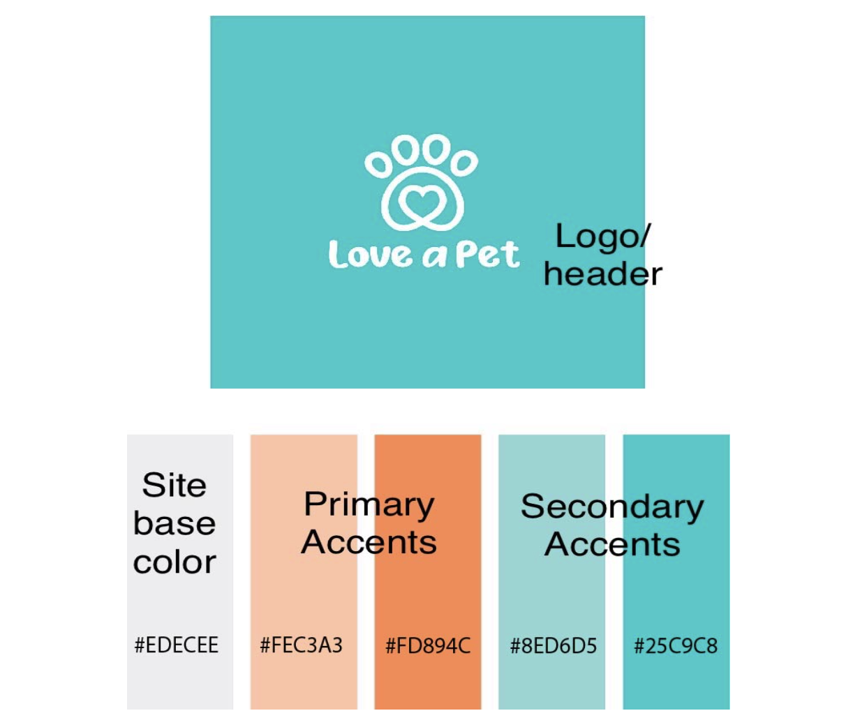
This is the color palette we would like to use throughout the website:
HOME PAGE

- MAIN BANNER
Slider:
- Large, full width slide with three slides. Slides are full page width that will include full width temporary modern/ lifestyle photos with clean type over type and “Shop Now” button that links to the “Shop”/ Product page.

- NAVIGATION BAR:
- Nav links in color that plays well off the logo/ color palette.
  - Logo is attached.
- Add a search button and a cart/ bag button next to the nav links.
- Inspiration: we’re looking for something like https://fablepets.com/ & https://www.redspaceevents.com/ navbar. Clean and modern styles.
- Nav links:
- Left align Logo: Home Button
- Shop
- Our Story
- Boop Blog
- Pet History 101

- SALE BAR:
- Thin call to action banner for sale items: Bold, eye-catching color, “50% off sale going on now! Because we love you too”.

- FEATURED PRODUCTS SECTION:
- Displaying 8 featured products at that moment.
- Please title this with “Furry Favorites”.

- BUY NOW, PAY LATER BANNER:
- “Buy Now, Pay Later” with Bread Financing logo and Klarna logo on an eye-catching banner.

- TESTIMONIALS:
a. Testimonials – Pictures of 4 happy pets with their funny “testimonials”.
1. Testimonial 1: Bella (dog) “Before Love A Pet my human bought me gifts that made me want to dig a hole under the fence and run. Now I still dig, but it’s to bury all my awesome toys!”
2. Testimonial 2: Leo (cat) “My favorite thing to do is watch the birds out the window. Those birds are lucky my house is full of comfy stuff from Love A Pet so I don’t ever want to leave.”
3. Testimonial 3: Max (dog) “Love A Pet is the absolute best! Now if you’ll excuse me I think I heard someone drop some food on the floor.”
4. Testimonial 4: Dora (fish) “I could rave about Love A Pet until I was blue in the gills! Those other brands just seem a bit fishy to me.”

- Chat & Rewards Buttons:
- Anchored to the bottom of the page no matter where you scroll

- Live chat (right side) – I really like something simple like this from alphapaw.com :

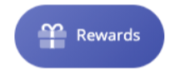
- Furrever Club Rewards (left side) – Also pulled from alphapaw.com

- FOOTER:

1. Definitely want this section to match the color theme. I like the
logo with the socials underneath like the Fablepets.com footer. I
also like the newsletter opt-in on the right hand side. The footer should include:

- COMPANY
- Shop
- Our Story
- Boop Blog
- Pet History 1010
- HELP & SUPPORT
- Returns & Exchanges
- FAQ
- help@loveapet.com
- Search
- CONTACT:
- (phone number) (With phone icon)
- help@loveapet.com (With envelope icon)
- Facebook, Instagram, and Twitter icons with the links to those pages.

2. At the very bottom of the footer, please add:
- Copyright 2021 loveapet.com: All rights reserved (With the Love A Pet logo.)

