New logo brief
A simple, unique, recognisable logo.
Incorporating a carpet python, drawn simplistically above the wording
This logo is to be appealing to both the general public and corporate clientele.
Wording for the logo is to say “Snake Catchers” as the main title.
Under this title is “Brisbane”, “Gold Coast”, “Ipswich”, “Brisbane & Gold Coast” & “Ipswich & Logan”
So that is 1 main logo with 5 different subheadings.
The logo will be used for Facebook, websites, business cards and magnets.
I’ve included a very badly drawn example on the last page.
The best representation of layout is Figure 1 below.
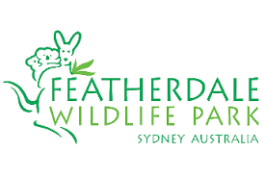
Figure 1. Example of logo that fits the brief. The snake tail to go above the picture, the body
“Brisbane”
“Snake Catchers”
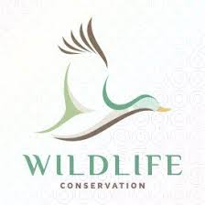
These colours are great. All earth tones
Figure 2. Simple and recognisable.

Figure 3. Simple, recognisable.

We want the snake to be simple, no patterns. We have had some logo examples drawn up and the pattern is too busy.

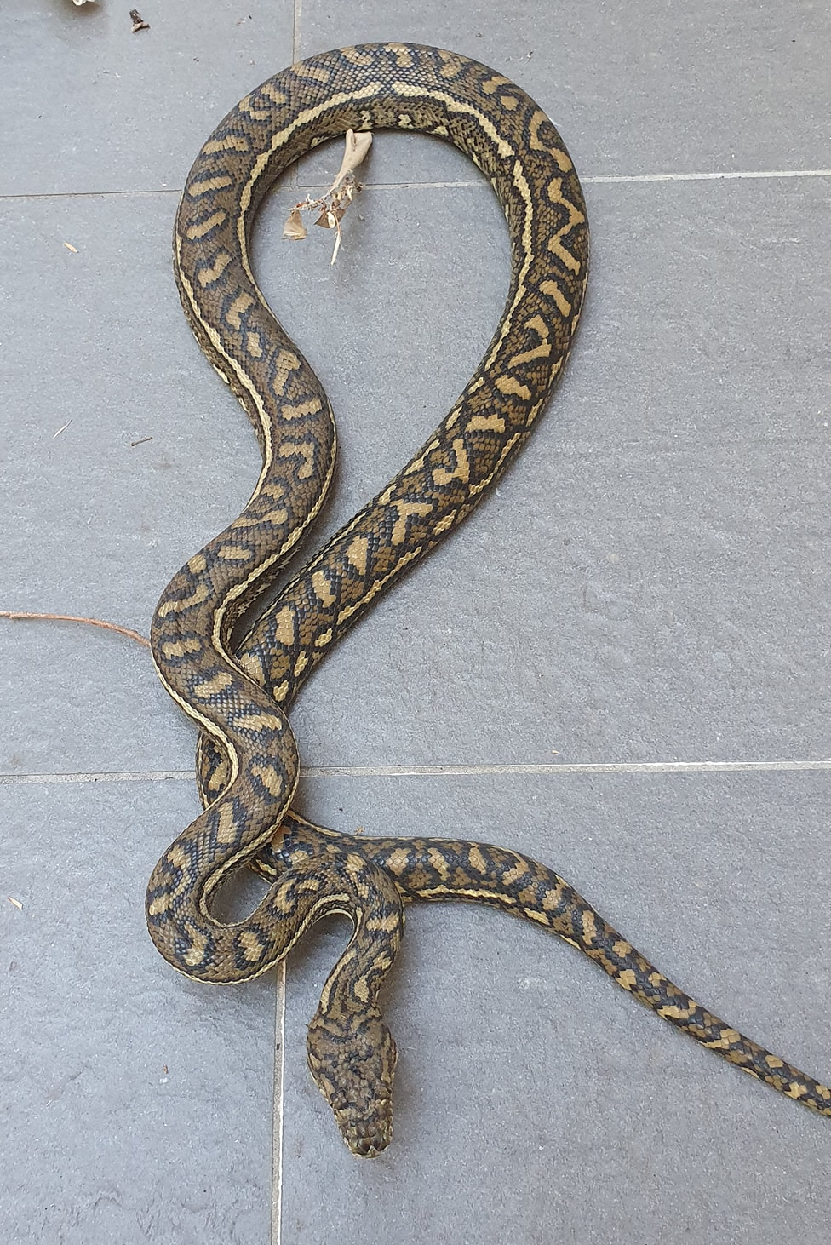
The section highlighted in the box is the part we would like down the left-hand side of the writing “Snake Catchers” with the tail end above the writing. It’s ambush position but with a nice, lengthened section of body

Font style
A simple, modern font style. Nothing arty or gimmicky
Can either use capitals for Snake Catchers, or all in Caps. Whichever is appropriate for the chosen font style.

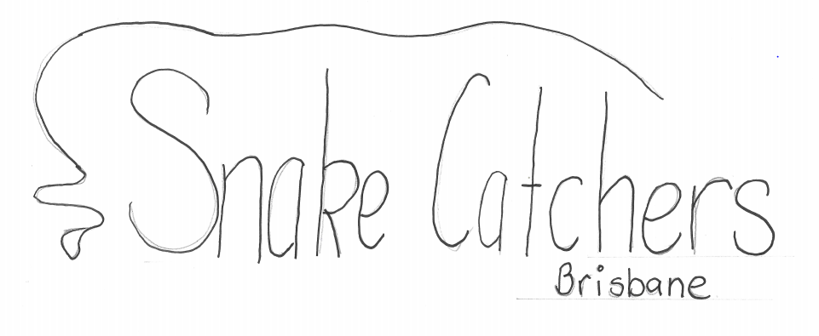

Below is the current (80’s, old) logo that we are using. This is why we are modernising!
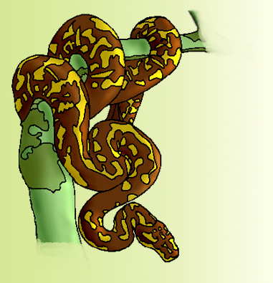

The current layout of the business card so you can see how the logo is used. We’ll be updating these as well.
