Revised Requirements:
Slate blue background with white, professional looking font.
D as the logo with a circle design around it (please show a couple different circle designs)
Dannegger Group below the D
Solid Realty Services below Dannegger Group in the same font size
Here is an idea but please also be creative

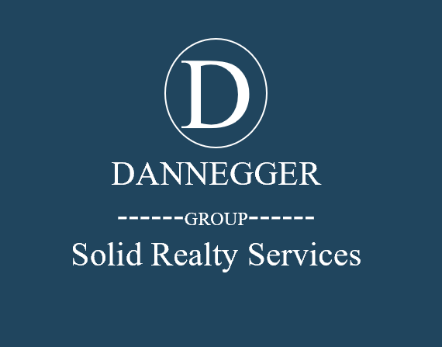

Color: Slate Blue

Example of sign we like
