
The reusable container service for restaurant takeout & delivery

60% of people polled said that they would favour a restaurant that offers Earthware over one that doesn’t.

Show them you care by giving them the Earthware choice.

Benefits for your restaurant
- Add a revenue stream
- Eliminate your cost for single use containers
- Reduce the amount of waste your restaurant puts into the landfill
- Attract more customers

How it works:

Customer chooses Earthware container from restaurant menu or delivery app
Customer enjoys food and rinses container
Customer uses QR code to notify us for pick up

Earthware collects container
Containers are washed and sanitised
Containers are recirculated back to partner restaurants

This is the graphic that needs to be created

Restaurants worldwide are embracing reusable takeout containers

Seamless
Earthware reusable containers fit right into your current operations, with no retraining or time lag.
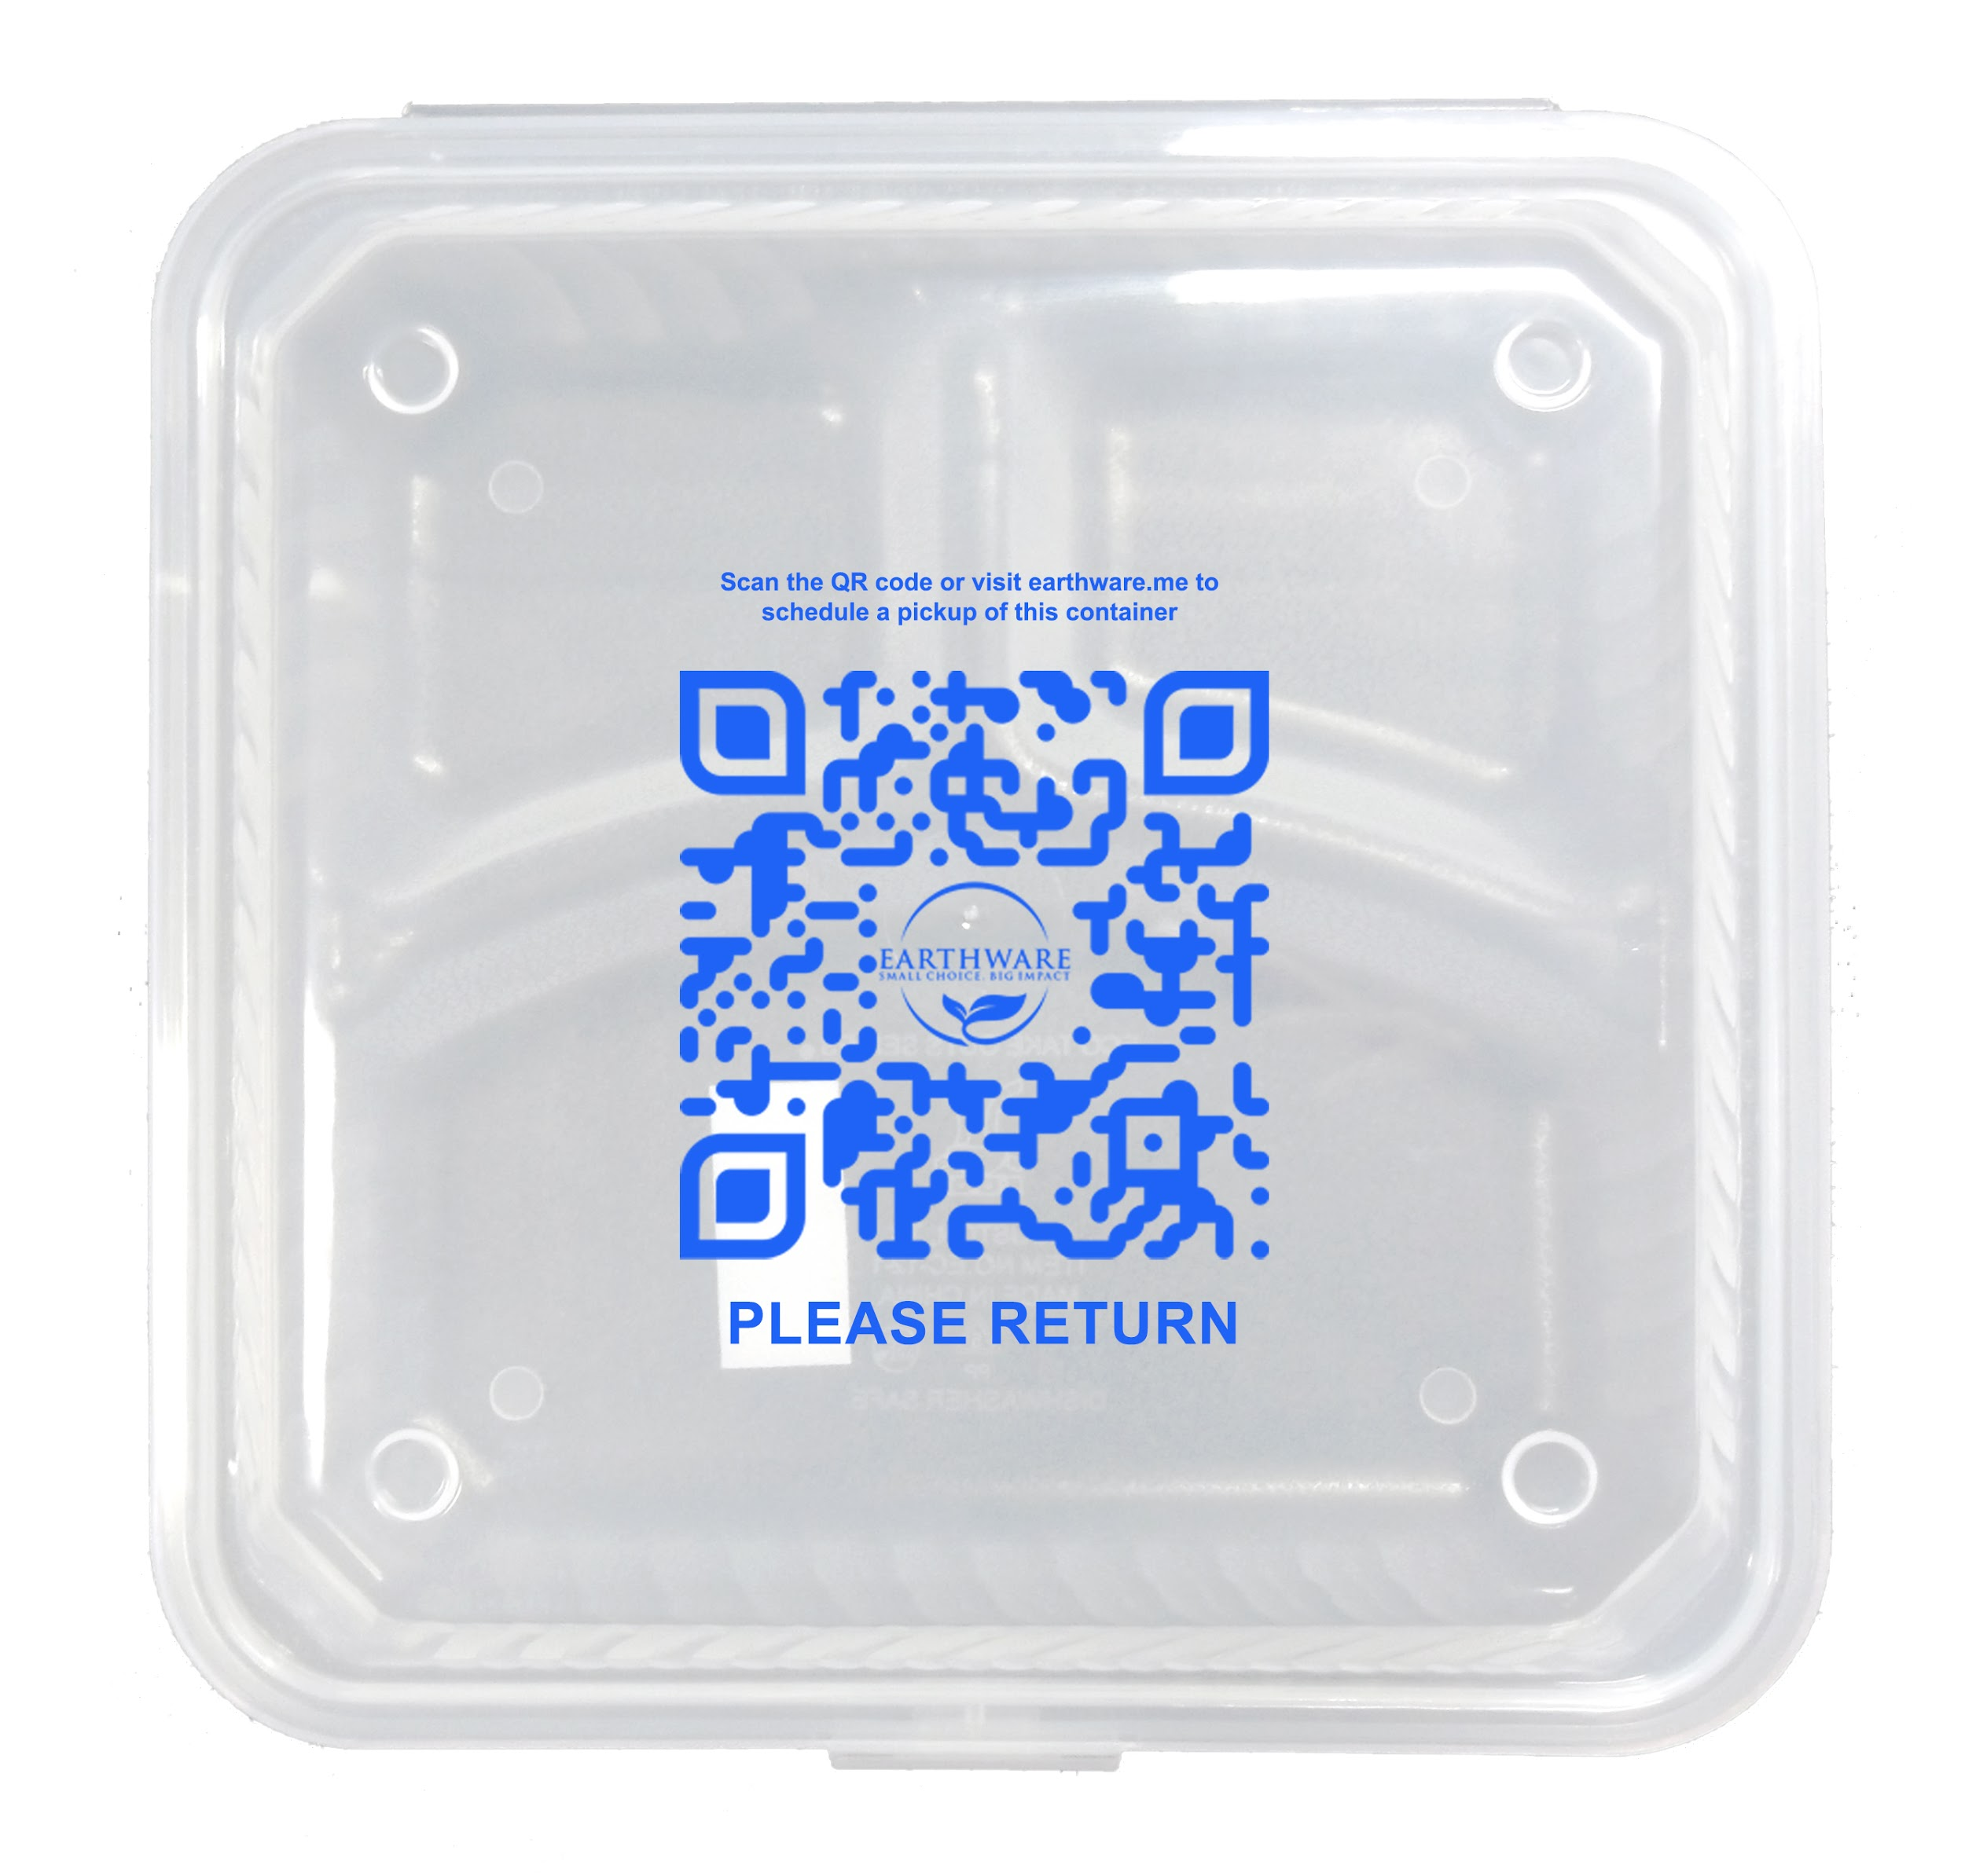

Our clean Earthware guarantee
Earthware washing and sanitising procedures exceed government regulations. If you find an Earthware container that does not meet your high standards , we will replace it with 10 free ones, no questions asked!

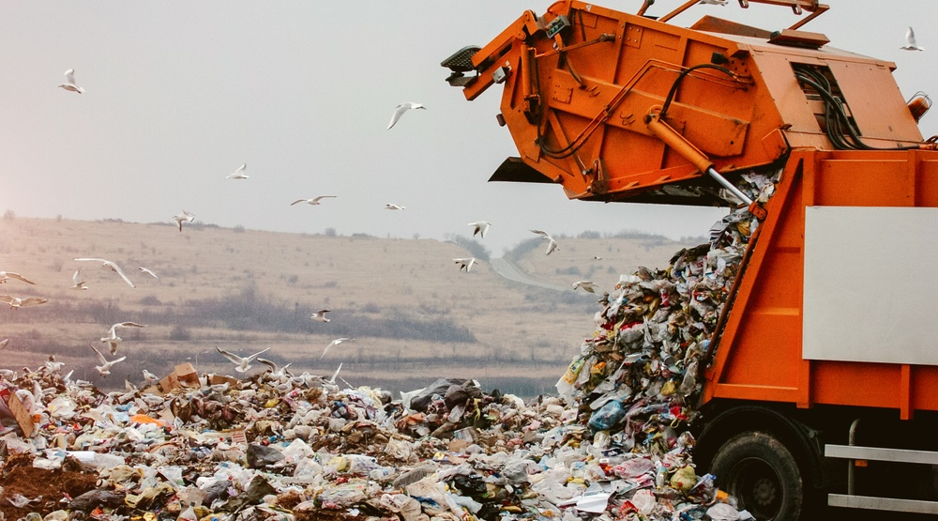
The Recycling & Composting Fallacy
91% of what we put into the blue bins is redirected to the landfill.
100% compostable containers are based on a 90 day active compost cycle. City programs typically have a 21 day active compost cycle, meaning those compostable containers go into the landfill.

Together, we can make single-use food containers a thing of the past, eliminate one of the biggest sources of landfill waste, and offer customers a great experience in the process.

CONTACT US NOW AT WWW.EARTHWARE.ME FOR MORE INFO AND LEARN ABOUT OUR FREE STARTER KIT

