LOGO BRIEF – LOCAL SEO SHOP

Table of Contents
LOGO BRIEF – LOCAL SEO SHOP 1
Table of Contents 1
BACKGROUND TO LOCAL SEO SHOP 2
WHAT DOES LOCAL SEO SHOP DO? 2
LOCAL SEO SHOP’S TARGET MARKET 2
THE CURRENT LOCAL SEO SHOP CUSTOMER 3
WHERE DO CUSTOMERS FIND INFORMATION ABOUT LOCAL SEO SHOP? 3
WHY IS A LOGO REQUIRED? 4
WHAT DO I WANT PEOPLE TO FEEL WHEN THEY SEE MY LOGO 4
VERSION OF COMPANY NAME TO BE USED IN LOGO 4
LOCAL SEO SHOP TAGLINE OR SLOGAN 5
WHERE IS THE LOGO GOING TO BE USED 5
DIGITAL 5
PRINT 5
BRANDS I ADMIRE | OTHER ELEMENTS 6
THE LOGO TYPE THAT I ‘THINK I WANT’ 6
IF LOCAL SEO SHOP WAS A CELEBRTITY OR CARTOON CHARACTER, WHO/WHAT WOULD IT BE? AND WHY? 7
OTHER INFORMATION NOT DIRECTLY RELATED TO THE BRIEF 8
WEBSITE DESIGNS I LIKE 8
MOOD BOARD 8
LOGO DESIGNS I’VE CREATED ON CANVA 13
TERMINOLOGY 13

BACKGROUND TO LOCAL SEO SHOP

Local SEO Shop is a small Australian based, B2B SEO agency helping generate more sales leads for local businesses. The website, https://localseo.shop is being developed as we speak.

The agency offers 3 services.

- SEO optimisation of local businesses (see below the target niches under ‘target market’)
- 360 virtual tours, and
- Google My Business (GMB) optimisation (to help ranking on Google Maps and Google Search Engine Result Page – SERPS).

Typically a client starts a 6-month agreement where 80% of the output is SEO related. Half- way through the campaign a client will express interest in a 360 virtual tour and GMB related optimisation to help more people find their business.

WHAT DOES LOCAL SEO SHOP DO?

In short, drive more organic business (a.k.a. sales leads) to largely service based businesses.

The pain-point local businesses have is they do not have the time nor will power to drive organic traffic to their site. Current solution? Pay directory sites to send leads on their behalf.

The core USP is providing a simple and scalable SEO agency solution to local businesses in a manner that wont break their budget.

LOCAL SEO SHOP’S TARGET MARKET

Local SEO Shop is targeted to Australian local businesses (B2B) who need more sales leads via optimising the businesses website. The types of targeted business will be (yet not excluded to)

- Local restaurants
- Local shops
- Real estate agents
- Independent hotels
- Service based businesses (plumber, electrician etc…)

THE CURRENT LOCAL SEO SHOP CUSTOMER

The Local SEO Shop customer is one that signs up for a 6 month (or greater), SEO Campaign to drive more organic traffic to their respective site. Whilst other services can be offered,

An example slide taken from the Local SEO Shop proposal deck illustrates the 3 types of SEO Campaign offerings.

This is the core offering. At present 80% of prospecting centres around this.

Supplemented to the core offering is

- 360 virtual tours, and
- GMB optimisation

WHERE DO CUSTOMERS FIND INFORMATION ABOUT LOCAL SEO SHOP?

The Local SEO Shop website will shortly be constructed to help drive organic traffic from on-site content pages.

In brief, this is an agency business thus the main origin of contact will come from Facebook ads and/or Google Ads promoting local business SEO (within the Australian and within, NSW).

WHY IS A LOGO REQUIRED?

The preference is to have a logo that isn’t just the words ‘Local SEO Shop’ within the website, Facebook page etc…

Currently, the business is a peer-to-peer referral business where I manage max 1-2 clients per month. I am looking to scale and build out my website before June 2021 and need to propagate my logo throughout the world!

WHAT DO I WANT PEOPLE TO FEEL WHEN THEY SEE MY LOGO

I’d love a potential prospect or customer to recognise my logo, even by design.

For example ‘oh, Nick, you are the guy that owns that company with the [insert object] in your logo’. I.e. it has a recognisable element within the logo that makes it me.

The hard part is, SEO is not a tangible object like putting a frypan in a cooking store logo or a shovel icon in a gardner’s logo.

VERSION OF COMPANY NAME TO BE USED IN LOGO

3 versions are recommended

- Logo graphic with name offset ‘Local SEO Shop’ NB. The capitalisation of SEO vs. Seo.
- Logo graphic
- Logo graphic as a favicon

The abbreviation LSS within the logo however, this doesn’t sell the business in my point of view. Happy to see suggestions if you feel this is a strong representation of the brand.

LOCAL SEO SHOP TAGLINE OR SLOGAN

Local SEO Shop does not have a tagline or slogan at the present point in time.

It’ll be something along the lines of

‘Optimise your local business’
‘Local SEO Shop – getting people to find you’

WHERE IS THE LOGO GOING TO BE USED

The Local SEO Shop logo will be used throughout the following areas

DIGITAL

- Website
- Favicon
- Email
- Social Media channels
  - Instagram
  - Facebook
  - Pinterest
  - TikTok
- Display advertising i.e. MPU 250x250px banners with text overlays and action buttons over 2-3 sequences.

PRINT

Business Cards
[TBC] Classified ad within local newspaper.

BRANDS I ADMIRE | OTHER ELEMENTS

To best answer this question it is better to link this to the logos styles I like, and within, brands that represent each logo.

THE LOGO TYPE THAT I ‘THINK I WANT’

Thinking about the different logo styles, I ‘think I want’

THINK I WANT | WHY? | EXAMPLE
Emblem | - Local SEO Shop wants to convey a sense of tradition and/or longevity.  - I’m looking for the Local SEO Shop logo to convey a sense of gravitas. | 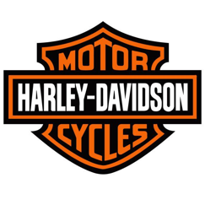
Monogram | - I want the tie between LSS visual identity and the long name of LSS,  HOWEVER  - LSS isn’t an established company without any reputation. Even then, an agency doesn’t really have a reputation unless you are a multi-national agency. | 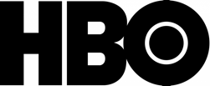  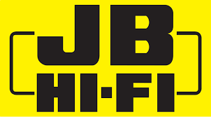
Abstract | I want something truly unique yet the challenge I also have is I’m yet to solidify my brand identity. The abstract mark conveys a feeling yet to do that with SEO services is quite hard! Vs. selling trainers that is. | 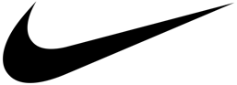
Combination mark | I want the best of both worlds with logos. Both abstract and monogram! | 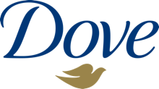

THINK I DON’T WANT | WHY? | EXAMPLE
Logotype | wordmark | Local SEO Shop is really long and to put in a logo doesn’t make sense and doesn’t really convey a sense of class. | 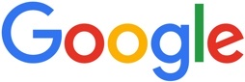
Brand  | Pictorial mark | - I’m still trying to confirm how LSS will operate and picking an image too early could lock me into a particular way of branding. | 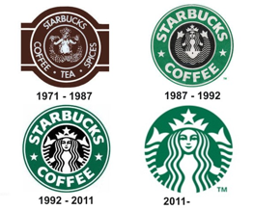
Mascot | Just not interested in a mascot style logo at all. It is isn’t interchangeable across enough mediums to redender correctly.

IF LOCAL SEO SHOP WAS A CELEBRTITY OR CARTOON CHARACTER, WHO/WHAT WOULD IT BE? AND WHY?

Celebrity

Celebrity / Cartoon character | Why?
James Corden  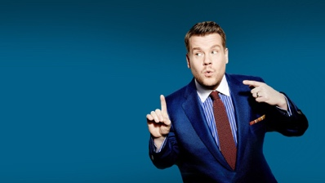 | James represents the slightly cheeky style of engaging with people. And in a playful yet, professional manner. A manner that I would approach when dealing with prospective clients.
Hugh Jackman  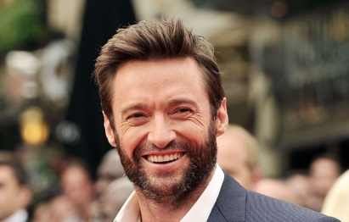 | Aussie. Actor/Dancer/Singer. A.k.a the triple threat. The ethos of what I am trying to deliver with LSS. That is, SEO Optimisation, 360 virtual tours and GMB optimisation wrapped around a warm Aussie persona. Obviously not the same but you get that I am trying to be a triple threat with my service delivery.
Gambit (X-Men)  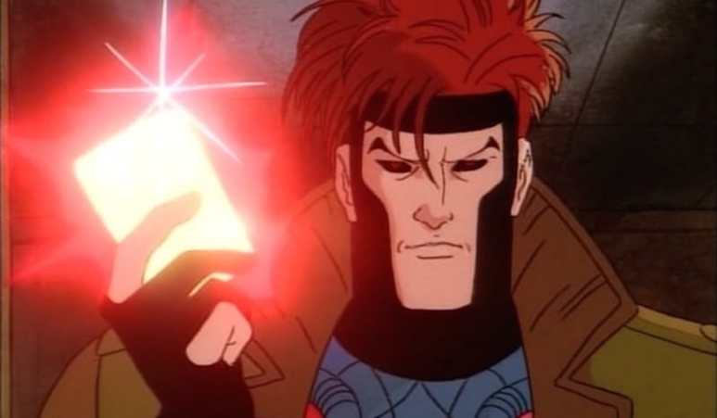 | He had the fashion sense, the attitude, and the one-liners.  I admire this and like the soft attitude he portrayed in this version of the X-Men cartoons (back in the late 1990s).  More background is here https://www.youtube.com/watch?v=LFVFoKshLdk and https://www.youtube.com/watch?v=y0f3vp5FZPU  FYI - He was a petty criminal with a heart of gold who had an entertainingly flirtatious will-they-won’t-they relationship with fellow mutant Rogue who had to constantly keep him at arms-length to protect him from her dangerous powers (Rogue can put people in a coma through skin to skin contact).

OTHER INFORMATION NOT DIRECTLY RELATED TO THE BRIEF

WEBSITE DESIGNS I LIKE

I’m still yet to design my website yet am looking at possible themes I admire. Below are some of these themes and websites.

Design name | Example | Why I like it
Agencia WAKA | https://www.somoswaka.com/ | Bold font, playful 1990s style arcade UX

MOOD BOARD

Below are some images I’ve collated to help illustrate what I think of when thinking about Local SEO Shop.

I love the colour yellow as it evokes this ALERTNESS vs. other more calmer colours. Maybe because I come from a retail background.

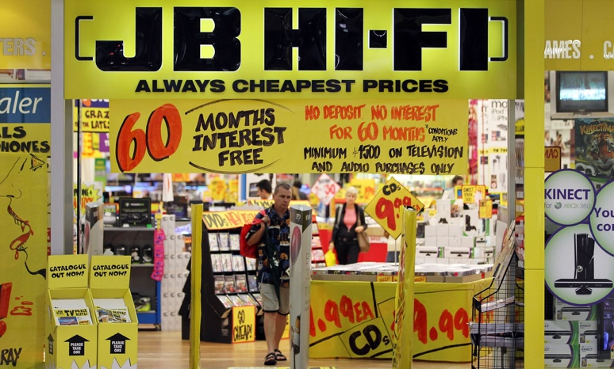 | 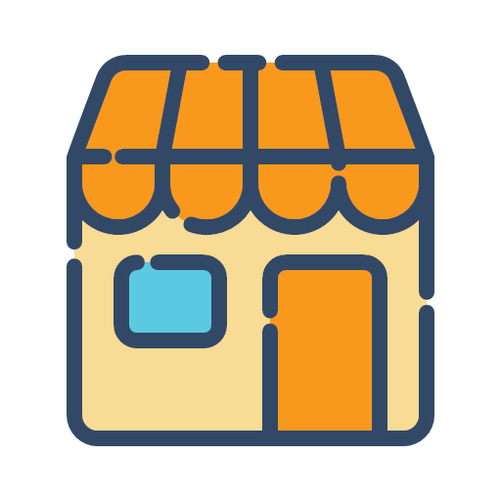
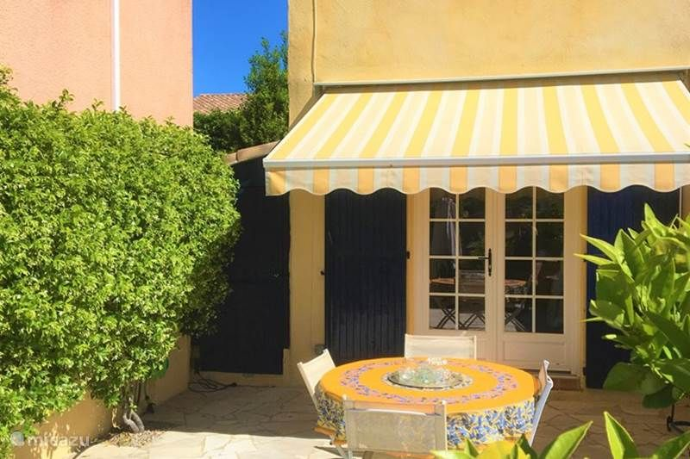

I also love the European café style culture. Sit parallel to a street where you can just people watch and have a coffee. Always think of the French Rivera too and sitting in a café where I people watch and I semi-bask in the Mediterranean sun under a yellow/white candy stripped awning.

This image makes me think I could sit down with a client to understand their business, their business goals and what they want to achieve and by when!

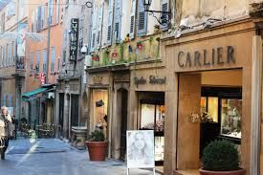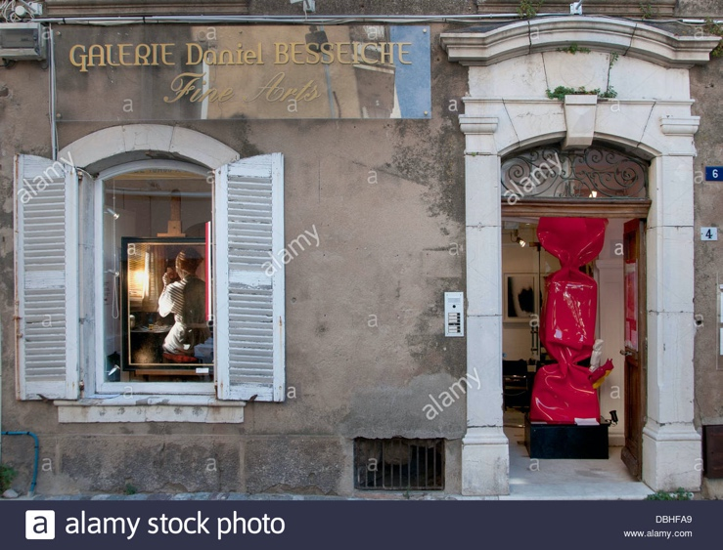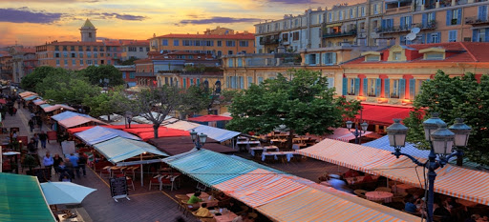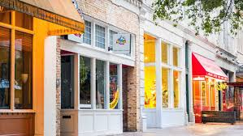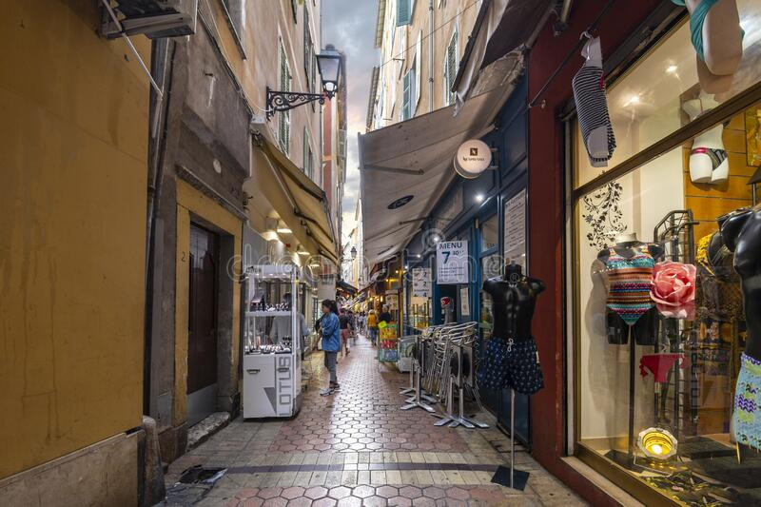
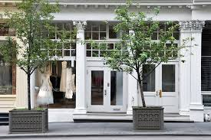

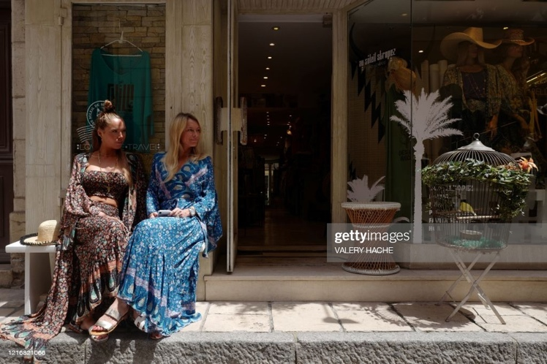 |  | 
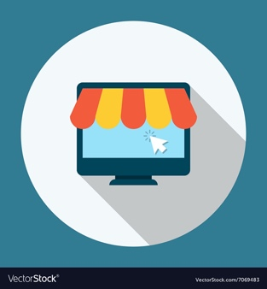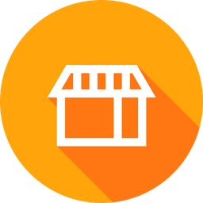
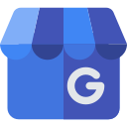  Love these favicon style icons as they are recognisable as ‘a shop’ and represent to the viewer that there is a Shop within the businesses operations. I.e. you guy to buy product and services. | 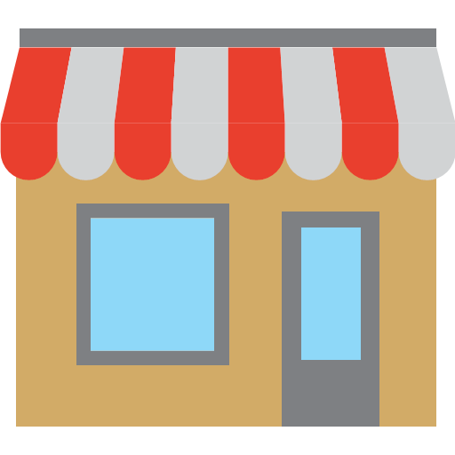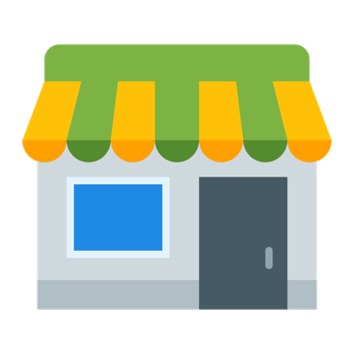
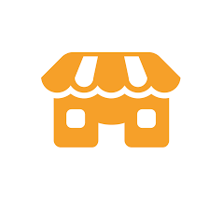 | 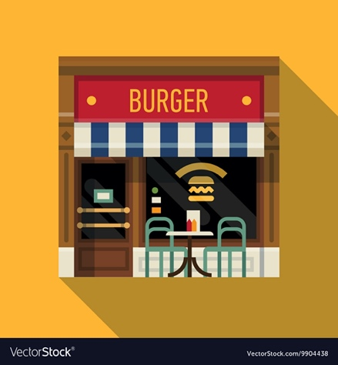

LOGO DESIGNS I’VE CREATED ON CANVA

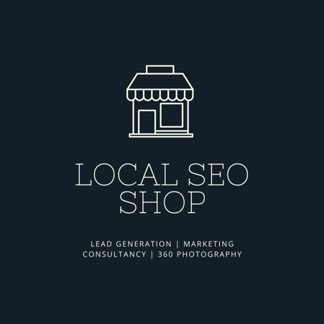

TERMINOLOGY

I cannot assume you’ll know what SEO is nor the services I provide. Thus, if you want to learn more, please read on!

Term | Definition
360 Virtual Tour | A 360 Virtual Tour is a collection of 360-degree panoramic rotating images, “stitched” together to form a full, 360° view of a location. Special cameras, lenses, technology, and methods are used to bring a tour together into a visual experience for the viewer.
GMB | Google My Business. Google My Business is a free tool that allows you to promote your Business Profile and business website on Google Search and Maps. With your Google My Business account, you can see and connect with your customers, post updates to your Business Profile, and see how customers are interacting with your business on Google.  Click on the hyperlink within the ‘Term’ field (left) to learn more.
SEO | SEO stands for Search Engine Optimization, which is the practice of increasing the quantity and quality of traffic to your website through organic search engine results.  Click on the hyperlink within the ‘Term’ field (left) to learn more.
SERPs | Search Engine Results Pages (also known as “SERPs” or “SERP”) are Google's response to a user's search query. SERPs tend to include organic search results, paid Google Ads results, Featured Snippets, Knowledge Graphs and video results.

