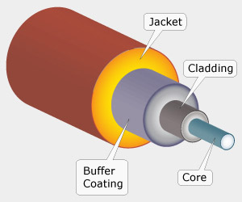

Figure 9. The structure of a fiber optic cable and how it works

There are three main types of optical fibers, i.e., single-mode optical fiber, multimode optical fiber with stepped index and multimode optical fiber with graded-index. Single mode optical fiber transmits only one mode of light (one wavelength of light) while multimode optical fibers allow multiple modes of light (a range of wavelengths of light) to travel along their axis. The stepped index fiber means the refractive index of the core is uniform while the graded index fiber means the refractive index of the core changes radially from the center of the core to its surface. Figure 9 shows the structure of a fiber optic cable which consists of four parts: core, cladding, buffer coating and jacket and how a fiber optic cable works.
A typical fiber optic communication system consists of three components: optical transmitter, fiber optic cable and an optical receiver. The optical transmitter converts electrical signal to optical signal; the fiber optic cable carries the optical signal from the optical transmitter to the optical receiver; and the optical receiver reconverts the optical signal back to electrical signal.
Optical fiber is used by many telecommunications companies to transmit telephone signals, internet communication and cable television signals. Current backbone networks are mainly using optical fiber. Fiber will be getting closer to the user. The development of optical fibre communication technology is unlimited (Miller, S. ed., 2012). A comparison of fiber optics, coaxial cable and twisted pair technologies can be found in Table 11.

