Coaxial cable is a type of cable that has a center conductor surrounded by a concentric conductive shielding, with the two separated by a dielectric. An insulating outer jacket is normally the protective outer layer. The figure below illustrates the construction of a typical coaxial cable. The shield consists of a foil shield and a braided shield. Electrical signal flows through the center conductor. This shielding characteristic of coaxial cable enables it to have strong anti-electromagnetic interference ability, which can transmit high frequency signals over long distances.
There are many different types of coaxial cables, the most common sizes of coaxial cable are RG-6, RG-11 and RG-59. “RG” means “Radio Guide” which was the original military specification for coaxial cable. RG Numbers are generally just an indicator of size. The actual performance of two different coaxial cables with the same RG number can be very different. RG6 most commonly used for applications such as closed-circuit television (CCTV) and cable television (CATV) in enterprise environments. The RG11's central conductor is thicker than the RG6's, which means it has lower losses and a longer signal travel distance. However, RG11 cable cost more and not easy to bend, making it less suitable for internal deployment which requires flexibility and more suitable for long-distance outdoor installations or straight backbone links. The RG-59 has a thinner centre conductor than the RG-6. This makes it the best choice for short runs and low frequency transmissions indoors.
The impedance of the coaxial cable is different also, usually 50Ω and 75Ω. 50Ω coaxial cable has high power handling capacity, it is mainly used for radio transmitter. 75Ω cable is better in keeping the signal strength, it is mainly used for connecting the various types of receiving equipment, such as CATV receiver. Although the most encountered coaxial cable is the one with 75Ω impedance, however, it is important to note that all components in a coaxial cable system should have the same impedance.
Coaxial cable connectors are used to connect cables to other devices and maintain the cable’s shielding. There are two connector styles – male and female. Male connectors have metals pin in the center and female connectors have a hole to receive the pin. The popular connects are BNC connector, TNC connector, QMA connector and QMC connector. Figure 8 shows a typical coaxial cable, and the advantages and disadvantages of coaxial cables can be seen in Table 9.
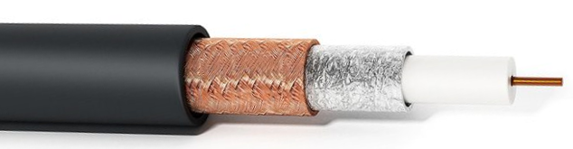
outer jacket
braided shield
foil shield
dielectric
centre conductor

Figure 8. Coaxial cable

