The leaky feeder system usually has up to 32 channels. Different areas have different channels to reduce radio traffic and for monitoring purpose, although workers can listen to any channel in any area. For instance, the simple example system has 6 channels:
- Channel 1 – emergency
- Channel 2 – level 1
- Channel 3 – level 2
- Channel 4 – level 3
- Channel 5 – surface
- Channel 6 – Line of sight (LOS) channel
Most of the channels are duplex channel, so repeaters located on base stations are involved in each communication. LOS channel is a simplex channel, when the LOS channel is used, repeaters are not needed.
When people at different levels want to talk, for instance, radio 3 wants to talk to radio 1, signal from radio 3 (should switch to channel 4, a duplex channel) goes through the leaky feeder cable up to the base station, and the repeater converts the signal to the downlink frequency and sends it down to all levels through leaky feeder cable, and radio 1 can receive the signal (listening on that frequency). If radio 3 is working on channel 2, radio 1 should choose channel 2 then it can also receive the signal from radio 3. Other radios if they are also on channel 2, they will also receive the signal. When handset 1 reply the message, the signal (using channel 4) also goes all the way up to the base station, the repeater sends down the signal using downlink frequency to all levels. Handset 3 can receive handset 1’s message.

When people at the same level want to talk, say handset 1 and 2, if they are all on channel 4, the signal will travel similar to the example of different levels. However, they can all switch to the LOS channel (channel 6) which is a simplex channel to talk directly. The signal may go through air or leady feeder cable.

It also possible to achieve surface to underground communication if the base station has the capability. When the base station received the signal from underground, the repeater boosts the signal, converts to downlink frequency, and spread to the whole underground mine. At the same time, the base station can convert the signal to another frequency and radiates it on the surface. Radio 4 at the surface receives the message (if it is on the same channel as the radio send out the signal in underground). The signal radio 4 responds to underground radio can be transmitted through air to the base station first, then through the repeater to spread in underground mine. The underground radio can receive the response.
Other than communication, leaky feeder can be used for remote control and transferring mobile data etc.

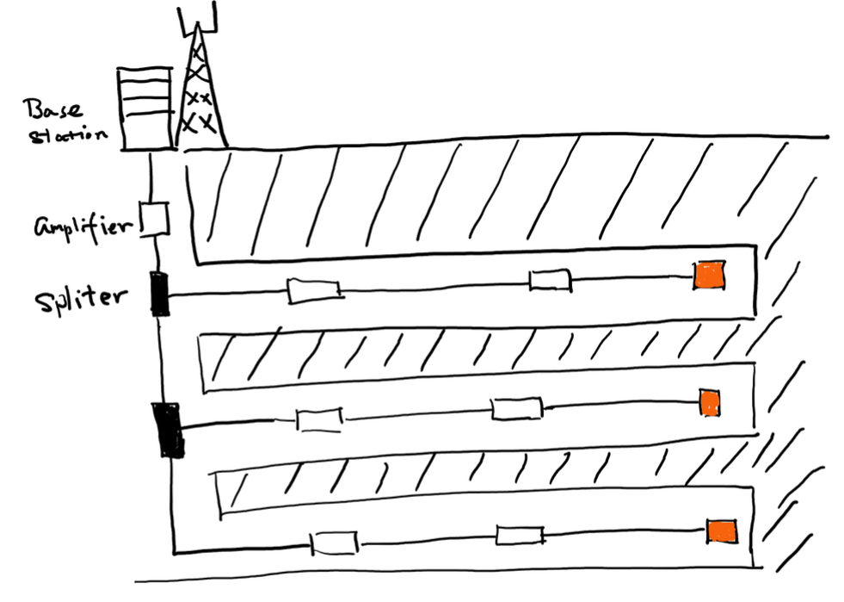
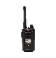
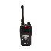
1
2
3
4
Level 1
Level 2
Level 3
Terminator
Amplifier

