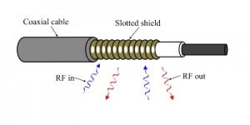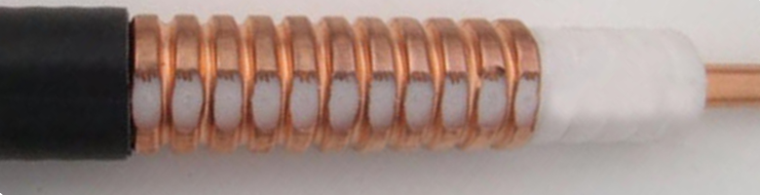

Leaky feeder can be considered a coaxial cable (introduced in Section 2.2) based wireless communication technology (Updyke et al., 1980). Leaky feeder is not found in most people’s daily life. However, it is popular in underground mines or other tunnel environments. Radio waves do not propagate well through tunnels at frequencies usually used for communications (refer to Section 3.?). However, the range of radio communications in tunnels can be greatly extended by the use of leaky feeder cables.

Figure ?? shows how the leaky feeder cable looks like. A normal coaxial cable has a copper shield surrounding the cable to prevent the RF signal to escape. A leaky feeder cable has small sections on its copper shielding stripped away to allow RF signal to leak out and get in. To maintain the signal levels over long distance, amplifiers are inserted along the leaky feeder cable every few hundred meters, typical 450-550m. A leaky feeder system consists of:

