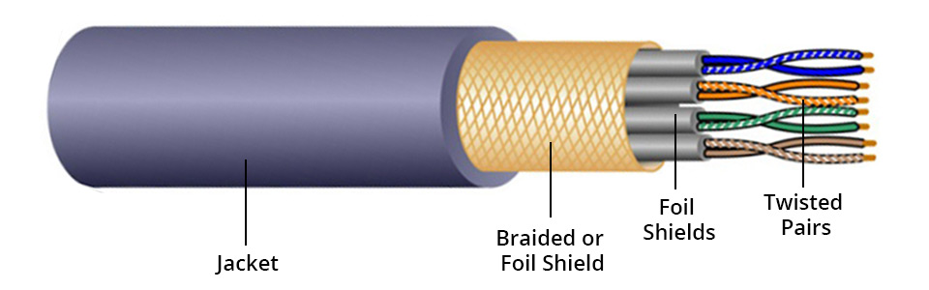
Insulation
Conductor

Could you make small changes: Jacket-> Outer Jacket; Twisted Pairs -> Twisted Pair; Braided or Foil Shield-> Foil Shield or Screen; Foil Shield -> Pair Shield
Add "Conductor", similar to other labels, point to the very end of one wire;
Add "Insulation"

Figure 6. Twisted pair cable
Twisted pair can be found everywhere, as the signal transmission between all kinds of equipment use it, such as network cable, communication line, encoder line etc. With the digitalization of the underground mine, more communication devices will be deployed or more devices will have the communication capability. As a popular connection method, more twisted pair cables will be used.
A twisted pair cable composed of two copper wires with an insulating protective layer. By twisting two copper wires together at a certain density, the radio waves emitted by each wire in transmission will be offset by the waves emitted by the other wire, effectively reducing the signal interference.
Twisted pair can be classified into two types, shielded twisted pair (STP) and unshielded twisted pair (UTP) according to whether there is a braided wired mesh or foil that encases each pair or not.
The most popular types of twisted pair cables are CAT 6 and CAT 6a. CAT 7 has double shielding (separate shielding for each pair of twisted pair and overall shielding for the cable). It is designed to transmit signals at 600MHz and has better performance than the CAT 6A. Figure 7 shows some of the twisted cable differences.

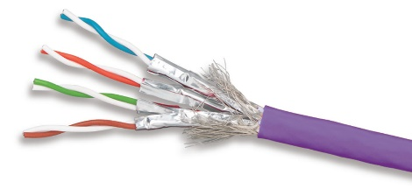
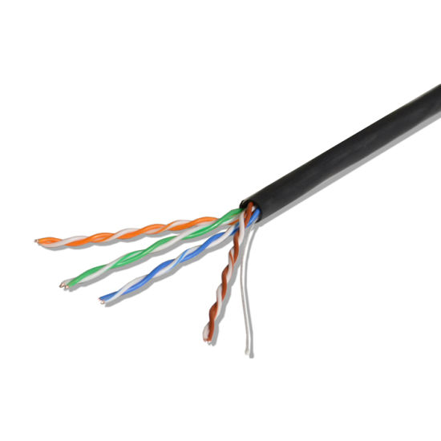
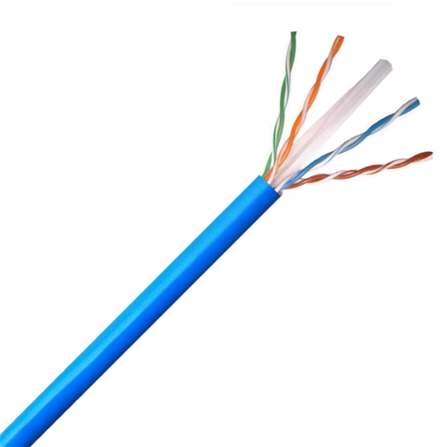
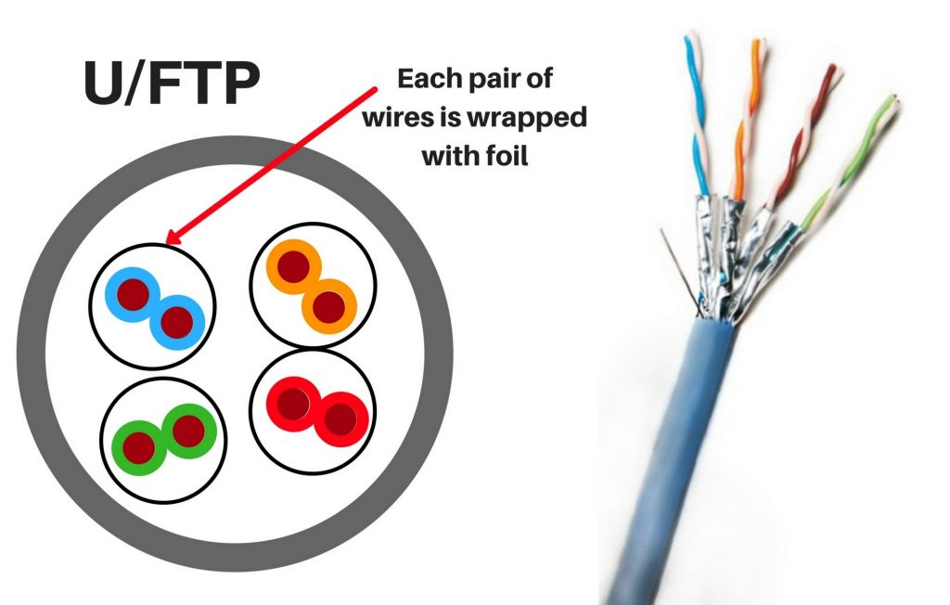
CAT5e
CAT6
CAT6a
CAT7

Figure 7. Twisted pair cable

