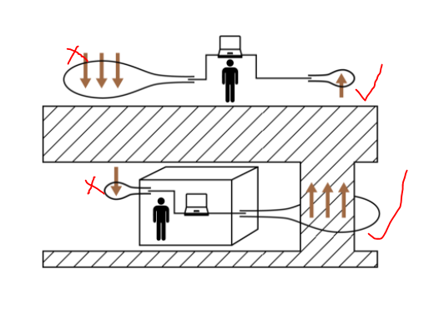
Like this

Note: Only one illustration is needed based on these two figures. I draft the top one, to make it clear, I copied a reference as below.
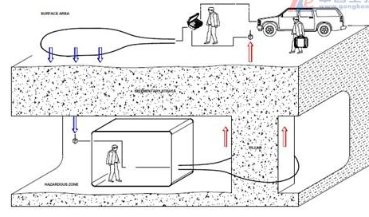

Through-the-earth (TTE) communications between the surface and underground is generally through the use of very low radio frequency (VLF) or extremely low frequency (ELF) signals. VLF refers to radio frequencies in the range of 3kHz to 30kHz, and wavelengths from 10 to 100 kilometres. ELF is the frequency range between 3Hz and 3kHz. The main advantage of VLF and ELF signals is that they can penetrate much deeper into the ground than higher frequency signals {Yan 2014}.
ELF and VLF signals are generated by various natural and artificial phenomena. The natural origin sources include lightning discharges and sprites from thunderstorms, volcanic eruptions, dust storms and tornadoes {Barr}.
TTE is useful in emergency conditions and for rescue operations, to name just a few use scenarios. For many years, investigators have been attempting to use VLF waves to navigate underground. However, there are difficulties when using either naturally occurring VLF signals (such as those produced by lightning strikes) or artificially generated VLF signals {Harner}.
The TTE system normally consists of surface transceiver, surface antenna, underground transceiver, underground antenna, and the transmission channel which is the earth’s strata. Power source for the transceivers is of course needed. The typical power source for underground transceiver is a battery.
In the event of an emergency, when all other communication systems are down, VLF or ELF signals penetrate the rock, to achieve one-way or two-way communication in the form of voice, text, or simple signal. As the signal frequency is very low, data transmission rates are limited. Some systems only support text messages, predefined messages, or beacon signals. Even the simple beacon signals are very useful in emergency and it can be used to locate the workers underground. Figure ?? shows a typical inductive coupling based TTE system. As the components of TTE system in underground is extremely simple compared with other communication systems, TTE systems have a much higher possibility to survive a disaster such as explosion. Hence, TTE systems can provide an emergency communications link to the surface for trapped workers.
So far, almost all the existing TTE systems applied inductive coupling. The VLF or ELF frequencies result in wavelengths between 10km and 100,000 km. To achieve high transmission efficiency in a communication system, half-wavelength or quarter-wavelength antennas are used. It is impossible to create a TTE antenna which is at least several kilometres long. Hence, TTE antennas are inefficient and only a small fraction of the transmitter power is utilised. The typical antennas for TTE systems are loop antenna, monopole antenna. Researchers also studied the helical antenna.
Not only the RF signal, but also the mechanical wave can be used for TTE. It has been reported that the low frequency seismic wave can propagate over a long distance. The elastic wave based TTE system has a much smaller size, however, the signal attenuation is normally severer than VLF/ELF signal. There is no commercial TTE system based on elastic wave available.

