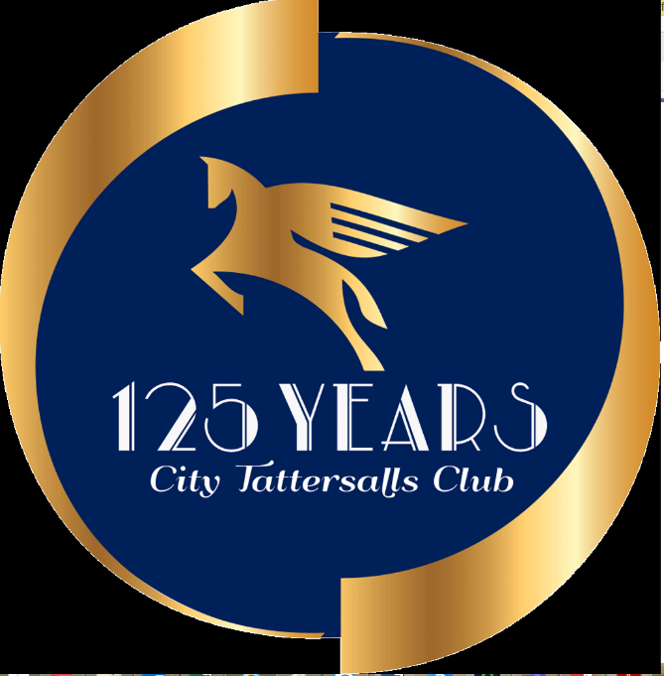

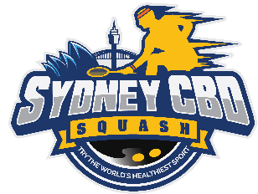





WORDING TO BE INCLUDED ON POSTER
Tournament Details
- 13 th – 15th August 2021
- Held at CBD Courts (Castlereagh & Tattersalls Clubs) and Sydney Uni. Sports & Fitness
- All finals will be at the Castlereagh Club
Saturday Night Open Bar in CBD provided by Sponsor ($3K bar tab)
Grades Available:-
1. Mens and Ladies Squash Open, $14k in prizemoney
2. Racquetball Open
3. Junior events
4. All grades / abilities catered for
Players guaranteed 3 matches
$60 entry fee
Weekday matches also organised for CBD workers preferring to play during the day
Entries close 7th August 2021

Tournament Director
Contact: Jason McLauchlan
Jason.McLauchlan@icloud.com
0403313648



