

YourHappySpace.com - Homepage NavMap
Rev. 4/28/21
by Will Burge and Ashley Slimak

Notes: For this one I worked off a template I thought captured the essence of what we want to accomplish for YourHappySpace.com. Once again this was just a guide for my own visualization purposes but I think something in this direction would make us feel more like a lifestyle blog they can trust that sells cool products. The template is too feminine but I felt like it was a good visual reference point so you could get a feel for the vibe we want to achieve. https://succulents.qodeinteractive.com/wellness-home?utm_source=pinterest&utm_medium=pin&utm_campaign=select This template will be referenced throughout the Navmap.
Color Scheme: Our current color scheme for YourHappySpace includes blue and purple as the main colors and also black as an accent color. Either the blue or purple can be incorporated into elements throughout the site such as button colors, link hoovers, strip colors, etc. We do not want black to be too overpowering on the site, but adding a few touches of it to places such as the footer, etc. would be great.
Navigation Bar
- We would like the navigation bar go across the top of the home page with the elements in the following order:
  - Logo on the left-hand side
  - Menu/pages to the right of the logo
  - Social media links on the right-hand side
  - A shopping cart/bag icon to the farthest right
  - Have a smaller strip above the navigation bar in a different color that states ‘Free shipping on all orders $50 and over!”

Main Banner
- Slider: Create a large, full width slider with three slides.
  - Slides are full page width with temporary modern/lifestyle photos with clean type over top and “Shop Now” button that links to the page for marquee products.

Sale Bar/Strip
- Call to action for sale items.
  - Bold, eye-catching color, “50% off sale going on now! Because saving money also makes us happy”

Featured Product Grid
- Have the heading of this section read: “The key to total bliss is nurturing the mind, body, and soul”
- I really like this style of layout from the referenced template. A grid with smaller blocks that are featured products and blog posts (if there are seven blocks then 5 products and 2 blog posts) and one larger cornerstone product image.
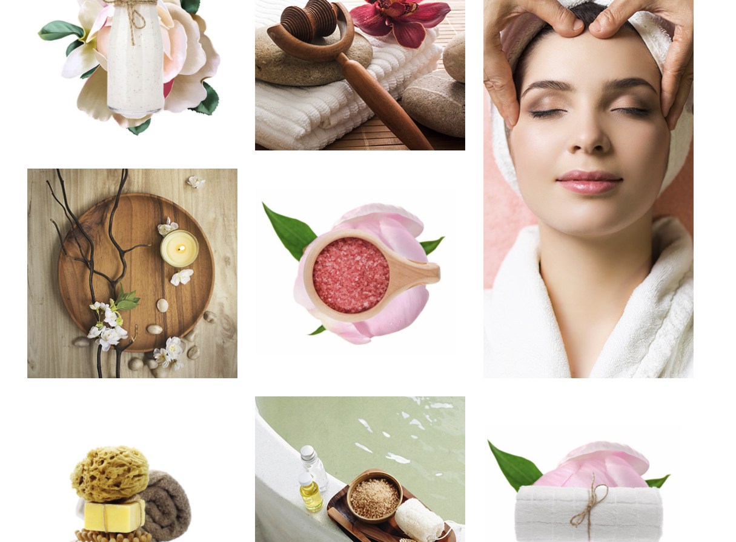

Banner/Strip (About Us)
- Have the copy on this strip read “They say that home is where the heart is. But home is also where your mind and body reside. At Happy Space we believe that home should be your place of Zen. A respite from the crazy world outside those walls. It is where you recharge your soul so you can approach each day with the focus and energy necessary to conquer the world.” With a “Tell Me More” button that links to the “About Us” page.
  - I think these strips done similar to the ones on Redspaceevents.com or under the ‘Spa Center For You’ section of the example template with the parallax scrolling effect (when the website layout sees the background of the web page moving at a slower rate to the foreground, creating a 3D effect as you scroll) would look awesome.

Banner/Strip (Payment)
- Have the copy of this strip read “Don’t sweat it. You can pay later.” with Bread Financing logo

Blog Section
- Title of this section will be called “The Happy Blog” with a subhead reading “Food for the mind, tips for the body and exercises for the soul”
  - Show 3 of the newest blog posts in one row, picture & title preview style, and link to those blogs. Mobile users will be able to scroll through these left to right.

Live Chat
- Include a live chat feature located towards the bottom right-hand corner of the homepage. I really like something like this icon from alphapaw.com, but we are looking for an icon that is similar, but has a simple feel to it.


Footer
- Definitely want this section to match the color theme. Possibly a black footer background with white text.
  - Add the logo on the left-hand side with social media icons underneath, similar to the Fablepets.com footer.
  - Add a newsletter sign-up section on the right-hand side with a ‘Submit’ button next to or underneath the text box.

Individual Web Pages
Below will include the details, ideas and copy for the individual pages on the website.
Shop
- Happy Space Hotstore product presentation with categories, search, and “customers also purchased” features.

Our Story
- Heading of this page will read “We’re just a group of folks who are passionate about happiness.”
  - The supporting text will read “In a single day the average person has 16 unplanned human interactions and is bombarded with as many as 10,000 ads. That is on top of all the stressors from social media, work, traffic and anything else this crazy world throws at you. We all deserve a place to escape the madness.
- Add a separate strip that reads “Our products are designed to help you decompress.”
  - The supporting text will feature “Studies show that heavy stress can shorten your lifespan by more than four years. Whether it is physically, mentally or emotionally we all need a break. We believe home should be your oasis from the chaos of the world. That’s why we only offer products that we truly believe will make your life a little easier, more vibrant or more enjoyable.
- Add another strip that reads “Our crusade for your tranquility”
  - Supporting copy will read “Our motto is people over profit. Our movement is to help the world focus on self-care. Our mission is to transform your home into your Happy Space. So come join us and let’s get happy together.”

The Happy Blog
- The header will read “Happiness is a journey, not a destination.”
  - Supporting text will read “At The Happy Blog we gather the latest trends, expert tips, and advice to help illuminate your path.”
  - We would of course love a version to match our site’s design. The blog at https://storego-demo.myshopify.com/blogs/news/nisl-sem-tincidunt-nulla is a decent example of how “Related Products” should populate on the side of all blog posts. This is our content marketing at work. We would want these populating on the main blog page as well (probably featured products since there won’t be any tags on the main blog page to pull related products from)

Stress Symptoms
- Include a large, full width slider with three slides. Slides are full page width with temporary modern/lifestyle photos with clean type over top. These are “featured product” sliders but instead of the picture focusing on the product, the picture is someone stressed out, tired, looking sad etc.

Copy

The main paragraph of this page will include the following copy:
We tend to focus on health strictly in a medicinal way despite the fact that 77% of people experience stress that affects their physical health. The stress you carry in your mind takes a toll on your body whether you realize it or not. Here are some common symptoms caused by too much stress in your life.
        - Low energy, feeling lethargic or unmotivated
        - Depression or general unhappiness. Anxiety or agitation. An inability to look to the bright side of things
        - Headaches, upset stomach and digestion problems.
        - Random aches and pains or tense muscles
        - Feeling overwhelmed, lonely or isolated despite being surrounded by caring people.
        - Frequent colds, infections or general malaise

This paragraph will follow after the list of conditions: “The good news is that, according to health.gov, managing your stress can reverse many of these symptoms and even lower your risk for other conditions like heart disease, obesity, high blood pressure and depression. It’s never too late to begin your fight against every day stress and take control of your happiness.”

“What can I do?” link to “Home Wellness Practices” page.

Home Wellness Practices
- Include a large, full width slider header photo with people looking happy, energetic with the copy “Your Happiness is in Your Hands”

Copy:
The main paragraph of this page will include the following copy:
A common misconception is that mental health is hard to maintain and true happiness can only be achieved by those with an abundance of money, time and resources. The fact is, there are things you can inject into your daily routine that will bolster your mental health in less time than it takes you to pick out something to watch on Netflix. Here are some easy tips and exercises to help you find a little more balance and keep stress at bay.

(Tips will be divided into three sections: Mind, Body and Soul)
Mind
- Read - Reserve 20-30 minutes per day to read a book. Pick something that has nothing to do with your occupation. It could be a book to better yourself or just a fun fiction read but no matter what you choose, try to lose yourself in the pages. This is your mind’s time to escape the daily grind and go play in its imagination.
- Journal - Take 10 minutes each day to journal about something you appreciate in your life. Taking a moment to recognize the positive things in your life will slow down your mind and allows it to step out of the swamp that stress can create. We tend to only focus on negatives and this will train your brain to reserve some space for the good stuff.
- Meditate - A short, ten-minute meditation can be the cleanse your mind needs to take on or recover from the day. You don’t need to be the Dalai Lama or a trained meditation professional to enjoy the benefits of mindfulness. Download a free ap on your phone for guided meditations or just find a quiet place to sit and be present. Either way your mind will thank you for the period of tranquility, no matter how brief.

Body
- Exercise - Get your body moving. It is no secret that exercise is vital to physical health but that extends to the mind as well. Working out, even if it is just a short walk each day, allows the body to burn away toxins and ease the negative effects of stress. After just a few short weeks of exercise you will see a huge difference in the way you feel and you will start to look forward to that release.
- Eat Healthier - The old adage “You are what you eat” couldn’t be more true. Processed foods contribute to the sluggishness of not only the body but the mind as well. Simple changes like substituting water for sugary drinks or a salad for fries can go a long way, even if it is just one meal a day. Matthew J. Kuchan, Ph. D., a senior research scientist at Abbott says, a healthy diet builds a solid, more enduring foundation for your body by reducing oxidation and inflammation.”
- Soak Up the Sun - One of nature’s main sources of happiness constantly surrounds us and we hardly pay attention. Sunlight is thought to increase the brain’s release of serotonin which helps you feel more calm and focused. Serotonin is the chemical in the brain that creates the feeling of happiness and euphoria. So get outside and get your daily dose of happiness!

Soul
- Cleanse Your Life - Life is hard enough without carrying other people’s baggage. We all have people in our lives that weigh us down mentally, emotionally or financially. Create some space between you and these people. If you can’t cut them out of your life completely then make rules for yourself. Limit the amount of time you spend with them or talk/text with them on the phone. If they begin to pile their problems on your shoulders politely excuse yourself from the situation. You have enough on your plate.
- Slow Down – Not everyone has the time or money for vacations to luxurious beach cities but you can always find ways to take a break. If it feels like your life is constantly on the go then schedule a “break day” the same way you would a work meeting or drinks with a friend. Stay home, get a hotel room by yourself or take a long drive. It doesn’t need to be extravagant, it just needs to be your time away from the real world.
- Surround Yourself with Positivity – In the same way that food becomes who we are, so does the external stimuli that we surround ourselves with. Changing the types of TV shows, movies and music we consume can have a major effect on mood and stress. We know you love those murder mysteries but maybe sub in a fun cooking show every once in a while. Your mind will thank you.

*Each of these will eventually be tied to product recommendations once the product line is filled out.

Wellness Club Rewards
- This will open a Loyalty Lion rewards program pop up. Below is an example of a Loyalty Lion pop up dashboard from another site

