Can you make the other women the same size as the black woman? The Black woman looks bigger. I want all the women to be the same size as the black woman. Make the other women larger. And be sure that they are centered on the page. Reduce some of the silver background.

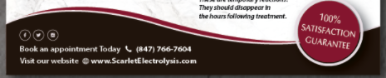
Can you Bold the following text:
Schaumburg’s #1 licensed and certified Electrologist.
Use Font:
Hearth Stone because it is easier to read.
Aftercare Instructions:
Come and meet Sangita!
Can you put the red swirl back the way it was. I want it to look like the one below.
Make this the same size as the one above.

