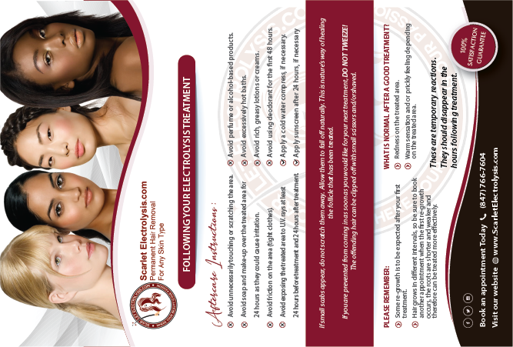
Please put the women back in the order that they were in because I did NOT ask you to change the order or placement of the women. There is space to the left and right of the women, so there is room for you to make each individual woman LARGER or BIGGER. With an EMPHASIS on making the middle eastern woman larger than any other woman. Show more of the women’s skin on body. Like you had it before.
Alex, You keep changing things that I haven’t asked you to change. If I don’t ask you to change something that means I want it to stay the same. I did not ask you to change the placement of the women!!!! I asked you to just make them BIGGER.

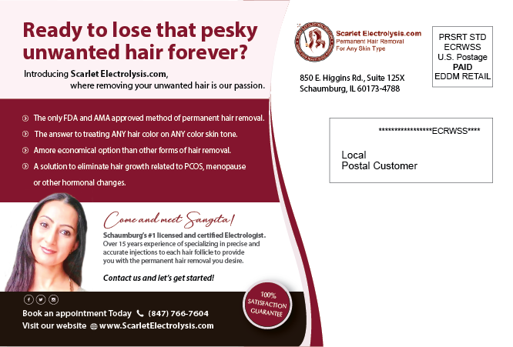
Change this wording per my lawyer:
Customers Are Our Priority
DO NOT MAKE THE CIRCLE BIGGER.
My lawyer made a lot of subtle wording changes on the attached word document so please replace all the wording on the attached Word document.

Show more of the women’s body. There is room for you to make this section smaller and move it DOWN so you will have room to make the top section bigger. DO NOT CHANGE THE SIZE OF THE WORDING. ONLY CHANGE THE SIZE OF THE BOX.
Move the address UP a little.

