PAM - Vertical Mixer

Introduction:
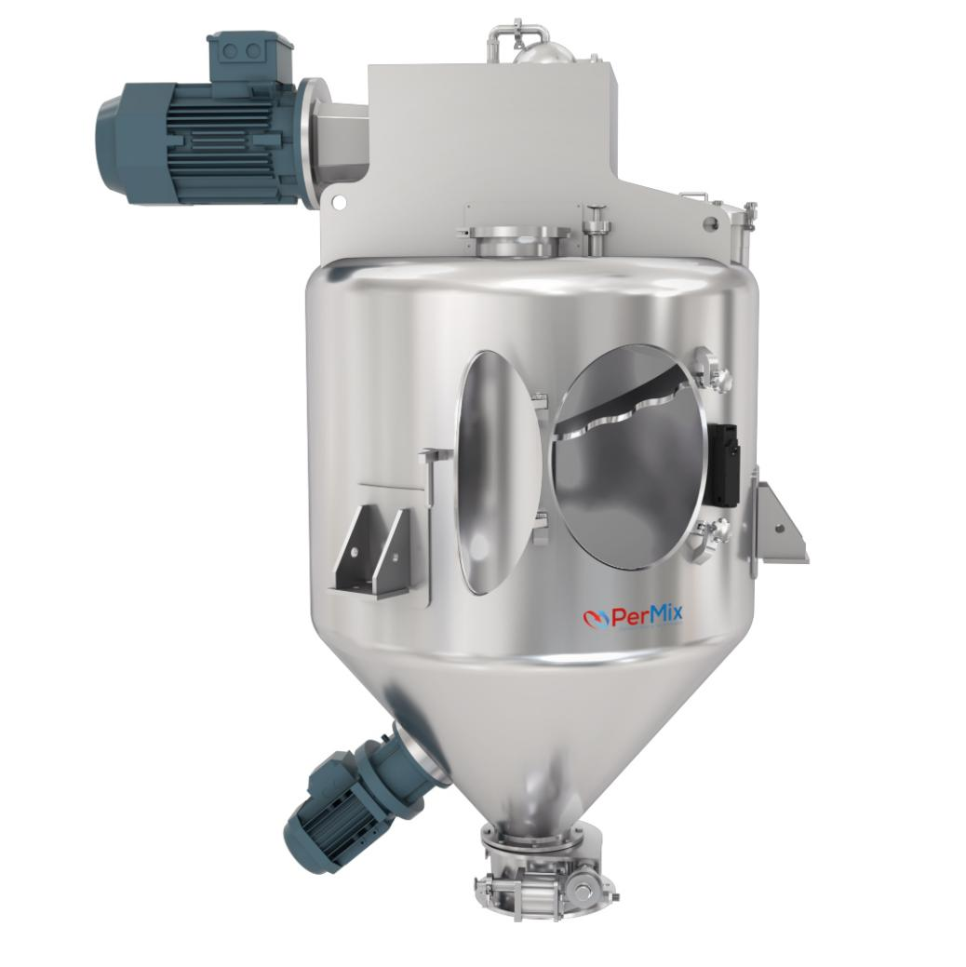
The PerMix PAM series Vertical Mixer is a super innovation that combines all the advantages of precise mixing homogenity, highly hygienic design, complete discharge with minimum residue, wide range of loading volume, robust design with long duty life and many others.

PAM Vertical Mixers are efficient and versatile blending machines for batch mixing of free-flowing powders, granules and pellets. They have been used widely in food, enzyme, cosmetics, fine chemicals, pharma, etc.

How It Works:
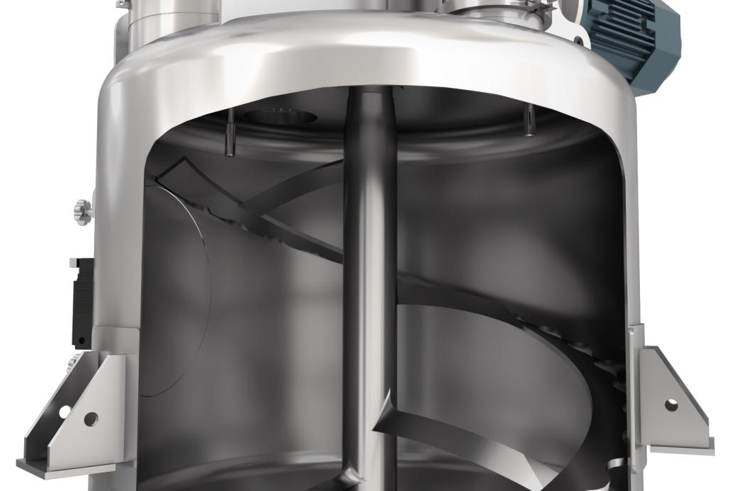
PerMix Vertical Mixers are degisned with a single shaft with only one ribbon, but is able to provide a multi-dimensional movement of the materials. They are with a cylindrical body with conical bottom, but sometimes can be with flat bottom and scrapers to assist the discharge.

There is a flush-fitting side mounted access door for inspection and cleaning purpose. A flush-fitting plug valve is mounted at the bottom for product discharge.
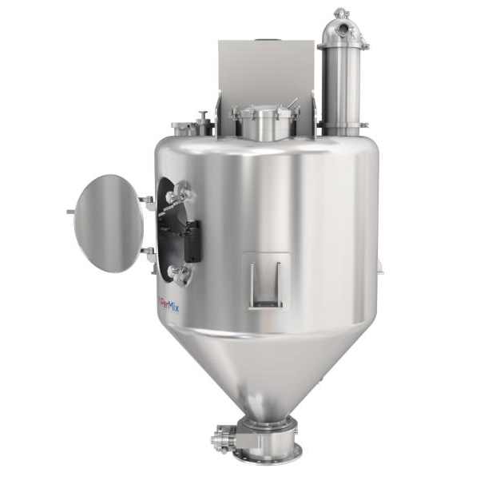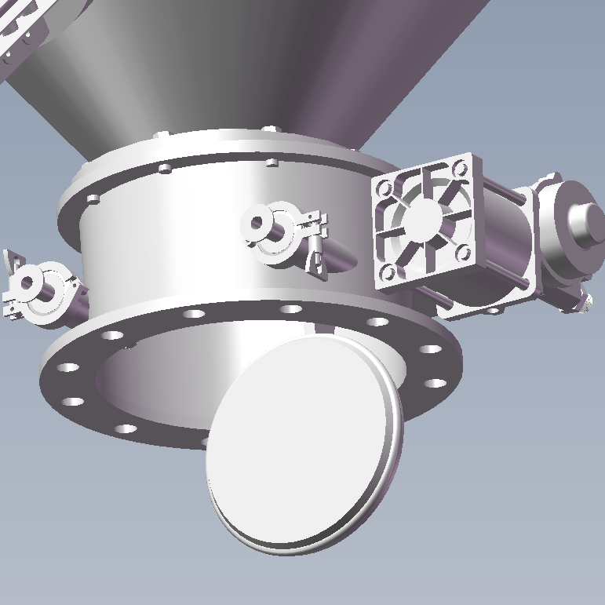

The ribbon inside the mixing vessel moves the materials upward from the bottom to the top, where the materials then drop by gravity into the center. This generates a good counter flow of the product particles. The ribbon design ensures that the linear speed of the particles are different from here to there, which results in a tubulence flow field. During this continuous operation, material particles and heat are exchanged quickly which leads to a homogeneous product.

Besides, the material particles are mixed with minimal mechanical and thermal stress, which makes this type of mixer a good solution for fragile and heat sensitive product.

Advantages:
- High level of accuracy with minor component ratio to be 1:1,000,000
- Gentle mixing for sensitive materials without generation of heat
- Chopper can be installed for intensive mixing and lump breaking
- Low minimal quantity required
- Full discharge with minimal residue
- Easy to clean in either dry or wet way
- High heat transfer rate, ideal for heating or cooling process of the powders

Options:
- Construction Material and Finish
Our mixers can be built in Carbon steel, SS304, SS316L, Titanium, Hastelloy, etc. Finish of stainless steel can be mirror polished or bead blasted.

- Feeding & Discharging
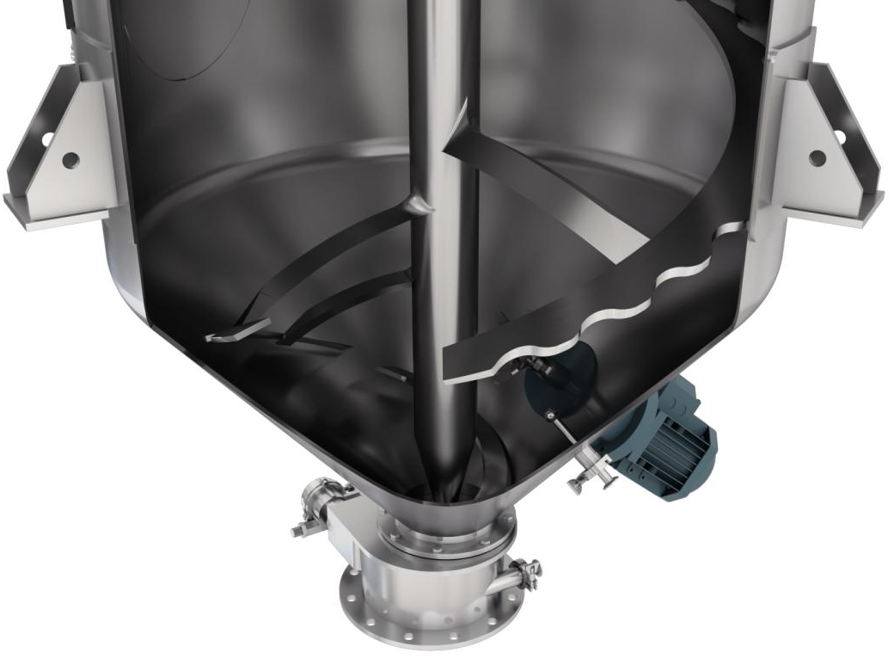
A variety of feeding & discharging methods can be selected by the customers.

- Heating/Cooling jacket
Jacketed trough for heating/cooling operation

- Vacuum drying & deaerating
The PAM mixer can be designed for vacuum drying & deaerating or for inner pressure working for special applications.

- Spray nozzle
Liquid can be added into the powder by spray nozzles on the top.

Specifications:
Model | Total capacity  (liter) | Working capacity  (liter) | Power (*)  (kW) | Shaft Speed (RPM)
PAM-150 | 150 | 105 | 1.1 ~ 5 | 105
PAM-300 | 300 | 210 | 3 ~ 8 | 83
PAM-400 | 400 | 280 | 5 ~ 15 | 73
PAM-500 | 500 | 350 | 7 ~ 21 | 66
PAM-750 | 750 | 525 | 8 ~ 27 | 61
PAM-1000 | 1000 | 700 | 12 ~ 40 | 52
PAM-1500 | 1500 | 1050 | 14 ~ 48 | 48
PAM-2000 | 2000 | 1400 | 19 ~ 64 | 42
PAM-3000 | 3000 | 2100 | 22 ~ 78 | 38
PAM-4000 | 4000 | 2800 | 29 ~ 101 | 33
PAM-5000 | 5000 | 3500 | 34 ~ 120 | 30
PAM-6000 | 6000 | 4200 | 34 ~ 120 | 30
PAM-7000 | 7000 | 4900 | 38 ~ 137 | 28
PAM-8000 | 8000 | 5600 | 43 ~ 153 | 26
PAM-10000 | 10000 | 7000 | 47 ~ 167 | 25
PAM-12000 | 12000 | 8400 | 50 ~ 180 | 24
PAM-15000 | 15000 | 10500 | 57 ~ 205 | 22
PAM-20000 | 20000 | 14000 | 63 ~ 227 | 21
1. All specifications and illustrations are as accurate as is reasonably possible, but they are not binding.
2. PerMix reserves the right to modify the design without notice.

