My Personal Learning Agility Framework

The process of reflecting between my data, the UAE education context, and the literature has enabled me to conceptualise a set of dispositions and a personal learning agility framework. This has emerged by reflecting on the context (Richardson, 2002, Riessman, 2005, Etherington, 2004), the inquiry habits of teacher educators, and the importance of research (Tack and Vanderlinde, 2014, 2019, Kreijns, 2019), workplace learning and the nature of time (Eraut, 2004), and inter-cultural learning (Huber et al, 2014).

My Personal Learning Agility Framework
In order to create this framework, I drew on Kelchtermans (2018) ‘Dynamics of Professional Learning’ model, together with the Flemish Teacher Educator Development Profile (2012) and Killick’s (2013) notion of self in the world as a means to develop cultural competence. Distinct areas of my professional practice have emerged and I have captured these within domains to indicate that progression of knowledge is possible across these development areas, which comprise:

Inter-cultural competency
I define context and relationships as the ability to navigate the different cultural, economic, and education settings of the UAE and interact with people within these environments. Within my professional roles, I have to demonstrate an ability to work not only with Emirati teachers, but also with Arab and South Asian expatriate teachers, and to recognise the educational and cultural nuances of each, within both the public and private sectors; and therefore to adapt my behaviour for each context. I have categorised the domains in Table 7 from beginner to master to indicate the various levels of the potential progression of knowledge (see Table 7).

Table 7 Inter-cultural competency domains
Beginner | Intermediate | Mastery
Awareness of the different education settings within the UAE, public, and private sectors.  Awareness of the different communities that exist within the UAE. | Awareness of the different education settings within the public and private sectors in the UAE, and ability to access key stakeholders in both settings.  Awareness of the different communities in the UAE and ability to build relationships with people within these communities. | Ability to use knowledge of the diverse education contexts, and leverage key stakeholders in order to further personal and collective interests.  Ability to access different communities and leverage relationships to further personal and collective objectives.
Awareness that different regulations exist for the public and private sectors. | Awareness of how different regulations exist and ability to respond to key stakeholders with support in light of the regulations. | Ability to provide tailored responses to key stakeholders within the context.
Awareness of some of the needs of Arab expatriate teachers working within the public and private sectors, and of the cultural differences that exist. | Awareness of some of the needs of Arab expatriate teachers working in the public and private sectors and ability to adapt one’s thinking to support their needs in either sector. | Awareness of the needs, challenges and opportunities of working with Arab expatriate teachers within the public and private sector and ability to demonstrate cognitive flexibility to further their professional learning.
Awareness of some of the needs of Western expatriate teachers working within the public and private sectors. | Awareness of some of the needs of Western expatriate teachers working within the public and private sectors, and ability to adapt one’s thinking to support their needs in either sector. | Awareness of the needs, challenges and opportunities present when working with Western expatriate teachers within the public and private sectors, and ability to demonstrate cognitive flexibility to further their professional learning.
Awareness of the economic structures and nature of employment contracts in the UAE. | Awareness of the economic structures and nature of employment contracts in the UAE, and the ability to write about the context. | Awareness of the economic structures and nature of employment contracts in the UAE, and the ability to make personal decisions that enable insightful decision making within the structures.

Access to people and information
I define ‘access’ as the ability to: 1) gain access to different groups of teachers within different settings, 2) to build relationships with them, 3) engage teachers in key issues within the profession in order to gain their insights, and 4) create opportunities for dialogue and engagement between teachers (Table 8).
Table 8 Progression of the ability to access people and information
Beginner | Intermediate | Mastery
Awareness of different groups of teachers and ability to access some of them. | Ability to access different groups of teachers and conduct research with them. | Ability to conduct research with different groups of teachers and disseminate the research with different audiences to influence decision making.
Ability to engage in sharing others’ research with teachers. | Ability to engage in sharing others’ research, and ability to share organic research conducted with teachers. | Ability to create opportunities for others to conduct research within the sector.
Ability to work with different teacher educators and teachers to develop conversations around professional dialogue. | Ability to develop and create professional dialogue within the context. | Ability to create new professional knowledge within the context of the UAE and engage others in discussions.

Uncertainty and Time
This ability involves recognising and strategically anticipating changes in the profession. I also define it as the ability to 1) adapt to different professional roles and maintain positive relationships with key stakeholders, 2) respond to opportunities in order to collect data that may have limited availability, and 3) adapt to changes within the sector and make an impact (Table 7).
Table 9 Progression of the ability to develop awareness
Beginner | Intermediate | Mastery
Awareness of my organisation’s funding model, how it generates income, and how my employment contracts fits in with this model. | Awareness of my organisation’s funding model, how it generates income and how my employment contracts fits in with this model, together with the ability to plan ahead to benefit from my awareness. | Awareness of my organisation’s funding model, how it generates income and how my employment contract fits in with this model, as well as the ability to plan ahead to benefit from my awareness, and to act upon this in time.
Awareness of how to change my employment situation within the UAE laws. | Ability to change my employment situation within the UAE laws without negatively affecting my personal situation. | Ability to change my employment situation within the UAE laws and navigate different professional settings with confidence.
Ability to recognise opportunities to collect data that may enable me to conduct research within the profession. | Ability to collect data within the various situations that may arise, and produce research reports that influence decision making with key stakeholders. | Ability to create research opportunities based upon situations that may arise and that require research to be conducted in order to influence decision making with key stakeholders.
Ability to recognize when changes within the profession may affect my organisation, my personal situation, or my employment. | Ability to recognise when changes occur within the profession that may affect my organisation, my personal situation, or my employment; and the ability to respond by strengthening my own personal situation through changing my employment position. | Ability to predict changes within the profession that may affect my organisation, my personal situation, and my employment; and the ability to respond by strengthening my own personal situation through changing my employment position and the personal situation of others.

The domains represent a hierarchy of knowledge of specific domains that have enabled my learning to develop in-depth. I chose the term ‘agility framework’ to emphasise the importance of a responsiveness to the context and of the ability to respond with urgency between the various components (The Economist, 2012). I present the agility framework in Figure 12. The concentric circles are inter-connected as they are inter-dependent aspects of developing personal empowerment. The applicability of each domain relies on my ability to be aware of the context and to build work with urgency.

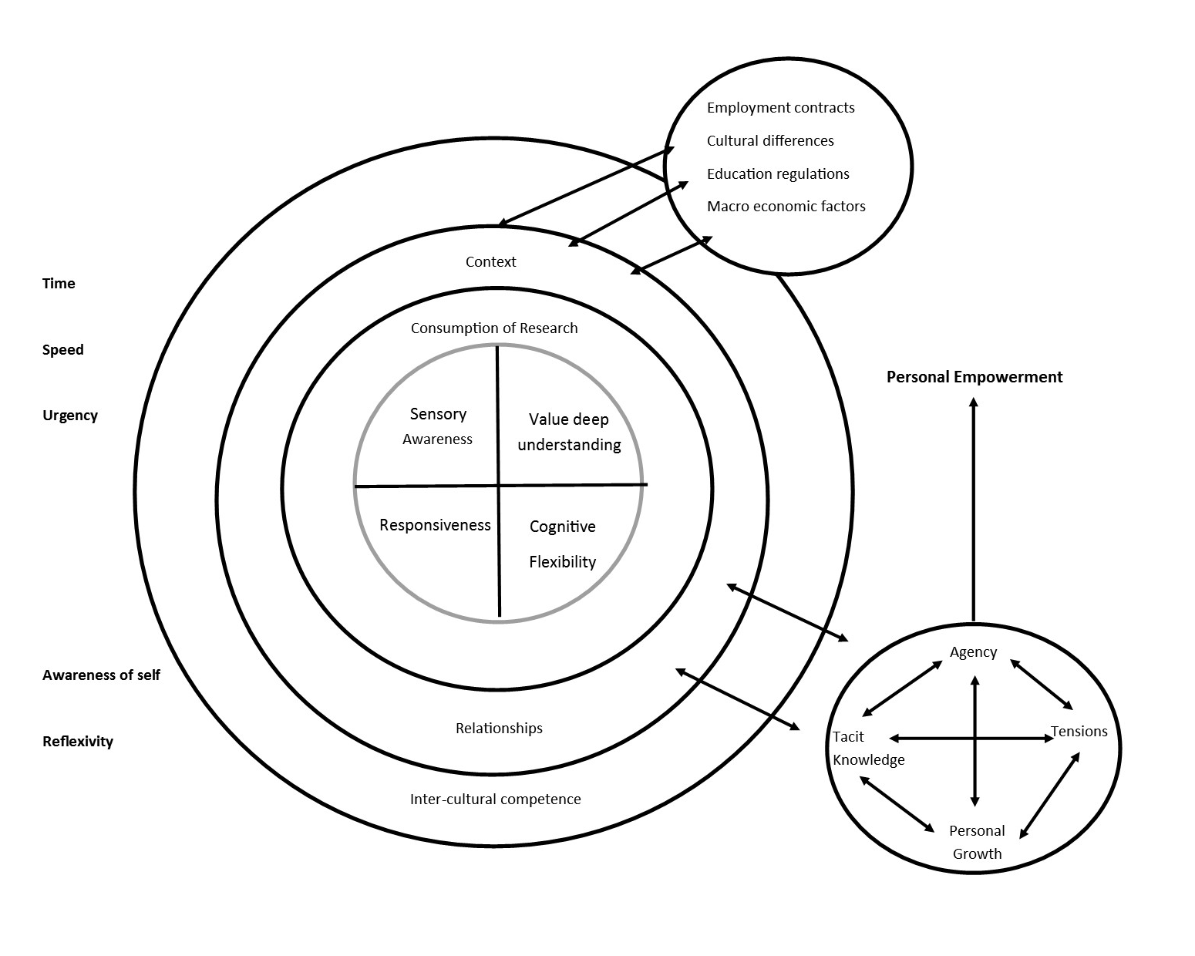
Figure 12 My Personal Learning Agility Framework
Source: Author’s own.

5.3 Summary of the framework
My learning has been iterative throughout this research, so this framework is intended to be understood as iterative, with movement between the concentric circles at a cognitive and behavioural level when greater awareness is gained. At the heart of the main circle are the researcherly dispositions that have been essential to my research and professional roles as well as to my personal learning. I have used descriptive headings for these dispositions that I believe are helpful for understanding them. The first one, ‘value deep understanding’, is modelled on Kreijns (2019); whilst ‘cognitive flexibility’ is an inter-cultural competency from Huber et al (2014). I have also added in ‘responsiveness’ and ‘sensory awareness’ which I believe are additional dispositions that have emerged in this study. Whilst conducting this research I have been responsive to the context, the participants, and the data, whilst gaining a greater awareness of my place within UAE society. This has made me more aware, and therefore, I have sought to leverage my awareness by making strategic decisions about my career. The researcherly dispositions are explained below:
Researcherly Dispositions
Value Deep Understanding
1. I am critical on whether I did the right thing.
2. I wonder if I can improve my work.
3. I watch how colleagues do things in order to learn from them.
4. I ask others for their opinion of my work.
5. I try to collect information so I can evaluate my work.
6. I can empathise with different teachers from different cultures.

Cognitive Flexibility
1. I can recognise myself in different contexts and how I may be perceived by others.
2. I try to view things from other perspectives.
3. I can adapt my thinking for different cultures and environments.
4. I can recognise power structures that have enabled others to view me, and can adapt my behaviours to cater for this and produce better outcomes.

Responsiveness
- I can respond in a timely manner to changes in my context and situation.
- I can respond to teacher educators, and teachers’ needs in light of their contextual challenges.
- I can respond to changes in my own personal situation and maintain positive relationships with all stakeholders.

Awareness
- I am alert to research opportunities within all aspects of my context.
- I can sense when research may be used to influence decision making or my own personal situation.
- I can see when I need to work faster and leverage relationships to produce or consume research.

Context and relationships are critical factors outside these psychological dispositions, and the wider context and smaller micro-contexts have been critical to my learning. At the same time, I have been required to consistently examine and respond to the Ministry of Education, KHDA and ADEK regulations within the UAE education system. The public sector, for example, has a large number of Arab expatriate teachers who have chosen to work with Emirati children. This professional setting is culturally different to the international sector within the UAE. The teachers that work within the public sector are in the midst of their own personal and professional stories and may not be aware of developments outside their immediate contexts. The skill set required to work with these teachers is primarily a communicative one, and at the same time, working within this context has challenged my worldview.

The private sector, which varies from emirate to emirate, is also diverse, with notable differences between the numerous education spaces. Western expatriate teachers working in the private sector are often operating within their own school communities. An awareness of the relevant regulations and political issues within the private sector has been an important feature of this research. Therefore, the decisions I have made in relation to my research were based on a wider view of the private sector’s current status.

When working with individual teachers, it has been imperative to know their demographic details—contract length, nationality, and years of experience—to allow for more accurate decisions with regards to their professional learning. As the majority of teachers operate on two-year contracts, professional learning not only has to be impactful, but must also provide a return on investment. Without knowing the wider demographics of the country, together with the smaller demographics of the individual teacher, we are at-risk of making poor decisions that may be costly in the long run. As with narrative research, the knowledge base about the context is always evolving, so it is difficult to define the appropriate knowledge needed. It is nonetheless imperative, however, that teacher educators know about the public and private sectors, and how they operate, as well as the demographic details of the schools and teachers they choose to work with.

Building networks is a valuable method of forming relationships, either in person or online. Professional networks have proved invaluable to me, as teachers have often relayed regulatory changes ahead of time, and as such, helped me to respond appropriately. These networks have also provided me with valuable insights into the lives of teachers in different locations across the country. In turn, these insights have enabled me to empathise with teachers and learn about the specific challenges arising within the profession in the UAE.

Time and Urgency
I acknowledge the importance of time and urgency as psychological factors that influence my professional roles (Eraut, 2004). As I have moved roles, as a result of my awareness of my position and self within UAE society, this has meant that I have taken decisions about my data collection methods from the perspective that my access to people and places may have an expiration point (Sparkes and Stewart, 2016). This has meant that narrative research is better suited to research in this context, rather than a traditional approach which favours a structured research design. The fluidity of movement—both with and between the agility domains—is reliant upon these factors. As I have gained knowledge about teachers, schools, regulations, and sector-specific information, I have needed to build momentum in, and awareness of, all the components in order to respond to challenges as well as gain further work.

Researcherly dispositions lie at the heart of the framework. This is underpinned by an understanding of the importance of time, and relationships, and an appreciation of the contribution of tacit knowledge and agency to my personal growth. Working through tensions may and discomfort as I navigated boundaries discomfort has led me to feel personally empowered, and with greater knowledge about myself.

This agility framework may not be a finished framework or a scalable model yet. It does, however, represent a potential area of future research. In constructing this framework, I have synthesised the components and created themes that provoke movement and agility, which I define as the ability to respond to change and make an impact.

