Book Cover Design Brief

Cover Title: Tears of Ice
Series Subtitle: Tears of the Heart Book One
Author: Sierra Knoxly
Genre: Reverse Harem Fantasy Romance
Concept: Central black-haired (long) woman with a magical stone portal (looks a bit like a stone henge) behind her. Setting is a hillside. Prefer casual modern clothing such as jeans, jogging-style shoes and blouse. Ice-look title lettering or icicles on the page. Just the word ‘Ice’ might be in ice-style lettering.
Exclusions: Ice does not refer to a winter season, so there should be no snow. Main character has no magic, nor any weapons.
Author’s Dream Inclusion: Would love to have an almost invisible shadow at the girl’s feet (if shown) that has multiple strands, i.e. the nine-tailed fox’s shadow. (Not essential, just a thought). This could be in the way the image fades to bottom of the page.
Series Continuation: The series contains 8 (possibly 9) books, with ‘tears’ of various elements: sweat, salt, blood, ink, fire, sand etc. The themes on the first cover need to be able to be replicated via the other compounds. The female character should stay the same, although in different poses/looks.
Alternative Ideas: Include the male characters. Book one would have 2 men, and the other 2 would appear further along in the series. I think it might be difficult to include these, although it would be amazing. For book 1, the 2 men are enemies, so might be back to back. One is a taller blond with blue eyes, the other is stockier, brown hair, brown eyes. Both would be wearing an Asian-style wrap jacket and pants.
I could also consider a cover series based on emblems, but this is far less frequent in the genre.
Mood/Themes: fantasy as dictated by the magical portal behind her. In book 1 the main character is kidnapped and stranded, so a low power pose. Not smiling. Should not be dark or spooky. Ice should be a strong element, which may indicate cool colours.

Book 1:
Synopsis –
One human stranded in another realm. Two mortal enemies who can't seem to stay away from her. One secret that could see them all destroyed.

Ava:
I escape from my kidnappers through a doorway only to find myself stranded in another world. Out of the frying pan and into the fire! Even worse, it's inhabited by shapeshifting beings I thought only existed in legend. Did I mention they're racists bastards with a dumb hierarchy that ends with humans? I want to stay as far away as possible from their literal ice prince, Erritt, who has a stick up his ass, but he keeps involving himself in my business. Around here, his word is law. Which is really bad news for the dragon he likes to torment. The dragon who has my heart fluttering, but blows hot and cold on me.
But then I stumble on Prince Erritt's secret. Now my life is on the line, because he'll do anything to protect it.

Skye:
We dragons are hated. Despised after an uprising two hundred years ago that no one, especially not the Exerin royal family, will forget. I thought I was okay with the status quo. Until a human who doesn't belong here shows up, seeing through me with those wide hazel eyes and asking uncomfortable questions. Despite her pathetic frailness, she's dangerous, because she has something stirring inside of me. Something that was supposed to stay asleep. Enchanted, I can't stay away. But any association with me puts her in danger. Especially after HE lays claim to her.

Erritt:
Duty, honor, obedience. My whole life is dedicated to the royal crown of Exerin. I've reconciled with my gilded prison fate. Then the human shows up. She's pathetic, and defenceless and beneath me. So why can't I ignore her? Thoughts of her invade my every moment, no matter how hard I try to keep her at arm’s length. But when she discovers my life and death secret, everything changes.

Cover ideas:
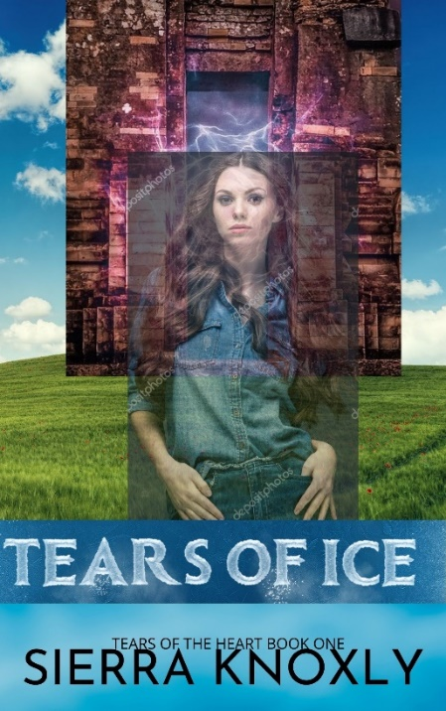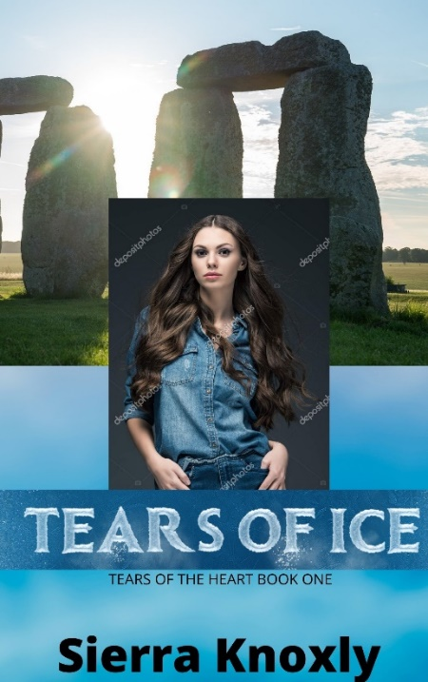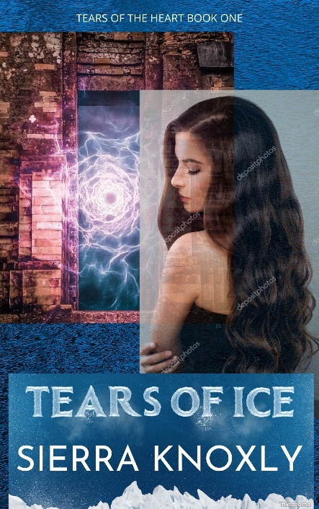

Similar covers published in the same genre (reverse harem – not all are fantasy): See attached document
Other inspirational covers:
