RUSTIC Design Style
Rustic design is drawn from natural inspiration, using raw and often unfinished elements including wood and stone.
Rustic design may incorporate accessories from the outdoors with warmth emulating from the design and architectural details that may include features like vaulted ceilings adorned with wood beams or reclaimed wood floors.
Many designs now integrate rustic design with more modern furnishings and accessories.

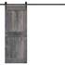 Link

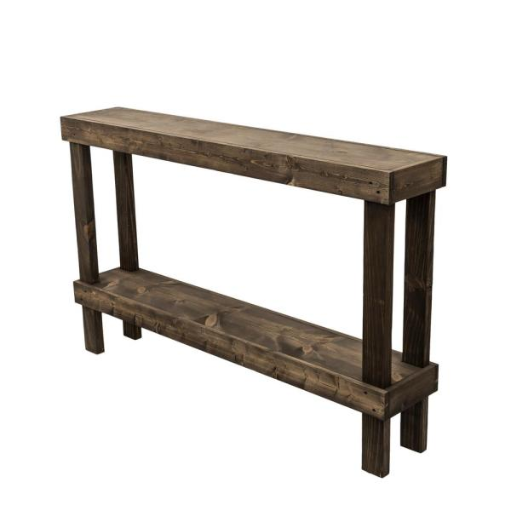Link

STYLE:

https://www.pinterest.com/pin/287878601155243145/

https://www.pinterest.com/pin/383791199491061034/

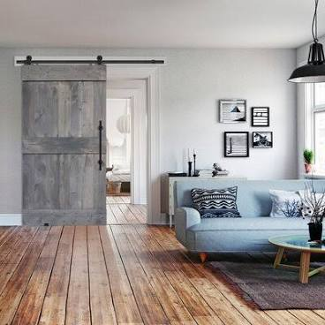

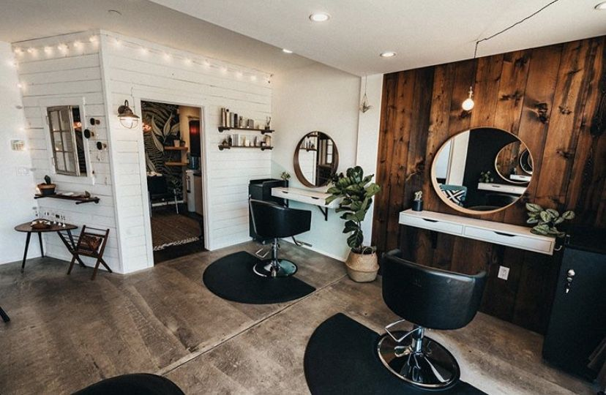

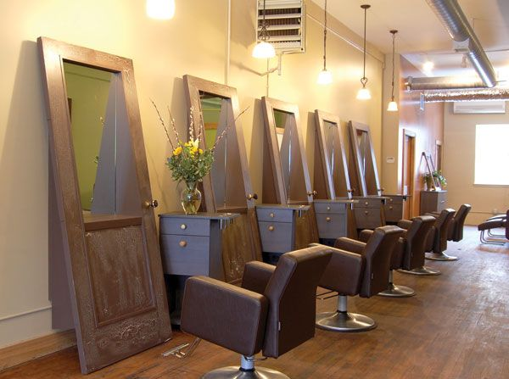

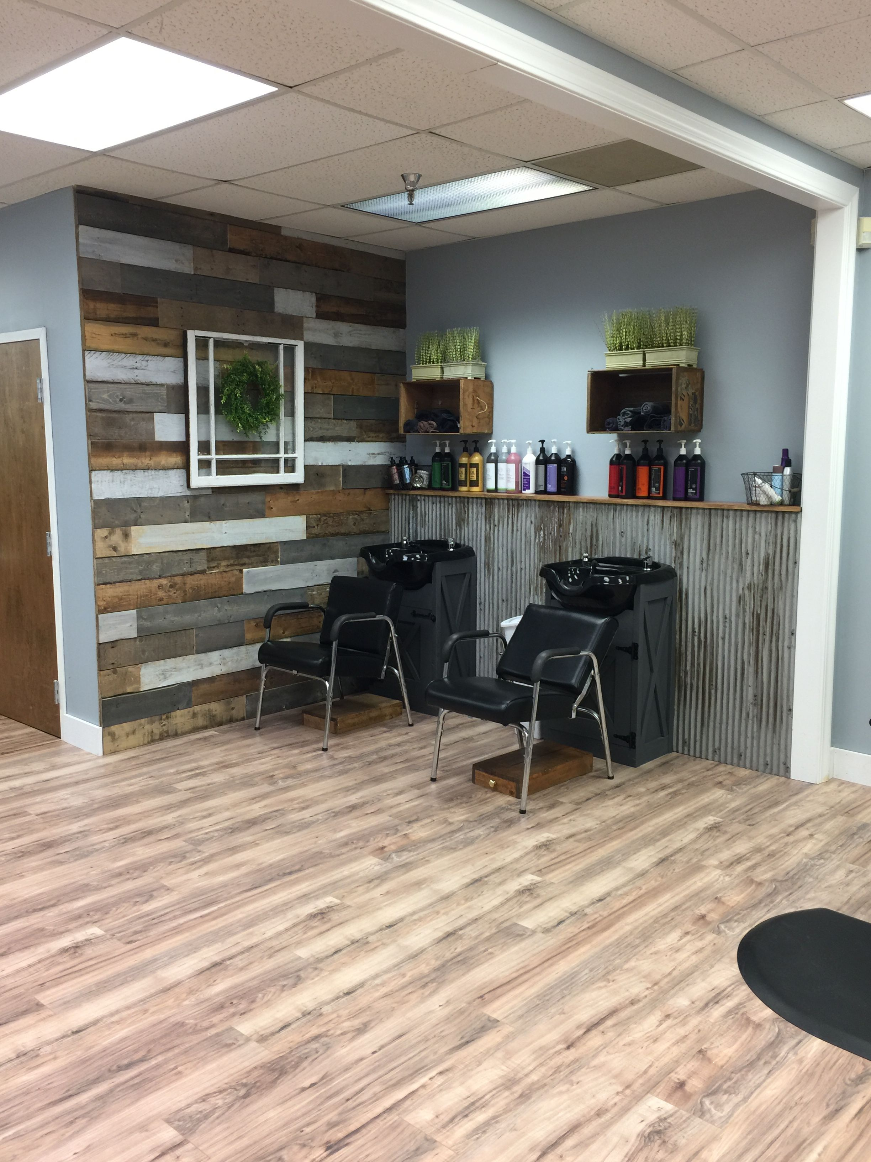

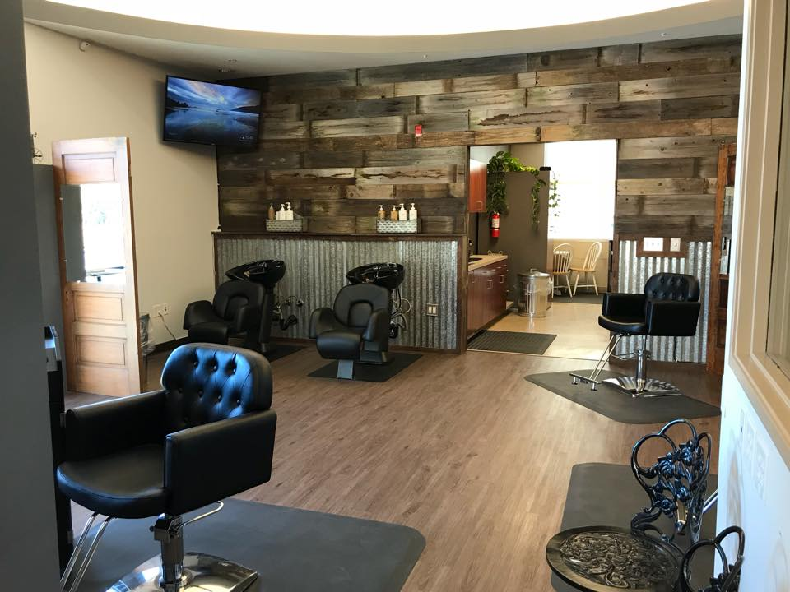

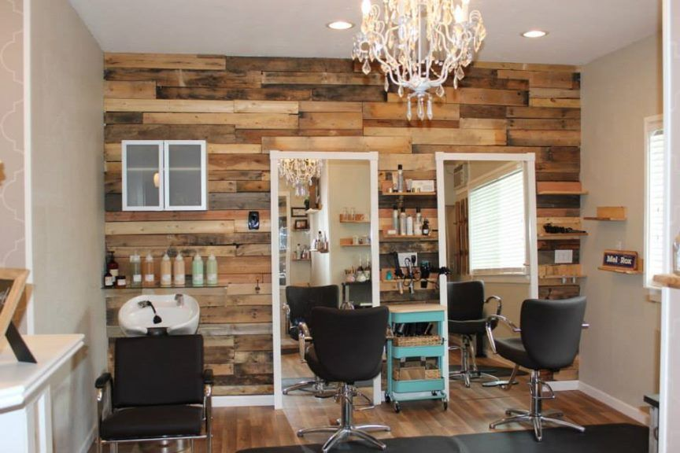

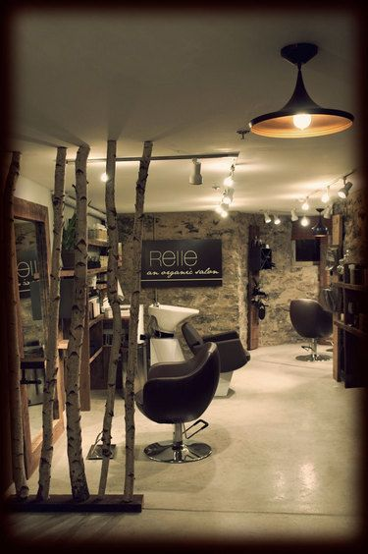

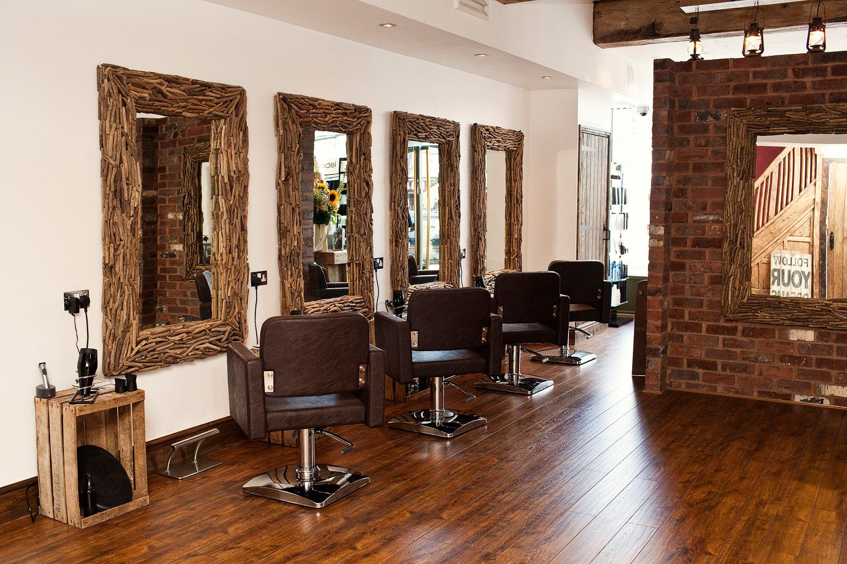

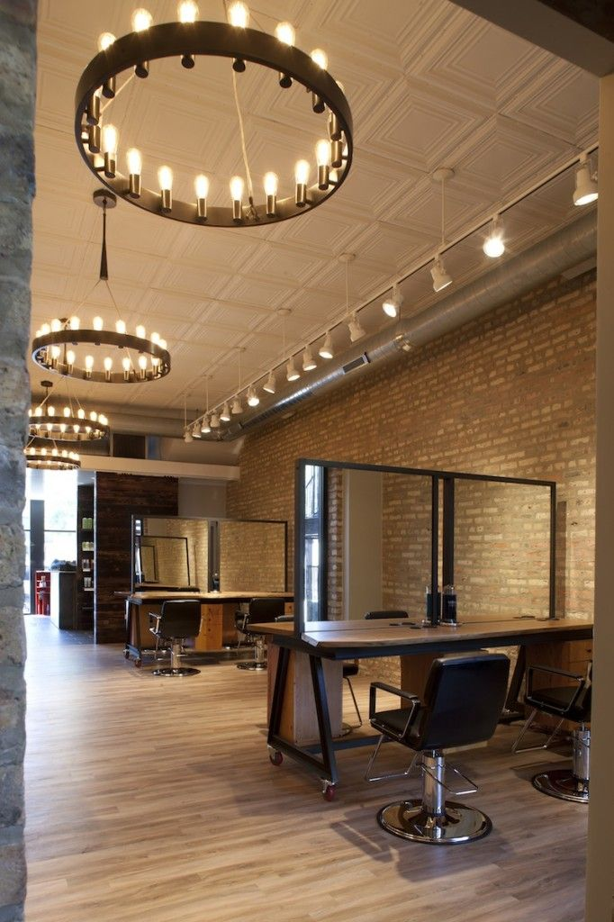

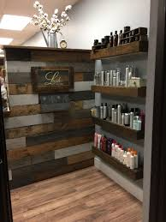

COLORS:

https://www.thespruce.com/best-paint-colors-rustic-style-decorating-797979

