I still see a few bugs:

- You didn´t change the texts as I told you in the main page of “Tätigkeitsschwerpunkte”, only in the subpages:
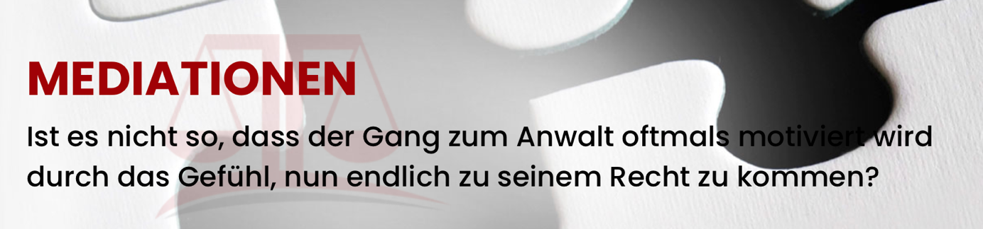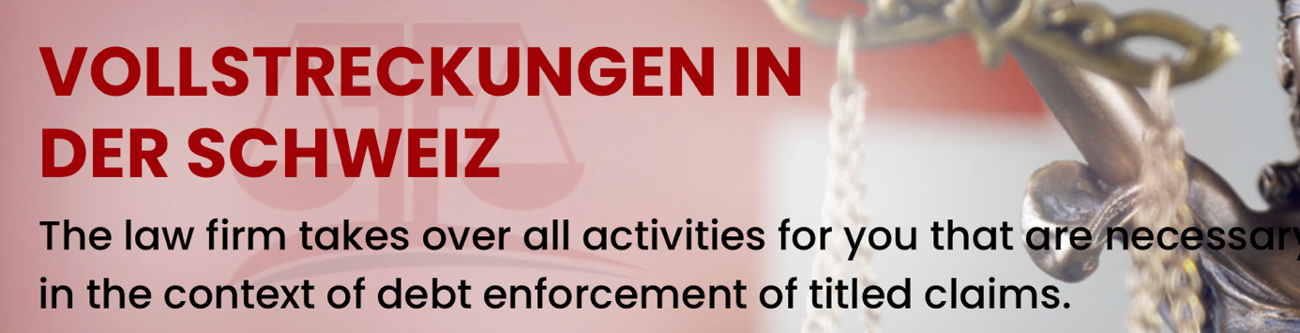

- There is a frame in the all sub page of Tätigkeitsgebieten. I now see you aded this more or less everywhere. This is not nice.


- In the subpages of Rechtliches the text Dr Faßbender Rechtsanwälte is not in the pic:


- It doesn´t look nice that the address info is not aligned. It all is in CH one line more down which doesen´t llok good.
- 