
Primary School
Secondary School
Administration
Employee Handbook
2021

Rigorous Minds | Compassionate Hearts



CONTACT DETAILS


Phone: (08) 9540 4400
email: info@scbc.wa.edu.au

Physical Address
30 Gnangara Drive,
WAIKIKI WA 6169

Postal Address
PO Box 6126
WAIKIKI WA 6169

ABN: 43829013154
ACN: A0821421A
Department of Education and Training number: 1324
AGEIDs
21644
for the Approved Authority, South Coast Baptist College Incorporated
5398
for the Regular School, South Coast Baptist College

Contents
CONTACT DETAILS 3
Contents 4
Welcome 6
HR Contact details 6
School History 7
Rockingham Baptist Church 7
The Board – 2021 8
PRINCIPAL 8
HEADS OF SCHOOL 8
Roles and responsibilities - 2021 9
Mission | Vision | Values | Strategic Plan 10
2021 Theme 10
MISSION 10
VISION 10
VALUES 10
Strategic Plan 11
Domain 1 – Faith Focus 11
Domain 2 – Student Focus 11
Doman 3 – Community and Culture 11
Domain 4 – Investing in staff 11
Domain 5 – Excellent Standards (Developing a culture of excellence) 11
Learning Needs Of Our Students is Central 13
College Map 14
College bell times 15
KEY DATES – 2021 16
Code of conduct – policy no. 6.1.0 17
Dress Code – General Conditions of Employment Policy – N0. 6.1.4 Dress Code 17
Sun Protection 17
Getting Started 18
Keys and Tokens 18
Arming and Disarming the College 18
Name Badge 18
Information Collection 18
Leaving the Campus -During School Hours 18
Getting Connected 19
IT Support 19
Email 19
Sending out Emails 19
College Devices 19
Back Ups of Files 20
ITC Architecture 20
Policies 20
Professional Teaching Standards 20
TRBWA 20
Working with children checks 21
security 21
Accessing the College over the Weekend 21
Other points of note: 21
SCBC Portal 23
What To Do When Going on Professional Development 24
AISWA – To Register 24
PD Tracker 25
PURCHASING GOODS AND SERVICES 26
SCBC’s Standard Purchasing Process is as follows: 26
Petty Cash 26
Reimbursement Requisitions 26
Staff Discount on School Fees 27
Payroll 27
South Coast Baptist College Staff Agreements 27
Salaries 27
HECS Debt 28
Deductions 28
Salary Sacrificing a Device 28
Salary Sacrificing into Super 28
Sick Leave – Personal/Carer’s Leaver 28
Leave Without Pay 29
Long Service Leave 29
Teachers’/EA Leave 29
Admin Leave 29
Parental Leave 29
Bamboohr 30
Go to the ‘My Info’ tab 30
Download the Mobile App 30
Finally, some key tasks you may want to know how to do: 31
When you are unwell and can’t come to work: 31
Company Directory 31
Leave Balances 31
Relief Teaching/E.A. 32
Pay Dates in 2021 33
Dispute Resolution 33
Change of Details Form 34
Marketing 34
Child Safety 34
Occupational Health and Safety 36
OH&S Officers/Representatives 36
Injuries/Incidences 36
Step Ladder Locations 36
Your Responsibilities 37
Emergency Procedures 37
Evacuations 37
Lockdowns 39

Welcome
On behalf of the College, we welcome you and wish you every success during your employment with us. We believe that each and every employee contributes directly to the lives and the growth of our students.
This Employee Handbook is not a Workplace Agreement. It is designed for all staff, but in particular to help new staff settle in. It has some basic outlines of some of our policies and procedures and we therefore recommend you keep it handy until you are familiar with the general running of the College.
Please contact our HR Manager, Jenny Currin should you have any further questions (contact details below).
We hope your experience at SCBC will be both enjoyable and rewarding.
Existing SCBC staff will find this a valuable source of current information, a copy of which can be found on our staff portal and on BambooHR.
Yours in Christ,

Des Mitchell
Principal

HR Contact details
HR Manager
Jenny Currin
email: currinj@scbc.wa.edu.au
Phone: 08 9540 4406 or Ext. 106

School History
After much planning and collaboration with Christian Community Schools and Emmanuel Christian Community School and Girrawheen, Maranatha Christian College (South Coast Baptist College) commenced at the beginning of the academic year of 1985, as an initiative of Rockingham Baptist Church under the leadership of Rev. Gordon Bassett.
The philosophy of the umbrella organization, Christian Community Schools included a local Church focus, which meant that the School was an integral part of the local Church community in terms of staffing and governance.
The School began in the Safety Bay Scout Hall with Principal Andrew Creelman and fellow teacher Heather Keown. The initial range of classes was Years 1-7. Using a public building meant having a team of dedicated volunteers set up the desks and other school furniture early every morning, and stacked them away after school each afternoon.
The City of Rockingham gave the School permission to use the Rockingham Baptist Church facilities during 1986 and 1987. At the time, these were located at the corner of Read Street and Wilmott Drive, but in 1986 the Church purchased ten acres of land in Gnangara Drive, Waikiki with a view to later relocate the Church and School. The first dedicated school classrooms at this location were completed in time for the beginning of the academic year in 1988, and since then the School has established a campus of excellent buildings, facilities and staff, catering for early learning through to Year 12.
Although the Umbrella organization, Christian Community Schools has long since amalgamated with other organizations, the initial local Church flavor of Christian Community Schools remains a positive, joyful aspect of the School community.

Rockingham Baptist Church
South Coast Baptist College is a ministry of the Rockingham Baptist Church. The church supports the College and families in leadership, evangelism, prayer and support with pastoral care. Rockingham Baptist Church membership from which the College membership is drawn are the key moral owners of the College. The College Board is elected and appointed by the elders on behalf of the church.
The church is necessarily bound through the commitment to and responsibility for the governing of the College. The membership meets at least once a year to listen to and review reports and adopt audited financial statements. The Church holds to the call from God to maintain a Christian, “born again”, college. As “moral owners” the church articulates why the organization exists and is responsible ultimately to make sure the College stays connected with why it operates as a Christian organization.

The Board – 2021
Chairman of the Board: Pastor Steve Galambosi
Board Members: Mrs Penny Trimble
Mrs Michelle Horne
Mr Grant Botha
Mr Peter Campbell
Mrs Christine Velebir

PRINCIPAL

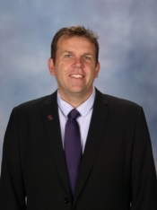

PRINCIPAL
Des Mitchell

HEADS OF SCHOOL


Head of secondary
James Trimble

head of primary
Anthony Moses

Roles and responsibilities - 2021
EXECUTIVE TEAM
Principal | Des Mitchell
Head of Secondary | James Trimble
Head of Primary | Anthony Moses
Child Care Centre Director | Jasna Trimble
Business Manager | Matt Robinson
BUSINESS ENTERPRISE TEAM
HR Manager | Jenny Currin
Marketing Manager | Adele Aspeling
SECONDARY DEPUTIES
Secondary Deputy Head – Curriculum and Admin. | Cheryl Thomas
Secondary Deputy Head – Pastoral Care | Shelagh Scott
HEAD OF YEARS
Head of Year 7 | Rainer Winkler
Head of Year 8 | Ollie Oeij
Head of Years 9 | Simon Bint
Head of Year 10 | Caroline Crowther
Head of Year 11 | Cornelius Smit
Head of Year 12 | Mikael Leo
HEAD OF LEARNING AREAS
Head of English | Catherine Lambert
Head of Arts | Justin Florisson
Head of Science | Felicity Barnabas
Head of Technology and Enterprise | Simon Watts
Head of Maths | Nathan Tibbits
Head of Humanities | Belinda ‘t Hart
Head of Health & Physical Education | Carly Phoebe
Head of Bible and Christian Studies | Andy Price
SPECIALIST EDUCATORS
VET Co-ordinator | John Scott
Outdoor Education Coordinator | Ryan Galambosi
Director of ICT – teaching and learning | Dave Burgess
Director of Football Academy | Stephen Posthuma
Gate Coordinator | Nathan Tibbits
Secondary AVID Coordinator | Ollie Oeij
Director of Sport | Zach Cottrell
PRIMARY DEPUTIES/CO-ORDINATORS
Deputy Head – Wellbeing |  | Jon Lituri
Deputy Head – K-2 |  | Jo-Anne Gudgeon
Deputy Head – 3-6 |  | Julie Bottomley
Years 5 & 6 and Primary Numeracy Coordinator |  | Craig Stoffberg
Kindy/Pre-Primary Coordinator |  | Adele de Wet
Years 1 & 2 Coordinator |  | Sharonne Hart
Years 3 & 4 Coordinator |  | Akila Senanayake
Primary Enrichment and Relief Coordinator |  | Laura Cooper
K- Yr 12
Counsellor |  | Amanda Robinson
Psychologist |  | Paul Russell

Mission | Vision | Values | Strategic Plan

2021 Theme
Excellence - God’s Love in Action

MISSION
Rigorous Minds | Compassionate Hearts

Rigorous minds
Students are actively encouraged to do their best work in every subject, in every activity, every day.
Students are taught by staff who have been professionally appointed on the basis of their academic success, excellence in teaching, professional experience and personal faith. Staff at SCBC are passionate about developing the talents of young people.
Students’ gifts and talents are nurtured to help them experience a deep sense of personal satisfaction and achievement.

Compassionate hearts
Students are actively taught about how God loved the world so much, that He sent His only Son to die on the cross for our sins. His example is of sacrifice for humanity.

VISION
SCBC is a thriving Christian Community that inspires learning as a means of transforming and empowering lives.

VALUES

- Wisdom
- Grit
- Hope
- Love

Strategic Plan

Domain 1 – Faith Focus
- Encouraging Christian Faith: discipleship and practice
- Encouraging and supporting Christian leadership
- Connection to Christian Churches and Christian Community
- Effective connectivity to Rockingham Baptist Church

Domain 2 – Student Focus
- Creating an inspiring, positive, caring and safe environment
- Flourishing students; individually and collectively – PERMA+H
- Curriculum and co-curriculum programs aimed at preparation for life
- Sustainable balanced growth ie. Quality diverse enrolments

Doman 3 – Community and Culture
- Healthy relationships; inside and outside, evidenced by
- Sense of community (functioning and feeling of “togetherness”)
- A culture of excellence (in all areas of college activity
- Opportunities to develop compassionate hearts
- Compassion education (explicitly teaching what compassion is)
- Positive Profile (presence); locally, nationally, internationally
- Post-school success; students (including a positive alumni community)
- Welcoming community, especially Australia’s indigenous culture

Domain 4 – Investing in staff
- Excellent staff who are Christians
- Building and maintaining staff relationships; platforms of trust, reciprocal and positive.
- Excellent professional development for staff ie. Targeted, personalised, planned (not ad-hoc), cost-time benefit, with Christian PLs to support staff
- Staff mentoring and leadership development; oriented to results

Domain 5 – Excellent Standards (Developing a culture of excellence)
- Excellent Academic pathways
- Effective teaching pedagogy
- Excellent stewardship of resources in all areas
- Effective board governance
- Financial Health
- Excellence in areas of specialisation eg Football-Academy, Vocal-Academy, GATE Program
- Excellent compliance with School Registration and educational frameworks
- Direction and sequencing of the Architectural Master Plan

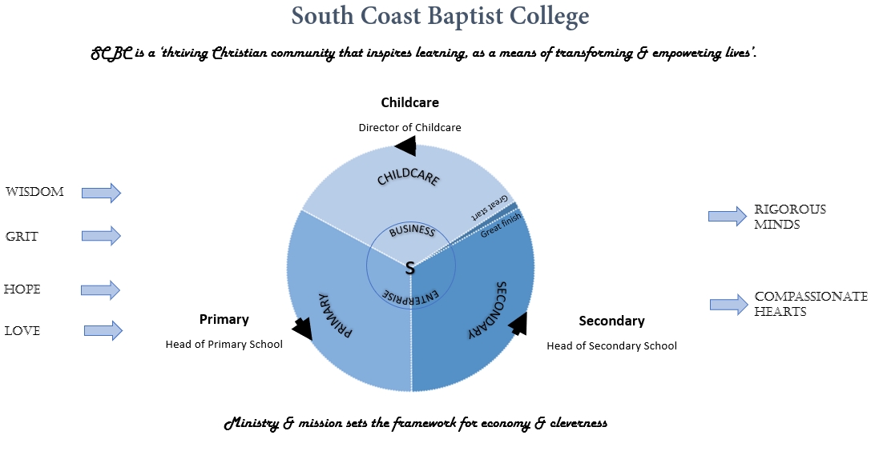

Learning Needs Of Our Students is Central


Students are taught to value the life of another human being unconditionally. They are led to be interested in the wellbeing of others.
The learning needs of our students is central to all the decisions we make. Recognising the benefits of an excellent educational experience, South Coast Baptist College was started by Rockingham Baptist Church. We are a values-driven Christian community, committed to encouraging rigorous minds and compassionate hearts. Precision curriculum content and the importance of character co-exist in equal measure. Helpful, positive relationship between parents, the staff and students is known to promote a supportive, effective learning environment. At SCBC we value strong relationships with parents, evident by a high priority on open, timely and informative communications.
- Following 30 years of partnering with families to provide an excellent education, we have become increasingly known for a number of positive distinctives.
- South Coast Baptist College has a widely respected standard of care, a view acknowledged by many educators in the independent school sector.
- We “catch students” doing the right thing and reward them. Lessons are both content and values driven deliberately promoting a Christian world view.

College Map

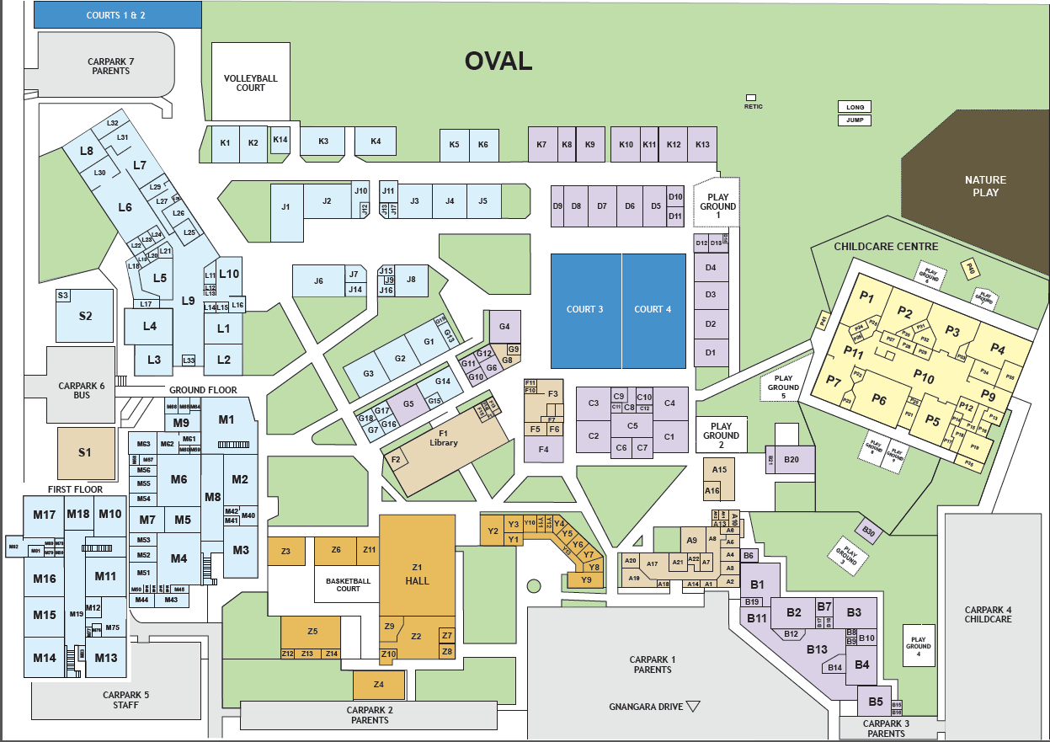

College bell times
Starting Times:
Kindergarten 8.40am - 3.10pm
Pre-Primary 8.40am - 3.10pm
Primary School 8.40am - 3.10pm
Secondary School 8:30am - 3.20pm
Tuesday 8.30/8.40 – 2.20pm
Secondary School (6 periods) |  | Thursday – (7 periods)
Period | Times | Period | Times
5 min Warning Bell | 8:25 |  | 8:25
1 | 8:30 | 1 | 8:30
2 | 9:25 | 2 | 9:20
Form | 10:20 | Recess | 10:10
Recess | 10:40 | 3 | 10:30
3 | 11:00 | 4 | 11:20
4 | 11:55 | Lunch | 12:10
Lunch | 12:50 | 5 | 12:50
5 | 1:30 | 6 | 1:40
6 | 2:25 | 7 | 2.30
Close | 3:20 | Close | 3.20

Primary School (7 Periods) |  | Thursdays (7 periods)
Period | Times | Period | Times
Start | 8.40 | Start | 8.40
1 | 8.40 | 1 | 8.40
2 | 9.25 | 2 | 9.20
Recess | 10.10 | 3 | 10.05
3 | 10.30 | Recess | 10.50
4 | 11.15 | 4 | 11.10
Lunch | 12.00 | 5 | 11.55
5 | 12.50 | Lunch | 12.45
6 | 1.35 | 6 | 1.35
7 | 2.20 | 7 | 2.20
Close | 3.10 | Close | 3.10

KEY DATES – 2021

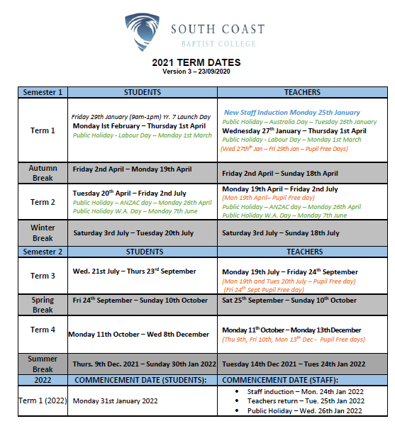

Code of conduct – policy no. 6.1.0
All staff, visitors and volunteers need to sign and abide by the College’s Code of Conduct. Please See HR if you have not signed one, or if you have any questions in relation to any part of the Code of Conduct.

Dress Code – General Conditions of Employment Policy –
N0. 6.1.4 Dress Code
While appropriate clothing will vary with the learning activity or task being undertaken, staff must present a professional image at all times. South Coast Baptist College retains the right to determine appropriate dress within the workplace. All staff will be informed of acceptable dress and grooming requirements during their induction process.
All staff are required to be neat and tidy, all tattoos should be covered (unless approved by the Principal), jewelry should be kept to a minimum, and all clothing, jewelry and hair must not present a risk to health and safety.
Where uniforms, protective clothing or footwear have been provided by South Coast Baptist College, they must be worn. It is the responsibility of the staff member to ensure that they are clean and well-maintained. If clothing or footwear has been damaged this must be reported as soon as possible to your manager to arrange a replacement where appropriate.
- All staff are to maintain a high standard of dress while on duty/representing the College. This dress is expected to be of a standard consistent with the professional position held and appropriate to the particular situation.
- For both men and women jeans should be reserved for excursion type activities where the students are also being permitted to wear casual clothes.
- For ladies’ slacks may be appropriate when a great deal of activity with the children is involved.
- Male staff members are required to wear a tie in Terms 2 & 3.
- When thinking about what to wear, please remember that students are required to wear the College uniform neatly and correctly at all times.
- If you have any queries in this area, please see your Head of School.
- Teachers engaged in PE Activities: Sporting attire should be at least as modest and becoming as that expected of the students.
- South Coast Baptist College requires a minimum standard of neat casual attire when staff are in the workplace. Neat casual attire does not include clothing that may be considered offensive or antisocial and does not include thongs, gym and/or exercise clothes. Where protective clothing or footwear have been provided by South Coast Baptist College, they must be worn. Covered footwear may be required to be worn.

Sun Protection
All staff must wear hats, appropriate protective clothing, and apply sunscreen where they are likely to spend time outdoors.

Getting Started

Keys and Tokens
- Please contact Jenny Currin in HR to organize and collect your token and Classroom key.
- In order to arm/disarm the school alarm, you will need a token.
  - If the main alarm unit is displaying a red light, you will need to swipe your token once. This will both disarm the entire school.
  - Should the main alarm unit have a green light, when it is out of school hours, then you will only need to swipe your token once to “unlock” the door.
  - If the main alarm unit light is green during school hours, there is no need to arm/disarm.
  - To arm, swipe your token 3 times until the light is red.

Arming and Disarming the College
  - Building A and Uniform shop ARM/DISARM at front reception
  - Buildings B is ARM/DISARM from Kindy/PP carpark door
  - Building C, D and F (Canteen) is ARM/DISARM from F4 classroom only
  - Building F (Library) is ARM/DISARM from front or rear entry doors
  - Building G1 – 3 & 13 (IT & Copy room) from G1entry doors
  - Building G (Admin Services) from either G6 or G7 entry doors
  - Building J & K from the J6 Entry door
  - Building L & S (Gym) from any of the Main 3 Entry points leading into Building L
  - Building M from the Side Entry door facing the Library
  - Maintenance Shed has its own code pad so they will be able to control the ARM/DISARM from there.
  - Building P – stays as its currently is.

Name Badge
Name badges will be provided for new staff. Please see the HR Manager should you not have one. Please wear your name badge to school every day.

Information Collection
Information is predominantly circulated via email; hence, it is imperative that you are regularly checking your email account. However, on the occasion that you must collect letters or forms they can be found either at Main Reception or from your respective Administration Area (eg. Primary Administration, Secondary Administration).

Leaving the Campus -During School Hours
Should you need to leave the campus during school hours, please sign out using the passtab stations in Reception or Secondary Admin. Staff need to be accounted for, in the case of an emergency.

Getting Connected

IT Support
The IT support office is located in the Library.


Tim Norris
ICT Support

Kim Warnock
ICT Manager

Kim or Tim can be contacted on:
Email: helpdesk@scbc.wa.edu.au
Phone: Extension 115 and 117
Please log all IT issues by sending a request to the helpdesk email address above.

Email
Once you have completed your E-Policy document (in your payroll pack), I.T. will set you up with an email address. It will generally be your first name dot surname eg. firstname.surname@scbc.wa.edu.au (unless we have another person in the system with the same name).
The generic password when logging on for the first time will be “Teacher6169”. You will be prompted to change this.

Sending out Emails
Please keep emails to a minimum, however should you need to send out an email, please ensure that it is courteous.
If you need to send out an email to:
      - “All Staff” - Needs to be approved by the Principal.
- “All Secondary Staff” – Needs to be approved by the Head of Secondary.
- “All Primary Staff” – Needs to be approved by the Head of Primary.

College Devices
If you have been provided with a College device, you will need to collect this from the IT support office and fill out any forms they require to register it to yourself. If you end employment with the College, all devices must be returned back to IT and be removed from your name on the register.

Back Ups of Files
Any files you place onto your H: drive or any other shared drive will be backed up onto the server, whereas the files on your Desktop or My Documents folders will be lost in the event of a virus or hard drive failure. As a precaution, we would advise saving all documents onto your H: drive.

ITC Architecture
The network drives will be laid out as below.
- K Drive (Policies) – Everyone has access to the Policies Drive
- S Drive (Admin) now replaces the O Drive (Adminshared)
- T Drive (Primary) now replaces the R Drive (Sharedstaff)
- U Drive (Secondary) now replaces the R Drive also (Sharedstaff)
- V Drive (School) is a generic shared drive giving access to all staff for file sharing only. This drive is not backed-up and is deleted at the beginning of every month.
Note: Staff will only have Write Access to the areas they are involved in, everywhere else within the School File structure will be Read Only or No Access (e.g., Payroll, Accounting, etc.)

Policies

HR, OHS and Teaching & Learning Policies can be found on the Drive:

In addition, you may access policies from the “File” tab on BambooHR

Professional Teaching Standards
The National Professional Standards for Teachers can be found on the portal at the following link. http://ourportal/forms/Information/National Professional Standards for Teachers

TRBWA
All teachers are required to comply with the Teacher Registration Act 2012 (Act) and it is a fundamental requirement for employment that teachers maintain full financial membership as a Registered Teacher with the TRBWA. The onus is on teachers to fulfill their obligations. For more information please visit the following website http://www.trb.wa.gov.au/Schools_and_employers/obligations/Pages/default.aspx

Working with children checks
All staff are required to have current Working with Children Checks. Application forms may be obtained from the HR Manager or applications may be made online. Receipts must be handed in to Human Resources for record keeping purposes until the new WWCC card arrives.
- The onus is on Staff to renew their WWCC prior to expiry
- Should a staff member’s WWCC expire they will be on Leave without pay, until such time an application is made.
- Should a staff member receive an Interim Negative Notice or Negative Notice, they will not be able to engage in child-related work and will be on Leave without pay.
- Teachers are asked to keep their details current with the TRBWA
- Should a teacher be de-registered for whatever reason, they will be on Leave without pay, until such time they are re-registered.

security

Accessing the College over the Weekend
If you do need to come in out of hours, please follow the following procedures:
- Arm/disarm the zone that you are working in only. The red dot on the map (below/next page) indicates where to do this for each zone. The system will identify who has armed and disarmed the building. Red LED indicates zone is armed; green LED light indicates zone is disarmed.
- If you need to go into another zone to use a printer or go to the toilet for example, you will need to arm/disarm that zone as well.
- When you leave, please check that other people are not in your zone prior to arming.
- If the zone does not arm, it usually indicates that a door is open/not shut correctly. You will need to check your zone before trying to arm the zone again.
- If you come in during the holidays, you will need to lock every door that you open, and check others as the cleaners are not necessarily on site to do this.

Other points of note:
There is no need to sign in and out of each zone.
- The cleaners are supposed to do a final check at the end of the shift, however if we can do our bit, it will help them out. There is also human error to contend with so if we can ensure our area/room is locked that will assist the College.
- As a back stop, the buildings are all armed at 9.30pm and disarmed at 7am or when maintenance come in. This is only a back stop, and again we need to make sure we do what we can to help out. If you have events on after hours, can you please let IT or myself know so that we can tell the security company and adjust the hours for that night.
- B Block has just come on stream as a zone of its own.
If you have any questions, please do not hesitate to ask the Business Operations Manager.
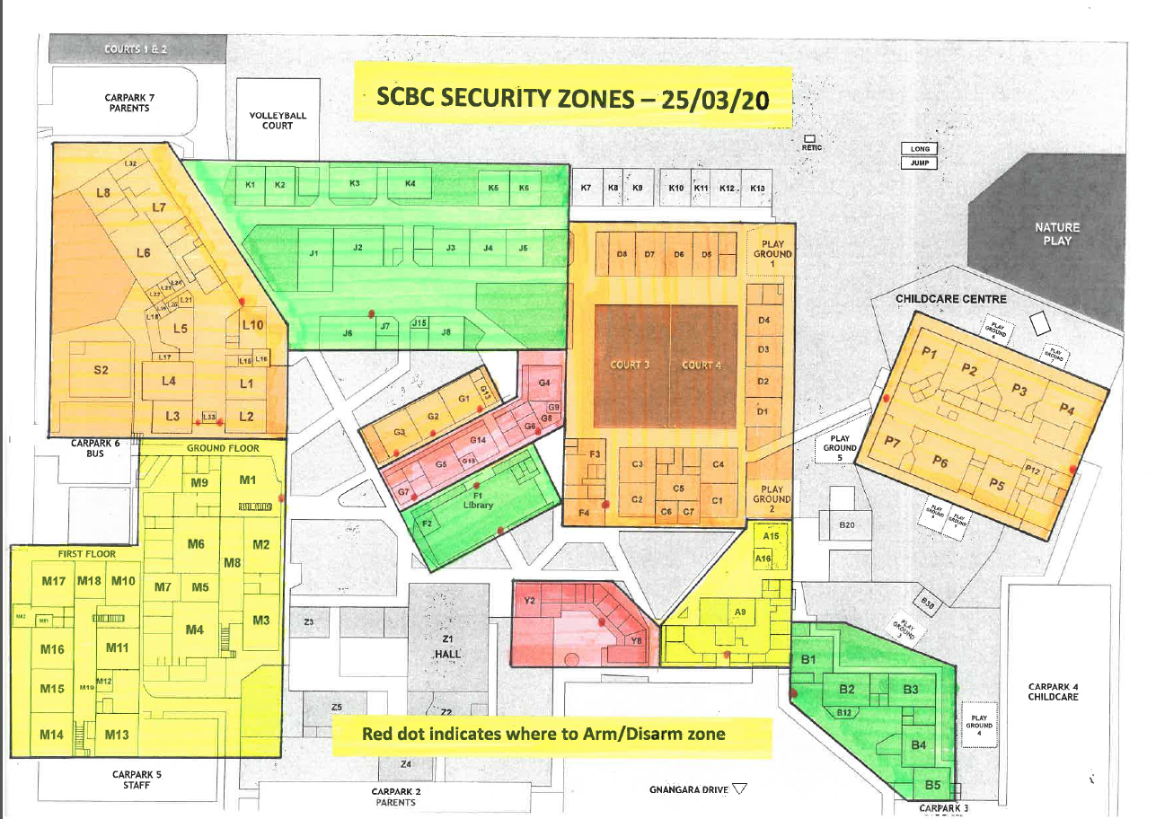

SCBC Portal
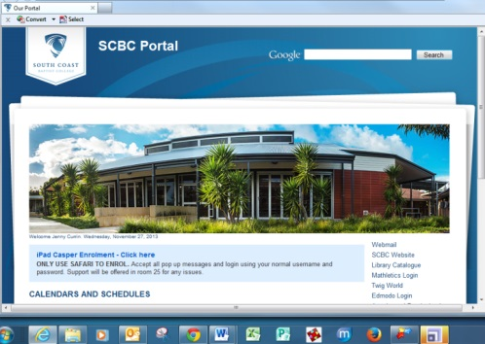
The SCBC Portal can be found, by going to http://ourportal/ when on campus or by going to http://portal.scbc.wa.edu.au/ when off campus

This is a great source of internal information.
You will have quick access to the following links:
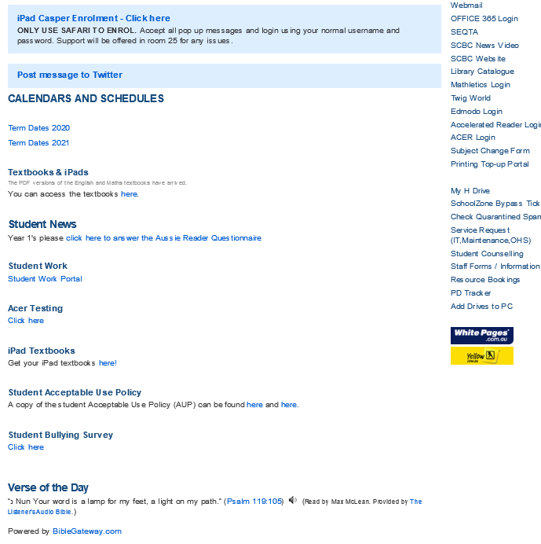

What To Do When Going on Professional Development

AISWA – To Register
Many of the Professional Development courses are organized through AISWA and in order to register, you will need a “login”. :
- Go to the AISWA website www.ais.wa.edu.au/user/login

- Click on Create New Account
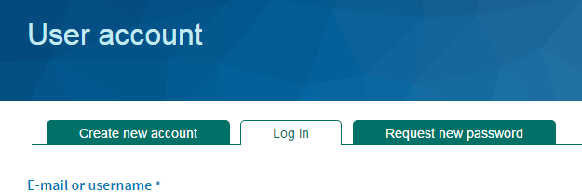

- Complete the fields below and then click on “Create New Account”
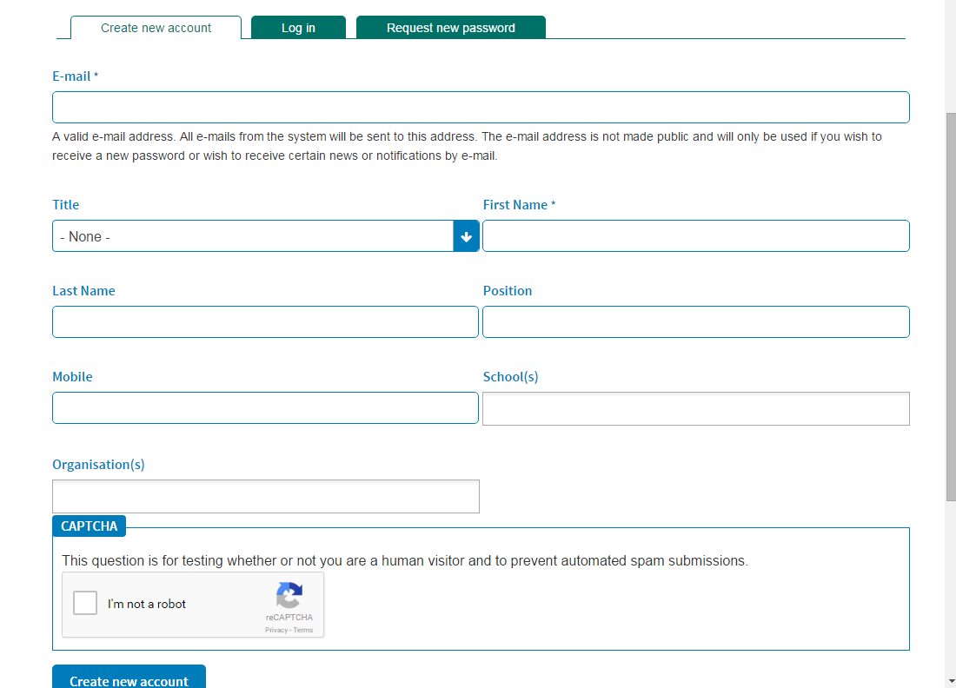
- You will not be registered right away as you will need to be “authorized”
- Once you have been authorized login through the “teachers login” drop down option at point 2.

PD Tracker
SCBC uses a system called PD tracker to track and approve all Professional Development Days. Please log your PD by doing the following:
- Go to the Portal 
- Click on PD Tracker on the RHS of the page
- Login in to PD Tracker by following the instructions below
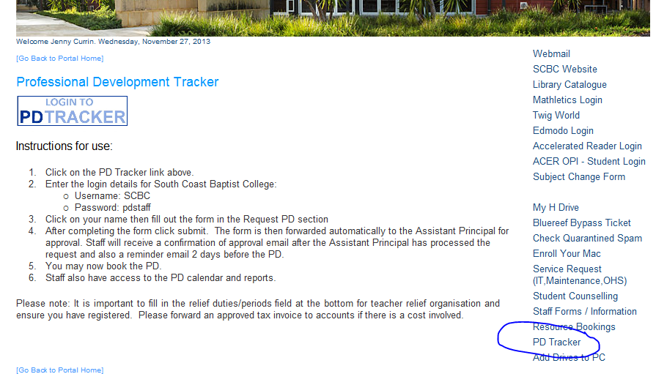
- Complete the on line form in PD Tracker and click on the Submit button.
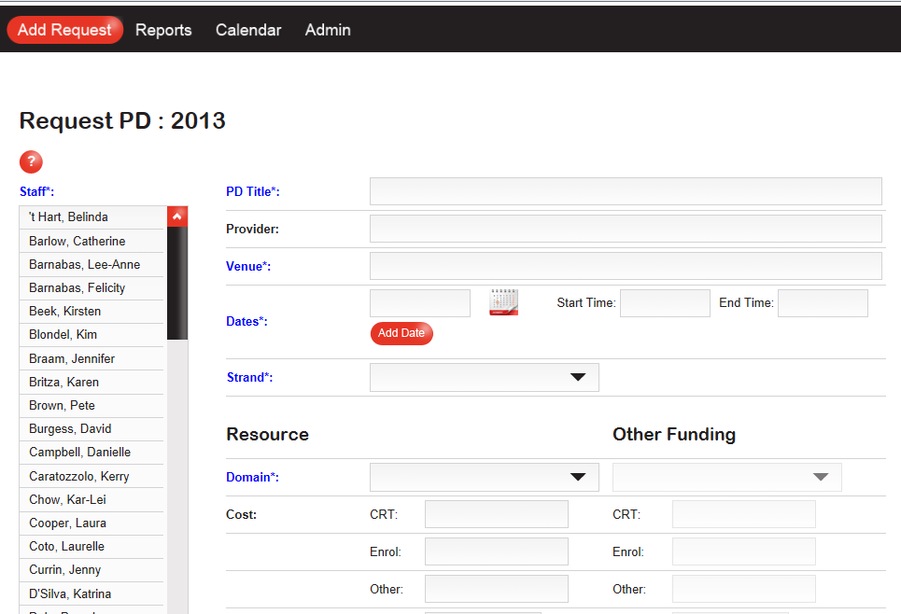
- Press “Submit” when complete.

PURCHASING GOODS AND SERVICES

SCBC’s Standard Purchasing Process is as follows:
- Ensure you know the relevant account code or cost centre for the budget that you are managing (Accounts Payable can help with this).
- All purchases less than $3,000 require an approved and signed invoice from the Budget Manager for that account code or cost centre.
- Any purchases above $3,000 but less than $10,000 require a purchase order authorised and signed prior to the purchase by 2 signatories: The Budget Manager, plus Your Executive Manager Please provide copy of signed Purchase Order to the accounts team prior to service or goods supplied. Also, please provide signed invoice with same 2 signatories once goods have been received/supply
- Any purchases above $10,000 require a purchase order authorised and signed by 3 signatories prior to the purchase:
  - The Budget Manager, plus
  - Your Executive Manager as per below, plus
  - Another listed person from the following list: Head of Primary, Head of Secondary, Director of Childcare, Business Operations Manager, Finance Operations Manager, or the College Principal.
  - Please provide signed invoice with same 3 signatories once goods have been received.
- Please note:
  - Purchase orders should be approved prior to committing the purchase.
  - In signing an invoice the Budget Manager is confirming that the goods and services have been received as ordered.
  - It is the responsibility of the Budget Manager to keep within the budget allocation given at the beginning of the financial year, unless otherwise agreed with your relevant line Manager (before incurring expenditure).
  - Payments are made weekly. Invoices and payment requests are to be submitted by 12pm Wednesday at the latest for inclusion in the week’s payment batch. After processing and approval, payments are sent on Friday at midday.

Petty Cash
The purchase of goods and services up to $100 can be facilitated through Petty Cash. Petty cash forms can be obtained from reception. Attach the invoice/receipt to this form and get the Budget Manager to approve and sign the documents, then submit the above to the accounts team for reimbursement.

Reimbursement Requisitions
Goods purchased using personal funds can be reimbursed through a reimbursement form that you can collect from reception. The reimbursement form should be completed with bank details for each new reimbursement submitted. Writing “as per payroll” will not be accepted.
Attach the invoice/receipt to this form and get the Budget Manager to approve and sign the documents, then scan and email it to the accounts team for reimbursement (you cannot authorize your own expenditure). Don’t hesitate to contact Accounts Payable on ext 110 if you have any questions.

Staff Discount on School Fees
Permanent Staff members who have a child/ren attend South Coast Baptist College, are entitled to an annual School Fee discount, applied on a pro-rata basis:
- $300 per family if you work 0.2-0.49 FTE
- $600 per family if you work 0.5-1.0 FTE
As with all parents, it is expected that school fees are paid through a direct debit arrangement. As a benefit of being a staff member, you can choose to instead have your school fees deducted from your salary each fortnight, please contact Shelley Roberts in Accounts to arrange for this to happen.
Staff are not required to pay the family bond.
Shelley Roberts
Phone: 9540 4407 or Extension No: 107
robertss@scbc.wa.edu.au

Payroll
Payroll Manager : Lee-Anne Barnabas (part-time)
Phone No: 9540 4409 OR Extension No: 109
Email: payroll@scbc.wa.edu.au
Payroll/HR Officer: Suzette Coetzee (part-time)
Phone No: 9540 4446 OR Extension No: 146
Email: hr@scbc.wa.edu.au
HR Manager: Jenny Currin
Phone No: 9540 4406 OR Extension No: 106
Email: currinj@scbc.wa.edu.au

South Coast Baptist College Staff Agreements
The following staff agreements can be found on the college portal:
- South Coast Baptist College Teaching Staff Agreement 2013
- South Coast Baptist College Non-Teaching Staff Agreement 2018

Salaries
Salaries and wages are paid on a fortnightly basis in arrears. (see pay dates for 2021 on page 33)
You will receive an email with your pay slip. A password is required to access your pay slip – your password is your date of birth (DDMMYYYY). Please contact the Payroll Officer should you have any questions.

HECS Debt
It is your responsibility to inform the College if you have a HECS debt so that the correct amount of tax can be deducted from your fortnightly wage. Similarly, once your HECS debt has been paid, the onus is on you to inform Payroll. payroll@scbc.wa.edu.au
A tax withholding declaration form will need to be completed in order to accommodate any HECS debt changes.

Deductions
- An amount of $5.00 (FTE 1.0) will be deducted from your salary for staff amenities. This will cover staff room supplies.
- If you qualify to be part of the College’s Income Protection policy, your portion of the premium will be deducted from of your pay on a fortnightly basis. The College pays 50% of the premium and employees pay the other 50%. Currently a 50% portion equals 0.57% of your gross salary. Should you not wish to participate in the scheme, please notify the College (Payroll Officer) in writing.
- Should you have a child that attends SCBC, you can arrange to have school fees deducted from your salary on a fortnightly basis. Please see Shelley Roberts in Accounts.
- Should you have a HECS/HELP debt, it is your responsibility to ensure the extra tax is deducted from your salary. Please check your pay and if in doubt liaise with the payroll officer.

Salary Sacrificing a Device
Staff can Salary Sacrifice up to two portable electronic devices per FBT year (1st April – 31st March), provided the devices do not have substantially identical functions to each other.
A signed agreement must be entered into 14 days prior to the first salary sacrifice deduction. Please speak to the HR Manager who will explain the process.

Salary Sacrificing into Super
Should you wish to salary sacrifice some of your pay into your superannuation fund, please notify the payroll officer in writing 14 days prior to the first salary sacrifice deduction. Please speak to the HR Manager should you have any further questions.

Sick Leave – Personal/Carer’s Leaver
- College Staff have 12 days sick leave per year (pro-rata if part-time).
- Sick leave is cumulative (prior to 18/12/13 accruals were 10 days per year pro-rata)
A sick leave form (found on the portal, under “Staff Forms”) must be completed and submitted to the Payroll Officer or the Head of Secondary/Primary.
Should you run out of sick/personal leave, Leave without Pay will automatically be applied.

Leave Without Pay
Leave without pay may be applied for by completing a leave form and submitting it to your Head of School, Business Operations Manager or Principal for approval. Consideration will only occur if the application is received prior to any arrangements being made. Leave without pay is not encouraged and unless there are extreme circumstances for the request, it is highly unlikely to be granted.

Long Service Leave
Long Service Leave can be taken after 8 continuous years of service.
Please check with Payroll/HR when you think you may be due LSL. Once confirmed, please complete a leave form, found on the portal and discuss your LSL intentions with the Head of Primary/Secondary, HR Manager or Principal.
Please note that LSL is paid on hours accrued during your time of service. e.g. If you worked 4 years at 0.5 FTE and 4 years at 1.0 FTE, your LSL accruals will be paid at an accrual rate of 0.75 FTE. You will always be paid at your current hourly/period rate of pay.
Accruals for Non-Teaching staff, prior to Aug 2009, are at 10 weeks after 10 years
Should you have any questions please contact the HR Manager or Payroll Officer.

Teachers’/EA Leave
Permanent Full time Teachers and Education Assistants are entitled to 12 weeks leave per full year of service (4 weeks annual leave and 8 weeks vacation leave) – pro-rata for part-time employees. Please see the college calendar for dates of annual leave and vacation leave. If you are unsure of what leave is due to you please contact the Payroll Manager.

Admin Leave
Permanent Full time Admin staff members are entitled to 4 weeks annual leave after one year of service (pro-rata if applicable). This is generally taken in the summer holidays as specified by the College - see the Payroll Manager for exact dates.
“Stand down” may be applied in the school vacation periods. Your salary will be averaged to factor in any stand down periods.

Parental Leave
- If you have been working as a permanent employee for more than 12 months, you are entitled to apply for unpaid maternity leave. (up to 12 months). Written notice must be given 10 working weeks prior to the date of leave. Please give copies to:
- HR/Payroll
- Head of Primary/Secondary
- The portion of unpaid leave does not form part of your “service”, however it will not break your service.
- If you have had continuous service for at least two years, you may qualify for SCBC’s paid maternity allowance. This is the gap between the Government Paid Parental leave amount and your weekly salary. This is payable for 10 weeks.
Please refer to the Parental Leave information booklet on the College portal for more information.

Bamboohr
SCBC is now using BambooHR to digitalise key HR tasks. This means your employee information is at your fingertips for you to see and update at any time. It’s quick and easy too. Here’s a 1-min intro from me. Also, please see attached the ‘BambooHR Employee Manual’ for more information.

What you need to do now:
Go to https://scbc.bamboohr.com/
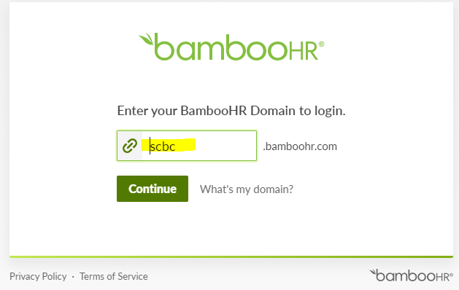
- Type in “SCBC” for the domain name.
- Then type in your work email address
- And then your work password
- It may ask you to save for Single Sign on. You can say “yes” to this so you don’t have to use your password each time.

Click through the interactive ‘How-to guides’ in your Welcome widget
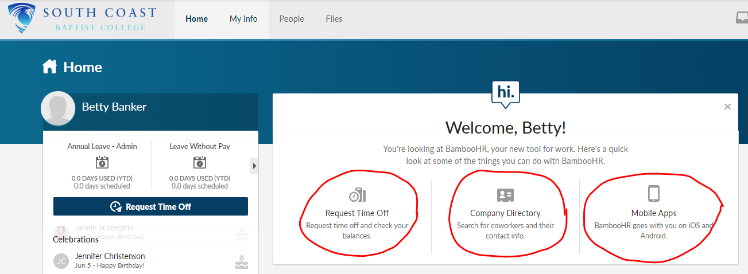

Go to the ‘My Info’ tab
- Check your Contact information is correct (e.g. address and mobile number).
- Click on the ‘Emergency’ subtab and enter the contact details. Here is a short tutorial on how to make your updates: Updating emergency contacts

Download the Mobile App
- The mobile app does not have the same functionality as the website, but it will still let you update your details, request time-off and make phone-calls – wherever you may be!
- Click here to download the Mobile App
- Download the BambooHR app – the Green one
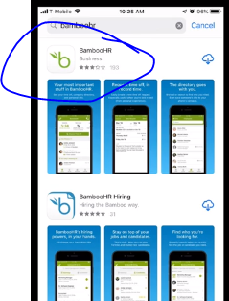
- Our company domain is…. SCBC.bambooHR.com.au
- Then add in your SCBC email address
- And your normal password
- It may ask you to always connect through Single Sign on – You can say “yes’ as this will allow you to automatically sign in each time

Finally, some key tasks you may want to know how to do:

When you are unwell and can’t come to work:
- Text the relief co-ordinator/Line Manager ASAP so they can organise relief for you
- Request time off through the BambooHR mobile APP. (This replaces the need for a text/email to your Line Manager and Sick Leave Form as this request goes to your Line Manager and then on to Payroll)
- Please go onto the BambooHR App and “request time off”. This request will be approved by your line manager.

Company Directory
Need a Colleague’s phone number? You can easily access the Company Directory from the BambooHR mobile app.

Leave Balances
- Please continue referring to your latest payslip for your current leave balances.
- Please don’t hesitate to contact the HR Manager should you have any questions.
- Watch out for additional announcements as additional features are added to your account. And please bookmark this site for future use.
https://scbc.bamboohr.com
You will need to use this to log any time off. If you are sick, you will need to text/let your line manager know (which ever is the preferred method) and then log onto BambooHR to lodge your “time off” request.
Non-teaching staff will need to log any vacation leave or annual leave through BambooHR.

Relief Teaching/E.A.
If you are a permanent part-time employee and have been asked to cover classes outside your normal or part-time hours, please follow the following process:
- Once you have completed your relief duties, please fill in a “Teacher/EA Relief Form”, sign it and bring it to the front office and ask the receptionist to hand it to payroll for processing. Forms can be found on the portal.
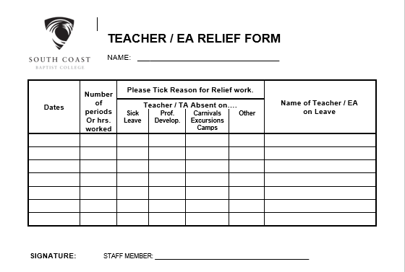

- The Payroll cut-off for date for receiving relief forms is 6 working days, prior to the pay date. Please consider this when anticipating when payment will be made to you. Please see “Casual Pays” table for guidelines of pay dates (page 30).

Pay Dates in 2021
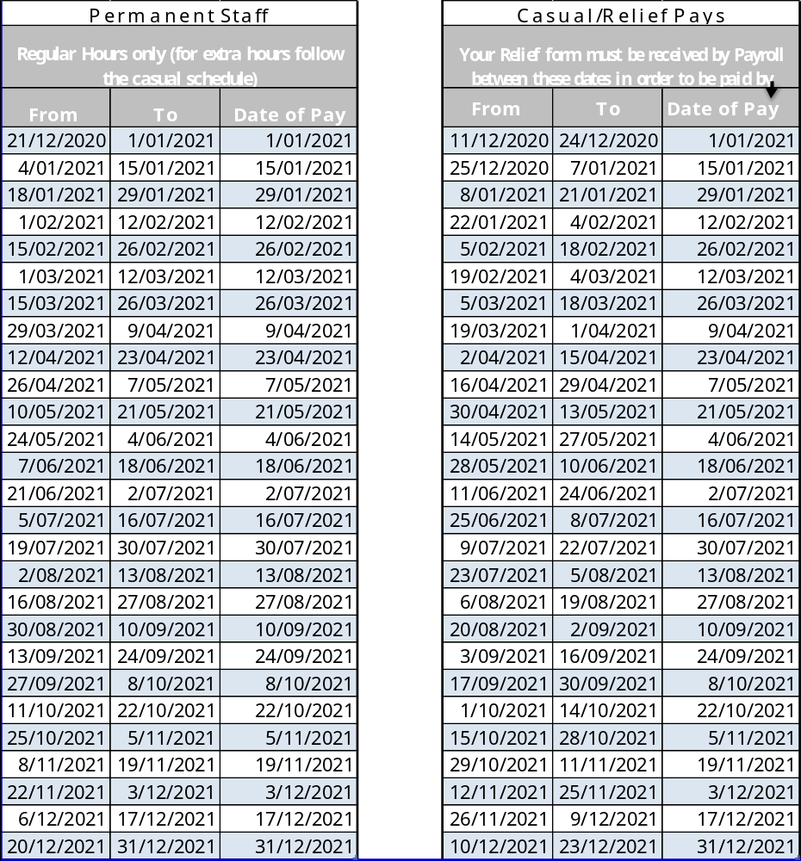

Dispute Resolution
The College’s Dispute and Complaints Resolution Policy can be found:
- In the College/Parent Handbook available at:
  - Website https://www.scbc.wa.edu.au/portal/booklists-handbooks-2/
  - Portal http://ourportal/forms.asp

- In the College Enterprise Bargaining Agreements on pages 31-32 found on our:
  - Portal http://ourportal/agreements/SCBC%20Teaching%20Staff%20Agreement%202013%20-%20FWC.pdf

Change of Details Form
Should you wish to change your personal, banking details it is important you complete a new “Personal Details Form - Payroll” found on the portal under “staff forms”.
Advance notice is needed when changing superannuation funds. It is vital you DO NOT close your existing fund until you get the “all clear” from payroll.

Marketing
Staff should note that all external communications are required to comply with the College’s style guide. The style guide can be found on the College’s portal at http://ourportal/forms.asp . The style guide sets out guidelines on formatting, fonts, colours, signage, the use of phots and the like.
If you could endeavour to keep the Marketing department informed of any newsworthy stories or unique photo opportunities in your department that would be really appreciated. If you have any questions or suggestions regarding any aspect of marketing please contact the Marketing Manager on extension 112.

Child Safety
The College is committed to safeguarding and promoting the safety, welfare and wellbeing of children and young people and expects all staff, volunteers and visitors to share this commitment.
If a Teacher/Staff member forms a belief based on reasonable grounds, that a student has been subject to grooming, physical, emotional, psychological abuse and neglect: please follow the notification procedure and mandatory reporting procedure on the next page:
The Mandatory Reporting Service must be contacted through one of the following means:
Telephone: 1800 708 704
Email: mrs@dcp.wa.gov.au
Post: PO Box 8146
Perth BC WA 6849
This unit is available 24 hours a day, 7 days a week to make a report or to raise a concern and seek advice.
Details regarding mandatory reporting can be obtained through:
www.mandatoryreporting.dcp.wa.gov.au

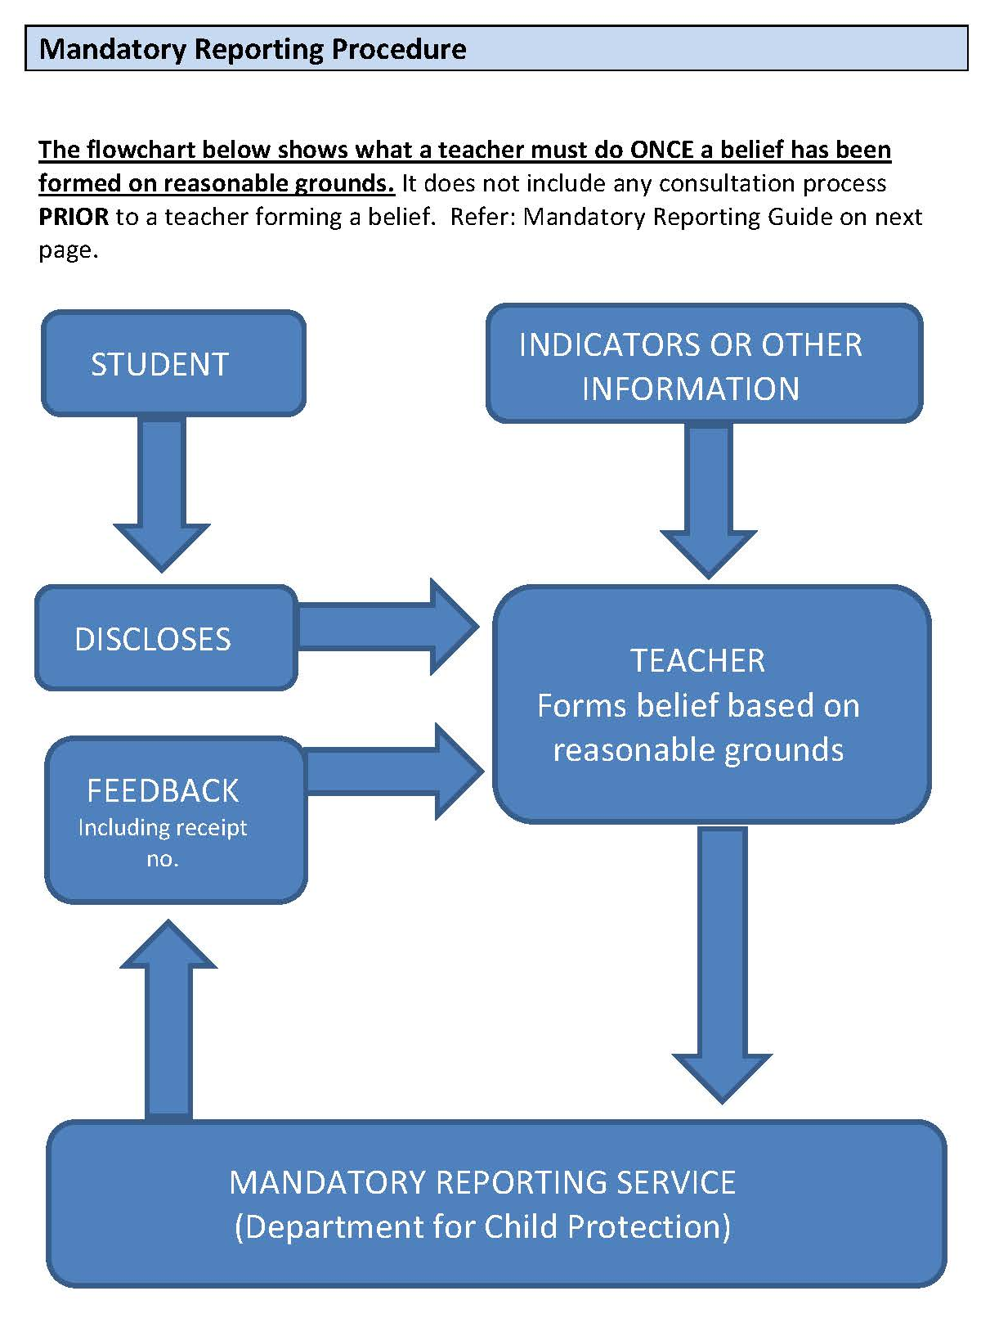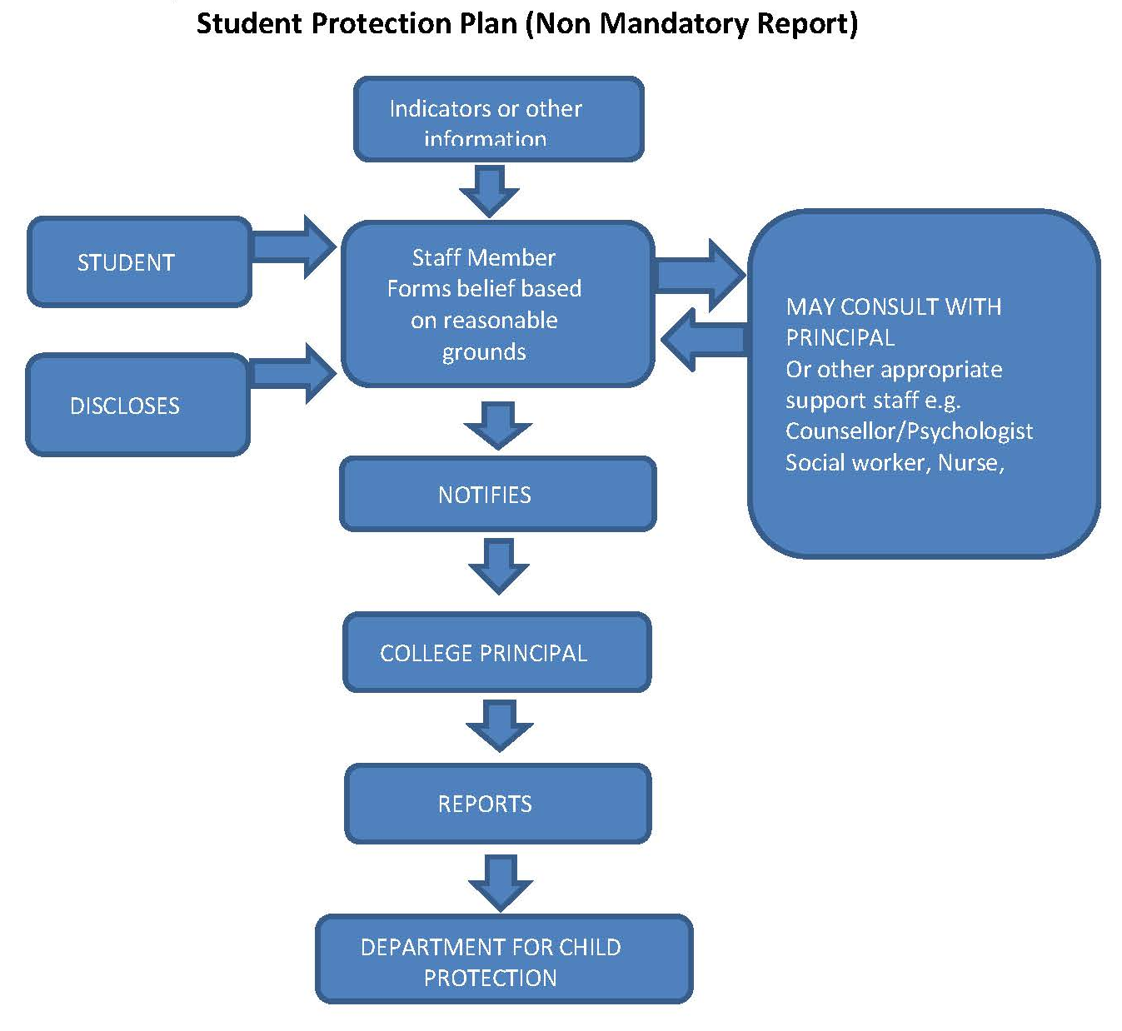

Occupational Health and Safety
The OHS committee has representatives from all sections of the College who meet regularly.
Please report any OHS issues to ohs@scbc.wa.edu.au

OH&S Officers/Representatives
The following staff members are designated OH&S Officers
- Primary –Adele de Wet
- Secondary – Rainer Winkler
- Admin – Trevor Darch and Mel Mirabella
- Child Care Centre – Tania Spiranovic

Injuries/Incidences
All injuries/incidences need to be recorded. Please obtain the form from the portal > Staff Forms/Information > Injury and Accident Form.
Please provide Payroll with a copy of the Accident form and alert the Payroll Officer if there is likely to be a Worker’s Compensation claim. If this is the case, you will need to complete a 2B form and provide a first medical certificate from your doctor.

Step Ladder Locations



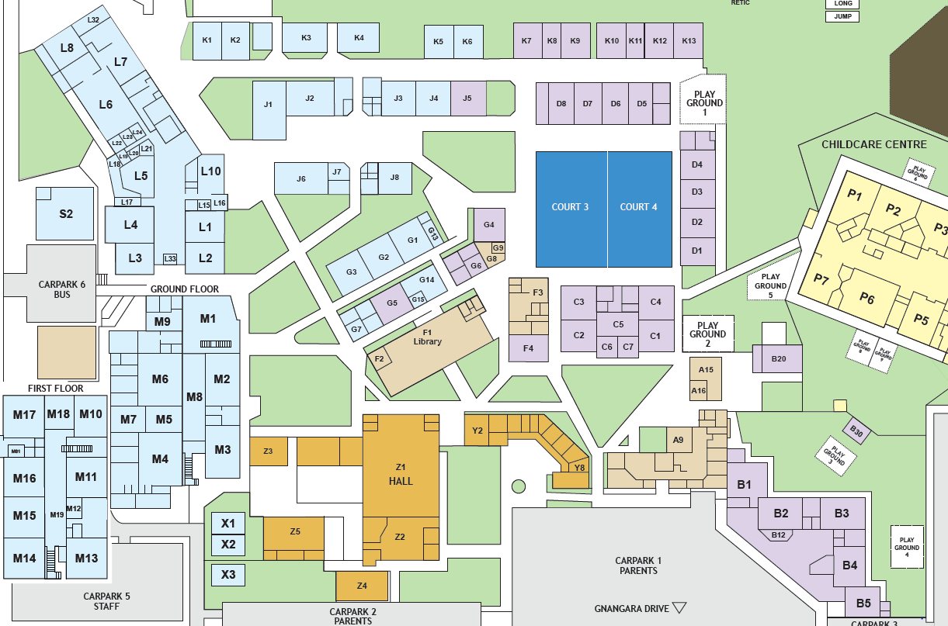

Your Responsibilities
As an employee you must:
  - Take reasonable care for the health and safety of co-workers and ensure that your actions do not put your co-workers at risk:
  - Work Safely
  - Use and maintain equipment properly;
  - Ensure that your work area is free of hazards; and
  - Co-operate with SCBC in anything that you are required to do in order to ensure a safe workplace including:
- Notifying your supervisor of actual and potential hazards, b) Wearing or using prescribed safety equipment, c) Carrying out work in a safe manner, d) Following health and safety instructions, e) Taking notice of signs, f) Participating in safety training
Teachers are responsible for ensuring they:
- Adhere to all the safety guidelines of the College
- Do not climb on desks or cupboards when hanging things from the ceiling or walls. Use a ladder or appropriate climbing equipment.
- Report any incident or near incident by completing the appropriate incident form.
- Report any malfunctioning or damaged equipment.

Emergency Procedures
There are two main types of emergency procedures:
- Evacuation procedures
- Lockdown procedures

Evacuations
You will know to evacuate when you hear the “whoop whoop” sound from the PA system. If the College has an evacuation, please make your way to the oval. Evacuation and emergency information is posted in the classrooms near the exit doors. If you are a Warden and are not in “the act of teaching”, please make your way to the front office for instructions on which area you will be assigned to check.
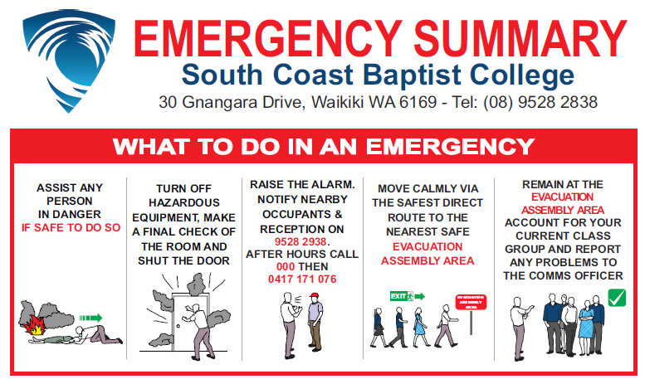
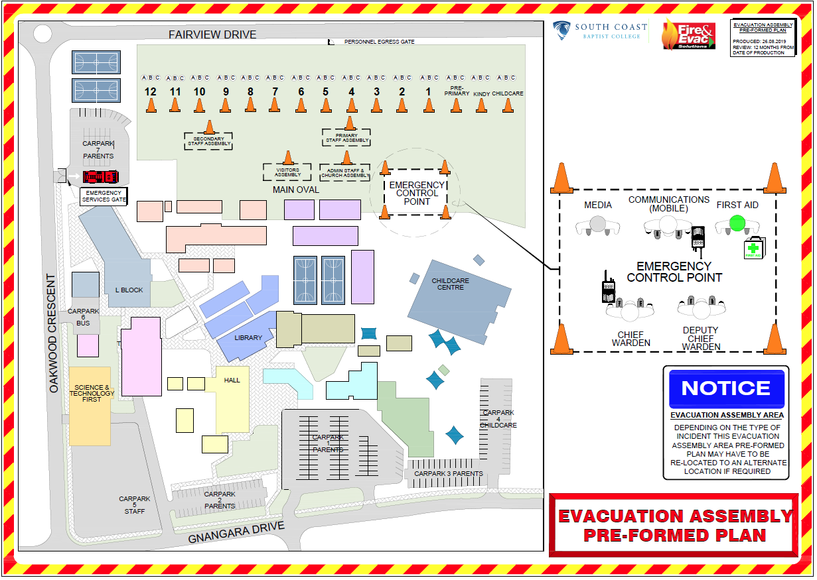

Lockdowns
A lockdown is the movement and confinement of individuals to an indoor area because of an external threat.
SCBC’s discrete lockdown code is “MR LOCK TO THE ………….” or any other part of the school where the external threat is.
Staff (in the act of teaching in a class) are to:
- Lock all doors and windows
- Draw blinds and curtains to limit the visibility of those inside to those outside
- Gather class together on the floor and wait for notification from the chief warden
Outside Class Time Procedure:
- Yard duty staff direct students to their home room or area nominated by the Chief Warden
- Grade Teachers attend their home class room or area nominated by the Chief Warden
- All other staff report to the Chief Warden to become Wardens

