EN3 Health - Website Specification

General
We need a web design for new health and wellbeing website. At the moment, I would like to focus on selling body and mind health products , specifically vitamins and nootropics, and so need an ecommerce solution.
You will need the option of being able to log into an account, either through facebook, google, twitter, Instagram or create an account with email. For accounts, users will need the facility to reset passwords, see previous orders, track current order, and maintain favourites.
It should be PC, mobile and tablet friendly.
This ecommerce solution is focussed on body and mind well-being. It will be offering the best-in-class vitamins and nootropics.
This contract would be to both design the site and then build the site.

Branding
I will provide all the logos an example of which is below.

Home/Landing Page

Logo is below.

There should be a search field.
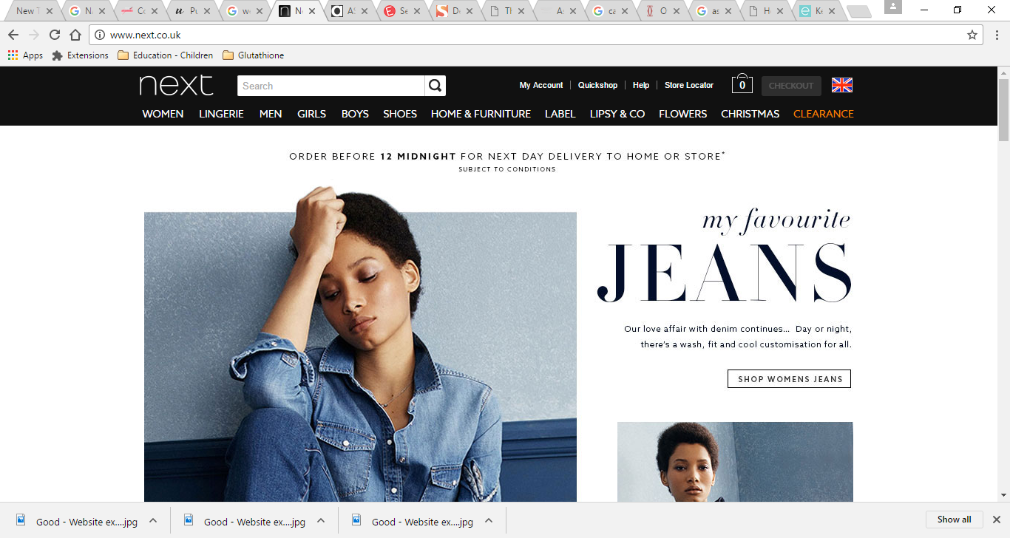
And cart
I particularly like the sign-in and cart logos on front page of this site. https://www.justvitamins.co.uk/
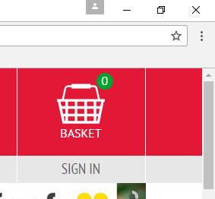
navigation bar should with menu for following categories;
- Vitamins
- Nootropics
- Contact
- About Us

Shop
Should allow customers to add to cart from shop landing page and should be able to click on more detail and pop-out of more detail should appear where they can also add to cart. The shopping functionality as seen this site is exactly what I want, including the review functionality. http://www.pureclinica.com/health-supplements.html

Shop should have a “sort by” drop down, and this should have options of;
- Name
- Top Sellers
- Highest review score
- Price high to low
- Price low to high
There should be ability to refine on left hand side, similar to that shown on following link http://www.asos.com/women/new-in-clothing/cat/?cid=2623

It should have the following refine categories down the left side;
- Category
  - Amino Acids,
  - Antioxidants
  - Cannabis Oil CBD
  - Chondroitin
  - Coenzyme Q10
  - Cod Liver Oil
  - Essential Fatty Acids
  - Evening Primrose Oils
  - Fish Oils
  - Glucosamine
  - Herbal / Botanical
  - Minerals
  - MultiVitamins
  - Omega-3
  - Pregnancy
  - Probiotics
  - Vegan
  - Vegetarian
  - Vitamin B
  - Vitamin C
  - Vitamin D
  - Vitamin E
  - Vitamin K

- Interest
  - Ageing
  - Bone Health
  - Children's Health
  - Circulation
  - Digestive Health
  - Energy
  - Eye Health
  - Heart Health
  - Immune System
  - Joints & Muscles
  - Memory
  - Menopause
  - Men's Health
  - Skin / Hair / Beauty
  - Sleep / Relax
  - Slimming
  - Sports
  - Stress / Mood
  - Women's Health

- Delivery
  - Tablet
  - Liposomal
  - Suppository
  - Intravenous
  - Spray
  - Pump
  - Nebulised
- New

Contact

This page should have a send a message tab as seen on this page - https://www.justvitamins.co.uk/contact-us.aspx
Please can you create page that gives the following message;
Get in touch for expert confidential supplement advice, or for customer services.
Calling from the UK
+44 20 8123 2555
To contact us by email, please click the send us a message tab on the right.
Our team is available
Monday - Friday: 08:00 - 18:00
Answerphone out of hours

About Us
Lorem ipsum dolor sit amet, consectetur adipiscing elit. Phasellus non sodales ipsum. Pellentesque ac nisi eu sem suscipit luctus. Duis commodo aliquam mi, non pellentesque est finibus vitae. Maecenas ut faucibus magna, eget volutpat lorem. Nunc vestibulum ut nunc ut tincidunt. Curabitur non ante porttitor lectus volutpat imperdiet interdum sit amet erat. Maecenas convallis erat massa, sit amet faucibus purus imperdiet sed. Sed tellus odio, ullamcorper sed elit consequat, pretium dictum dui.
Morbi a euismod sapien, ac porttitor sem. Suspendisse molestie at urna quis accumsan. Suspendisse potenti. Integer id dui elementum, feugiat erat quis, ultricies dolor. Quisque in ullamcorper purus, efficitur ultrices leo. Nullam non gravida nunc, eget interdum mi. Suspendisse ac nisi aliquet, tempus urna vitae, venenatis nibh. Vestibulum aliquet in tellus et aliquet. Praesent consequat arcu et mauris porttitor, ut lacinia dui lobortis. Praesent hendrerit dolor eu faucibus venenatis. Mauris porta auctor ex lacinia mollis. Morbi euismod massa a lacinia porttitor.

Target Market
Middle aged women are our most common client, however, younger and older patients, both male and female, will often visit the site. In summary, I would like the site to appeal to all age brackets.

Look and Feel
It should be an elegant, modern, professional, trendy, unisex website. It should look clean and calm. Am happy to try interesting and slightly unusual designs. I would also like to have chat functionality, either powered by zopIMchat or by
Websites I like are
https://www.elite-aesthetics.co.uk/
https://www.justvitamins.co.uk/
http://www.pureclinica.com/

PLEASE DO USE YOUR KNOWELDGE OF WHAT WORKS FOR WEB DESIGN. YOU’RE THE EXPERT AND NEED YOUR EXPERTISE. CARTE BLANCHE TO DESIGN AS YOU SEE FIT. Please be creative, I need my site to stand out from the crowd.

