Name: SAFETE
Circle of some kind with electrical bolt and possibly another symbol. Shield, safety, electric bolt, etc. See ideas below…
One idea, similar to
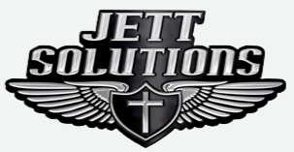
Other figures / ideas
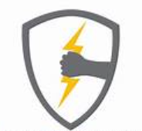
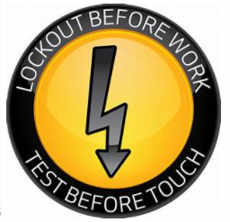
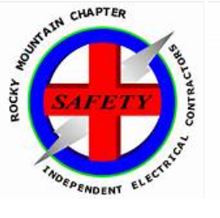
Possibly the above with bullets around the circle containing:
- Safety
- Arc Flash
- Engineering
- Training
- Experts or

