Our background:
Since its inception in 1998, Road Rules Driving School has strived to help drivers maintain their driving independence while leading safe and productive lives. Our motto “making drivers safe for life” drives our vision of helping drivers across industries and at all stages of our driving careers.
Road Rules started out working with school boards to deliver driver training to beginner drivers. Thousands of students have graduated from our ministry-approved curriculum. We are also ministry-approved to instruct defensive driving (DDC) and driver improvement courses (DIC), for drivers with speeding tickets, demerit points and at fault crashes.
Road Rules has also evolved to provide comprehensive driver rehabilitation to those who have lost, or are at risk of losing their license for medical reasons. This includes mobility issues requiring adaptive equipment, as well as traumatic crashes resulting in cognitive impairments and PTSD. We work with clients before the courts charged with impaired driving (alcohol, cannabis, opioids), road rage and stunt driving.
Founder Matthew Rivers started driving at an early age on his parent’s farm. Driving professionally and doing so safely is in his DNA. Matthew has a degree in Business and Psychology from Bishop’s University and is a certified in-car and in-class driving instructor.

Maintaining
driving independence,
while leading
safe and
productive
lives!

For more information:

Call: 705-874-9220
mrivers@roadrulesdrivingschool.ca
www.roadrulesdrivingschool.ca

Stunt-ED
A 1-day educational course for those
charged with Stunt Driving.



50 over gets you nowhere fast

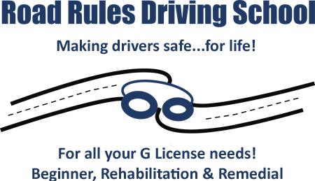

A 1-day, 7-hour, intensive remedial measures course for those charged with stunt driving.

Our goal is to equip our customers with knowledge and help them to avoid something devastating and/or irreversible from happening in the future.

Topics covered:
Law:
- Highway Traffic Act (privilege vs right)
- Federal and Provincial
- Implications of criminal record (financial, work, relationships, etc.)

Road Rage:
- Triggers
- Personality types (Type A); Holmes & Rahe stress scale
- Aggressive driving (overlap between aggressors and victims)
- Psychiatric issues/PTSD: Not uncommon to have professional drivers come through the course due to over-exposure to stress from driving (both on the job or the commute to their driving job)

Physiology and the negative impacts of stress on the body
- Fight or flight response: how it works
- Hormones (Adrenaline, Cortisol, Norepinephrine)
- Chronic levels of exposure/Immune system suppression
- Hypertension
- Sympathetic nervous system
- Substances (brief overview of drinking and driving if relevant i.e., individual risk factors and thresholds)

Personal context:
- Genetics (chemical predispositions)
- Socialization (role models)

Strategies to manage:
- Window of tolerance (hyper-arousal vs hypo-arousal)
- Breathing: how to have the cerebral part of the brain making decisions and not “lizard” part of brain (amygdala vs cerebrum and their roles in the body)
- We look at how our bodies have not kept up from an evolutionary point of view to manage daily stresses and stimuli
- Stages of change theory: habit formation and how to reprogram (many of our decisions on any day are subconscious i.e., no decision-making process)

Defensive Driving skills:
- Following distance (different according to speed and conditions); space cushion driving
- Defensive stopping (what we should do every time we apply brakes)
- Driving in bad weather (adverse conditions exist every time we drive)
- Friction and traction
- Using your eyes and strategic driving (keeping eyes moving, motion induced blindness)

Courses are individually tailored
one-on-one.

OFFERED REMOTELY!



Course Cost: $775.00 + HST.

Stunt-ED

