Email Design For Memorial Plan

Need an email designed for a funeral home company called Memorial Plan.
Final design needs to be delivered in HTML5 but can mock up design in any format.

CONCEPT/THEME

Design email for Pre-Planning Funeral Arrangements
Company is called Memorial Plan Cemeteries and Funeral Homes

Email will target consumers that are interested in pre-planning for their funeral arrangements.

Theme is Spring Time To Do List – include below image showing spring time To Do List with word Pre-Plan on it.



Include Logo at top of fold


CONTENT

Content is below – can include all or part of this content:

Planning ahead can make all the difference
It’s not easy to talk about your end-of-life wishes before you have to. But it’s one of the most important conversations you’ll ever have with your loved ones. By preplanning your funeral, you can make sure your life is celebrated the way you want, and give your loved ones the peace-of-mind they need when the time comes.

Put your wishes in writing
You want your funeral to be meaningful, right? By sharing your end-of-life wishes, you’ll ensure your funeral will truly reflect you and your life.

Eliminate stress for your loved ones
By prearranging your funeral, you can alleviate the stress and burden of making tough decisions at an already difficult time for them.

Save time and money
Protect your loved ones from inflation by locking in today’s prices for the funeral you truly want. Your expenses will be taken care of when you need them to be, guaranteed.

Personalize your service
It’s your funeral, so celebrate your life, your way. By preplanning, you can choose your own funeral services, including songs, readings or other personal details that are important to you.

CALL TO ACTION

Call today to learn more from the safety of your home:
(305) 351-9471
Mention this email and get an additional 5% our Spring Savings with promo code MMPSpring2021

Se Habla Español

INCLUDE LEARN MORE BUTTON

Include A Learn More button that links to:
https://www.memorialplan.net/news-and-events/event-detail/45551-we-are-here-for-you
Include location

Miami Memorial Park Cemetery
6200 SW 77th Avenue
Miami, FL 33143
Include image of location

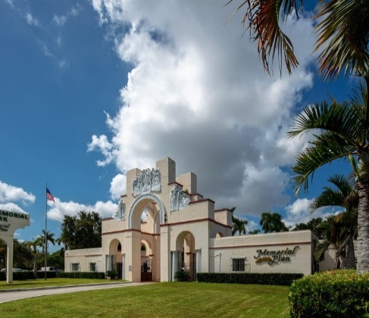

Include facebook image with link

link
https://www.facebook.com/Memorial-Plan-at-Miami-Memorial-Park-Cemetery-467041673715645

