We are looking to freshen up the look of our existing website using a new color scheme and logo. Looking for something visually grabbing and vibrant. We would like to see a website that displays trust, dedication and passion. Needs to be responsive and mobile friendly for all browsers and coded for both Android & IOS. SEO is also important.

Make sure there is no reference to a World Class Facility. Remove news section.

Focus on Rehab and Boarding Services. No reference to racing.

Use only photos with horses standing. No running.

Wordpress or Joomla – must be desktop and mobile friendly with fast page load speed. Need the ability to edit ourselves.

Existing website:

https://westanaequine.com/

I have attached edited content that we do not want. Some content can be taken from the existing site.

Use new logo and new color scheme:

Logo colors:
Pantone Cool Gray 9C
Pantone 7621 C
Pantone 618C
5 pages
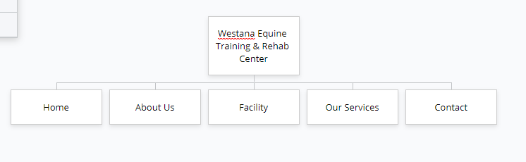

No newsletter signup

