Primary Goal:
A marketing tool to attract (1) central city church planters who desire to plant and; (2) donors; (3) churches or church plant networks that have an interest in partnering financially or through collective impact. Information should be provided on how to become part of the movement.

Secondary Goal:
- Make the argument why central city church plants are needed
- Make the argument why Multi-Ethnic churches are needed
- Candidates can apply for residency at one of the network churches
- Churches can apply to join the network
- Church Planting Networks can apply to partner

Target Market
- Church Planting Networks
- Ethnic Homogenous Churches
- Church Networks
- Church Planters
- Diversity Seekers
- Impactors of Distressed Communities

All Domain Names Wanted:

- wechurchplant.org
- Urbanchurchplants.org
- cccp.org

>>>>>>>>CONTENT<<<<<<<<<<<<<

Home Page

- Mission Statement:
“To multiply the gospel in urban centers by raising up and equipping church planters in a central city or multi-ethnic context.”

- Problem-The church planting scene in the central city of Milwaukee is fairly problematic. While church planting networks have been planting many churches in a suburban context each year, the central city has been ignored. Unfortunately, many church planting organizations have little to no understanding of the central city context and have therefore avoided planting central city churches in Milwaukee and beyond.To exacerbate the issue, Black churches historically do not plant churches.

Subsequently, the central city church planter has been deserted. In many cases, those called to start a church in the central city are left to go at it alone with zero support. It’s not because there’s a lack of churches or church plant organizations available, as there are many. It’s either they don’t see the value in planting central city churches or they don’t have the expertise to do it. Either way, the central city is lacking new gospel centered churches that will reach new generations.

These generations will be lost if something is not done to create new churches. Consequently, the suburban cookie-cutter approach applied to a central city context commonly ends up in a failed church plant. In many cases, these plants include a church planter that is a transplant instead of an indigenous minister empowered to further the kingdom in a central city context.

Today, more people in the central city are leaving traditional churches and transitioning to nothing. Further exacerbating the problem is a growing demographic of central-city residents who have completely lost faith in the church altogether. The African American Millennial has completely disconnected from the church in central cities across America due to an ineffective gospel presentation that’s not relevant to them. There has never been a greater time than now to raise up the next generation of central city church planters who will reach the next generation.

- Barrier to address
  - Suburban Support Raising Model
  - Launch Team
  - Church Planter Assessment
  - Cultural Competency
  - Cultural Communication Priority

- FAQ

- Why partner with CCCP?
      - Urban Church Planting Experts
      - Cultural Competence
      - Successfully Planted urban churches
      - Urban Church Planter Pipeline
      - Indigenous Urban Leadership
      - Strong Partnerships with other planting arms
      - Strong Understanding of Central City church dynamic

- Who Do We Partner With?
- Churches
- Church Planting Networks
- Church Planting Denominations
- How do my network partner with CCCP?
      - Action Button (Partner Interest)
- Why does CCCP work with so many different planting arms?
      - We are better together. With so many church planting organizations failing to successfully plant central city churches, why not tap into the best of each organization and collaboratively make that impact. The more resources available to our planters the better the outcomes for central city church planting. We believe if we are truly building the kingdom, why can’t kingdom people come together and plant kingdom minded churches in a central city context.
- Do CCCP only work with minority church planters?
No...while minority church planters are a demographic of planters we specialize in we also work with planters from all backgrounds

- I want to plant a church, what do I do?
    - Action Button (Church Planter Interest)

- In what ways can I support CCCP?
      - Prayer
      - Partner
      - Donate

About Us Page
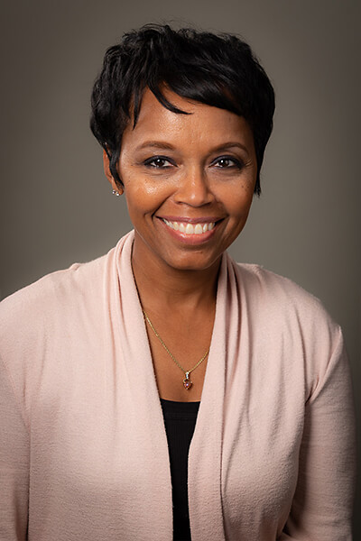

Melva Henderson along with her husband are church planters who founded and serve ss co-pastors of World Outreach Center located in Milwaukee, Wisconsin and have a powerful vision to impact lives around the globe.They travel nationally and internationally as both humanitarians and ministers of the Gospel. Since the inception of the church, several charitable outreaches have been founded by Ervin and Melva: The Give, a local annual outreach that has fed and clothed tens of thousands of individuals in the inner city of Milwaukee and surrounding areas. The Little Feet of Mexico, a mission outreach providing new and gently used shoes to children on the streets of the remote villages of Mexico and The Melva Henderson Foundation a public foundation established to support the humanitarian and philanthropic endeavors of Melva Henderson and Melva Henderson Ministries. Melva is a graduate of Rhema Bible Training College in Tulsa, Oklahoma.
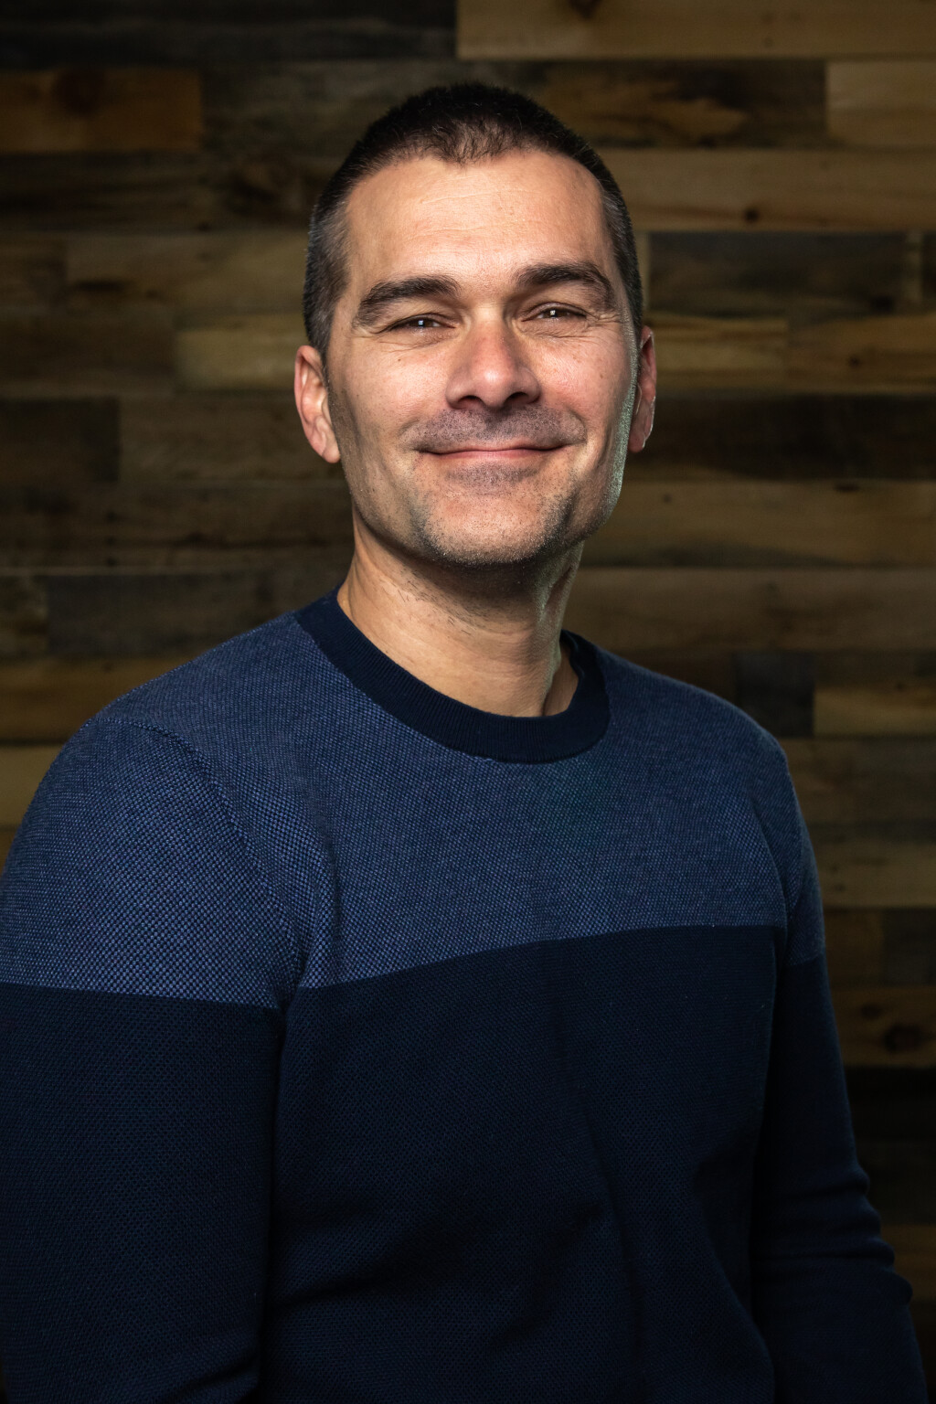
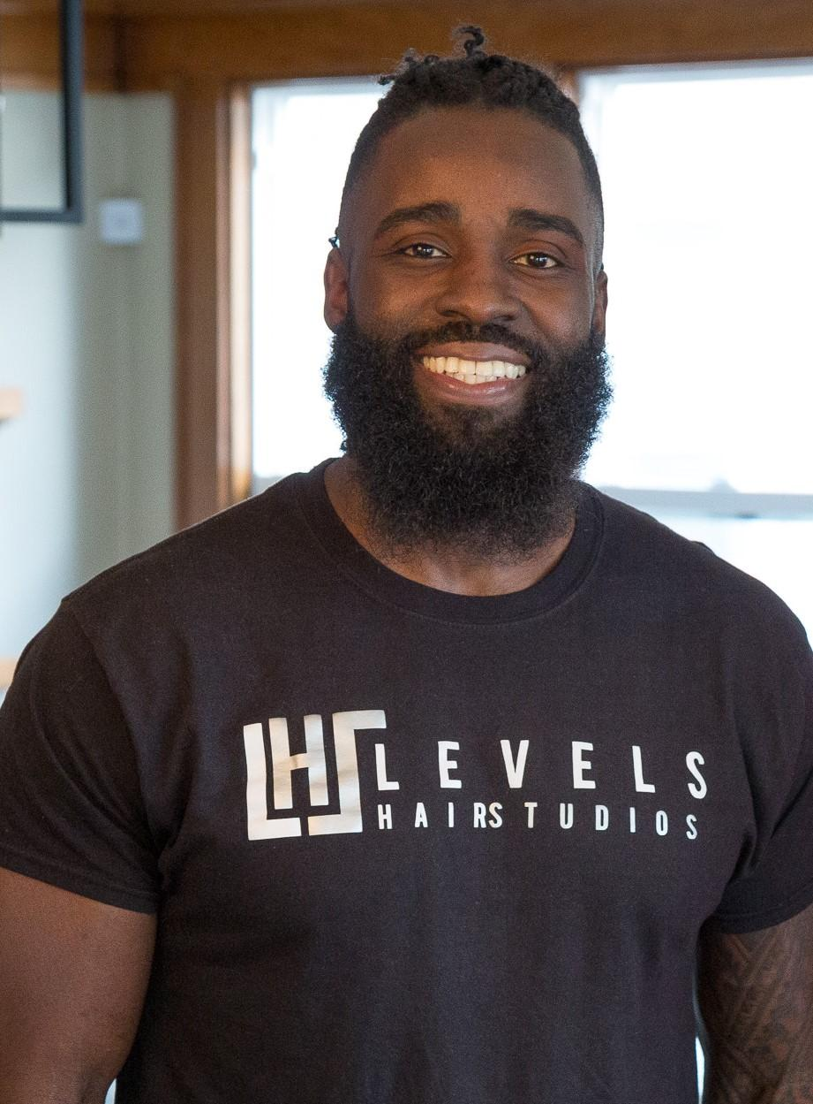
Mark Weigt is a church planter and has been the Lead Pastor of The Ridge Community Church since the day it began in 2006. Mark was born and raised in Oshkosh, Wisconsin. He earned a business degree from the University of Miami and a Masters of Divinity at Asbury Theological Seminary in Kentucky. Mark has worked at churches in Florida, Kentucky, and California, but he and his wife Donna felt a need to come home and start The Ridge for a very specific reason. "It bothered us that people didn't go to church. And it's not their fault. It's our fault. Churches weren't there for them. We wanted to create a church for non-church people."
Kenneth Lock II is a Native Born of Milwaukee Wisconsin. Pastor Ken is a church planter who amazingly and successively planted a church in a matter of four month planning. He is passionate about the city of Milwaukee. Respected as an accurate prophet and seasoned teacher, Pastor Ken served his parents ministry for 10 years before the unction of the Holy Spirit led him to launch Evolve Church of which he serves as lead pastor.

Pastor Ken has a Bachelor's Degree in Biblical Studies and is currently obtaining his Masters. He is a loving husband of his wife of 11 years (Krystel) and the father of two beautiful children (Nehemiah and Kennedy). Additionally, Pastor Ken serves as the Chaplain for the Milwaukee Bucks.
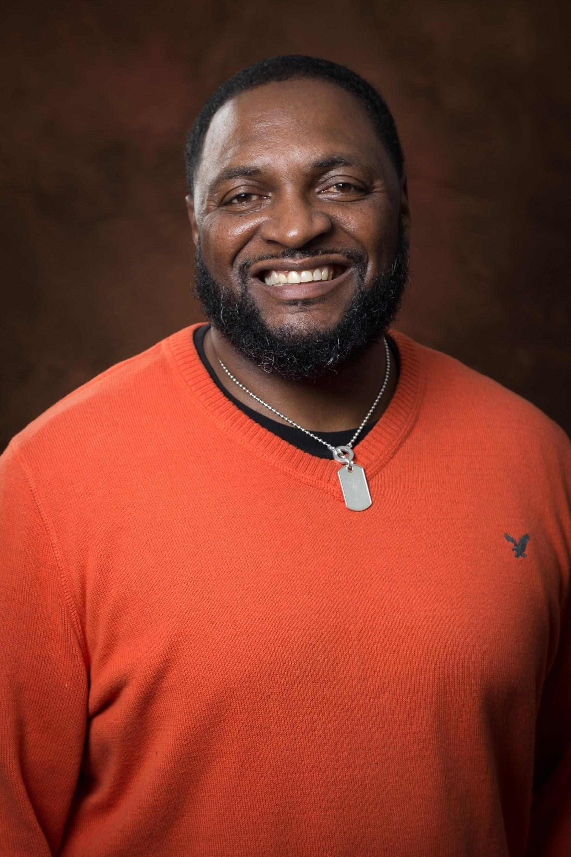
Kurt Owens was born and raised as a preacher’s kid in the central city of Milwaukee. As a youth, he was involved with gangs and by the age of 22, was a successful drug dealer. After a near death experience, he gave his life to Jesus and would later become an ordained minister. In 2005, he planted his first church in the central city of Milwaukee.

In 2016, he led the launch of a north side multi-ethnic ministry initiative for epikos church. Currently, he is planting a multi-ethnic ministry called Uflourish Church in a central city context. He and his wife Dee-Dee are the proud parents of 5 adult children and the proud grandparents of 10. Kurt has a B.A. in business from Concordia University, he holds an M.A. in Christian Ministry from Liberty Baptist Theological Seminary and an Ed. D in Organizational Leadership (ABD) from Grand Canyon University

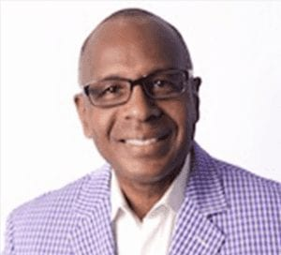
Walter F. Harvey served as the Senior Pastor of Parklawn Assembly of God from 1992 until 2020. He is the Chief Apostle and Presiding Bishop of the Outpouring Ministry Network Group, and the co-founder of the Milwaukee Declaration Pastors Group. Bishop Harvey is a graduate of Marquette University, with a Bachelor of Science Degree in Liberal Arts (Major: Psychology and Minor in Counseling). He is an ordained minister with the Assemblies of God and serves on a statewide and national level as a General Presbyter and the President of the National Black Fellowship of the Assemblies of God and serving pastors and churches in a governance and spiritual advisory role.

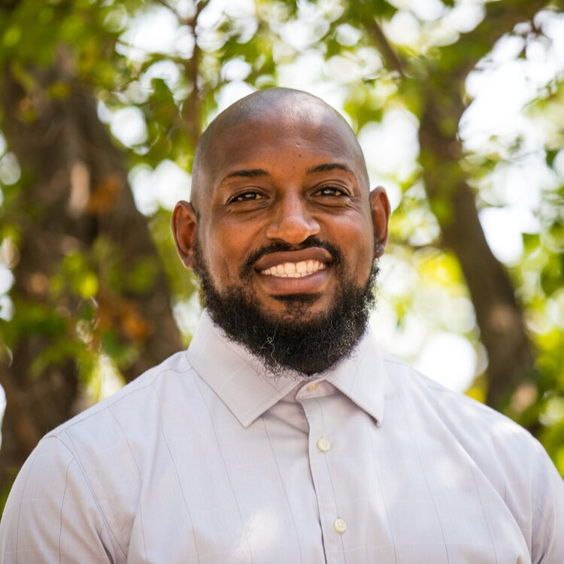
Raymond Monk is the senior pastor of Ephesians MB church in Milwaukee, Wisconsin. He is a graduate of Moody Bible College in Chicago, IL. He also serves as a community organizer and is responsible for the Neighborhood Strategic Planning in Area 4 for the City of Milwaukee. He has a passion to help transform our city one block at a time.

Contact Us
- Contact us form with comments

Donate

