FRONT LABEL REQUIREMENTS
Item # | Items to Indicate on the Label | What is this? | Requirement
1 | KINETIC | This is the company name. | This should be given emphasis and needs to be obvious as this is the company name.  Please refer to 1st attachment for the KINETIC text artwork.
2 | PHENOM Hybrid | This is the product name. | This should be the 2nd item to be given with emphasis.  The word PHENOM is the brand of the product, while the word HYBRID is the sub name.
3 | 0W-20 | This is the viscosity of the oil. | This is part of the brand and sub name, i.e. PHENOM Hybrid 0W-20.  0W-20 needs to be easily identified too in the label as this helps the buyers in deciding the right oil specification to buy.
4 | API SP | This is the main product specification. | This is the 4th item to be given with emphasis. This needs to have its own identity in the label.  This is the key specification of the product.
5 | FULLY SYNTHETIC ENGINE OIL | This is the quality of the oil. | This is the 5th item to be given with emphasis.  The price of the product depends on this quality and it is important that this word is easily recognized in the label. This can be smaller than items #2 and #3.
6 | ILSAC GF-6A  RESOURCE CONSERVING  FORD WSS-M2C946-B1  CHRYSLER MS-6395  GM6994M | These are other specifications. | These are sub specifications. It must be obvious too, but a little bit less obvious than the main specification (#4).
7 | 1L | This is the content of the oil. | This text should be bold so it is easy to see the size of the product.
8 | 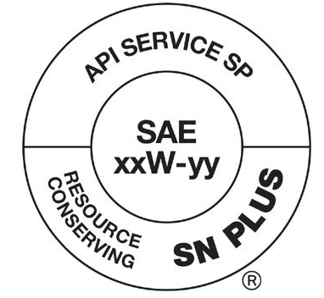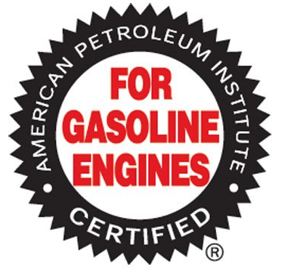 | These are API logos. | These are added features of the products. These should either be side by side or top-down arrangement.  Please refer to 2nd attachment of the API logos to use.
9 | 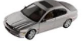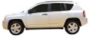 | These are the applications. | Please put a car and SUV logo, simple image will do, can either be grey or black color depends on what is suitable for the label.  These tells that product is meant for use in cars and SUVs.
10 | Improved Fuel Efficiency | This is the product feature. | This can have a dedicated line in the label.
11 | LSPI Shield | This is the technology. | This must be featured as a logo as this will be the product’s unique feature.
12 | FORMULATED FOR JAPANESE, AMERICAN, KOREAN & ASIAN VEHICLES | These are added features. | These texts can be given less emphasis. It can be smaller than the rest of the information above. Suggested to put below the volume, like the texts indicated below the 1L from Shell bottle in page 3.

SAMPLE LABELS WHICH CAN BE USED AS REFERENCE:
Sample #1 – MOBIL
Application (#9 requirement)
Content (#7 requirement)
Quality (#5 requirement)
Main Specification (#4 requirement)
Viscosity (#3 requirement)
Brand (#1 requirement)
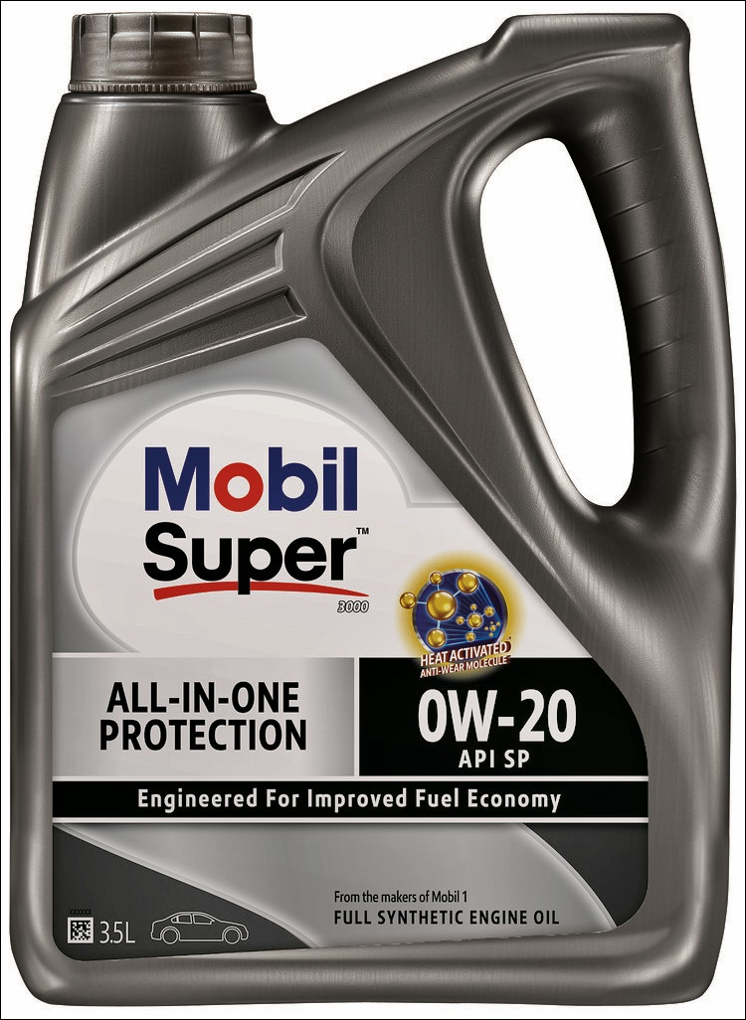

Product Name (#2 requirement)
Super – is the brand
3000 – is the sub name

Technology (#11 requirement)

Product Feature (#10 requirement)

Sample #2 – SHELL
Quality (#5 requirement)
Main Specification (#4 requirement)
Sub Specifications (#6 requirement)
Content (#7 requirement)
Viscosity (#3 requirement)
Product Name (#2 requirement)
Helix – is the brand
Ultra – is the sub name

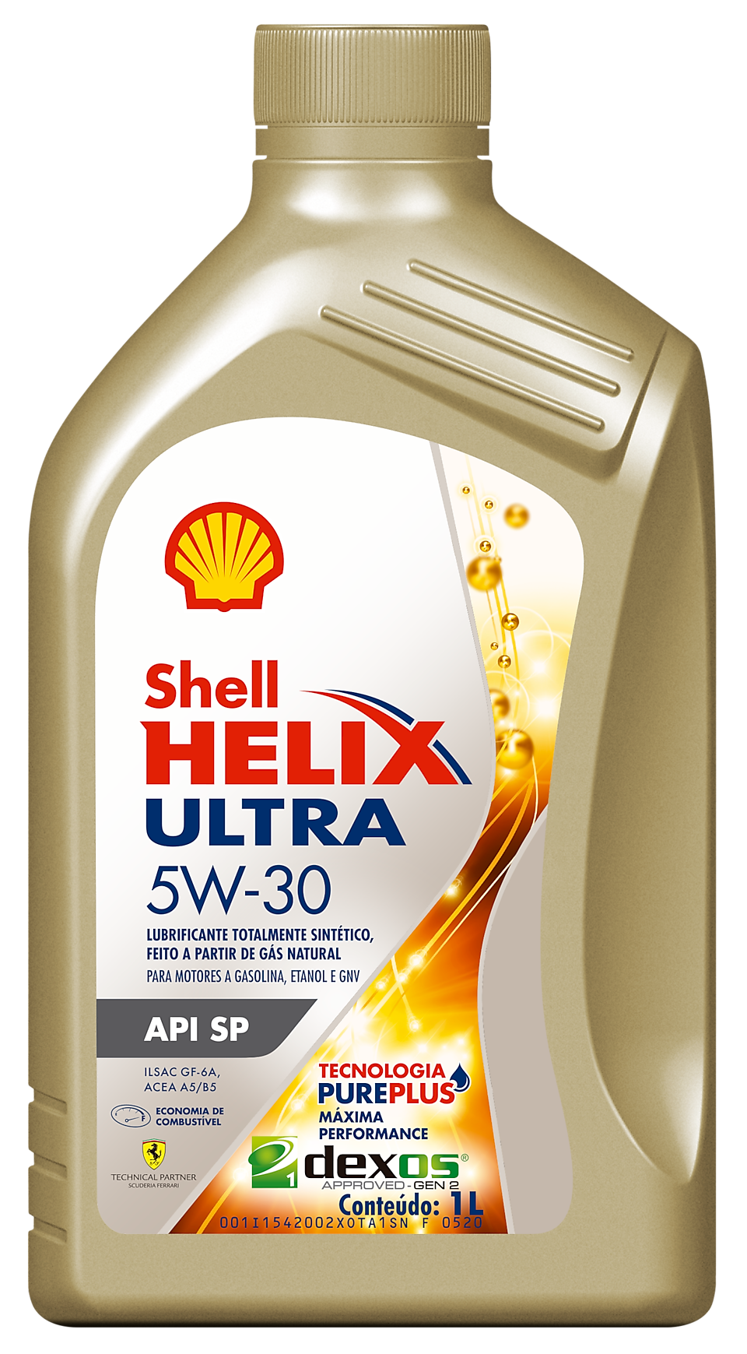

Brand (#1 requirement)

Technology (#11 requirement)

Product Feature (#10 requirement)

Sample #3 – LUBREX
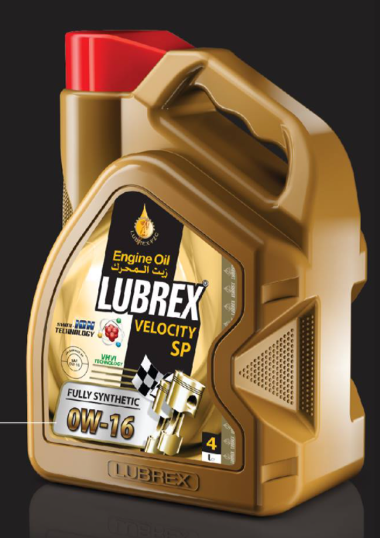
Technology (#11 requirement)
API logos (#8 requirement)
Quality (#5 requirement)
Product Name (#2 requirement)
Viscosity (#3 requirement)
Main Specification (#4 requirement)
Application (#9 requirement)
Content (#7 requirement)
Brand (#1 requirement)

