The size of these headings are really good. Keep these | 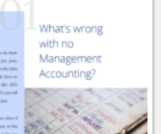
The way that the text and pictures alternate from side to side is really good, please do lots of this. | 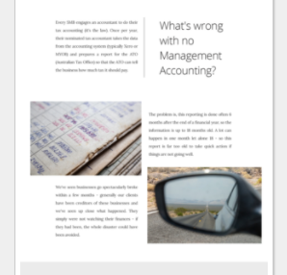
These large blocks of colour are not good, needs more white space like the example above. | 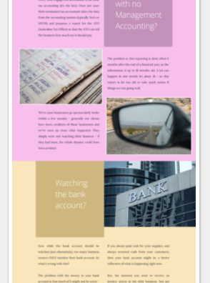
We don’t like the design of this section. It goes right across the page. I feel that it may make people think that they have reached the bottom of the page. Please keep the “Contact Us” to half the page, so people will easily see that there is more further down. | 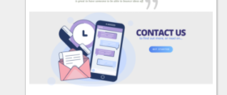
We need to break up this text some more.  I will send more images, or ideas for images so that we can do this. | 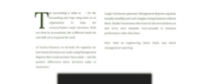
Don’t do the section numbers – good idea but we don’t think they are needed. | 