[Management reporting page for Tactica]

Tax accounting is what most public practice accountants do. Management Accounting is very different – it’s the accounting and reporting done in an organisation to help the owners/leaders make decisions. Both are done by accountants, but a different mind-set and skill-set is required for each. | 
At Tactica Partners, we do both. We regularly see how timely decisions are made using Management Reports that would not have been made – and the positive differences those decisions make to businesses. | 
Hear what an engineering client, Mark, says about management reporting | [Video testimonial from Mark Chisholm]  [will provide link to youtube channel]
Larger businesses generate Management Reports regularly (usually monthly) and can’t imagine doing business without them. Smaller businesses often haven’t discovered them yet and we’ve seen dramatic turn-arounds in business performance when they have. | Stock library image of financial reports but with lots of graphs etc. Something like this one.  
This is what XXXX, a hospitality client says about management accounting:  [associate this quote with a stock library of hospitality such as this one]   | "We have worked with Tactica for over 10 years now and really value the way they keep us focused on the numbers. They have shown us the KPI’s we should be tracking in our most recent business venture, which gives us insights into areas that are going well and those that need work. We check in monthly to see how the business is performing against the forecast that we set together and it is great to have someone to be able to bounce ideas off."
Contact us to find out more, or read on…

What's wrong with no Management Accounting?
Watching the bank account?
Committed future expenses
The Problem with the Profit & Loss Report
"Profit" isn't what you might think it is
The Ups and Downs of Profit
Management Accounts with Budget Forecasting is the Answer
The Benefits of Management Reporting
What can Tactica do for you?
The Tactica Management Reporting package

What's wrong with no Management Accounting?  Every SMB engages an accountant to do their tax accounting (it's the law). Once per year, their nominated tax accountant takes the data from the accounting system (typically Xero or MYOB) and prepares a report for the ATO (Australian Tax Office) so that the ATO can tell the business how much tax it should pay. |   Put the words “Ancient history?” over this image.
The problem is, this reporting is done often 6 months after the end of a financial year, so the information is up to 18 months old. A lot can happen in one month let alone 18 - so this report is far too old to take quick action if things are not going well. |   Use this photo above complete with the text    Or mark up this photo with the same text as top photo
We've seen businesses go spectacularly broke within a few months - generally our clients have been creditors of these businesses and we've seen up close what happened. They simply were not watching their finances - if they had been, the whole disaster could have been avoided. | Use an image like this one  
Watching the bank account?  Now while the bank account should be watched (not obsessively), too many business owners ONLY monitor their bank account. So what's wrong with this?  The problem with the money in your bank account is that much of it might not be yours - either now or in the near future. Similarly, much of your money might currently be in other people's bank accounts.  If you always paid cash for your supplies, and always received cash from your customers, then your bank account might be a better reflection of what is happening right now.  But, the moment you send or receive an invoice, you're in the debt business. You are lending to, or borrowing money from, the businesses you exchange invoices with. So you need to know how much you owe, and how much you are owed. These debts could be getting out of control and the bank transactions simply aren't going to tell you. | [insert image of bank]  
Committed future expenses  That's not the only problem. When you take on other commitments to fork out cash in future such as employing staff, buying vehicles or plant, or signing a lease, you're committing to that expense (and hoping you'll be able to cover it when the time comes).  So you see, the bank account is a very late (and inaccurate) indication of what will happen. Businesses are like ships with large turning circles - even a small business can take many months to turn around if things change quickly. You need as much warning as possible of trouble ahead. [insert image of large ship turning]  This is where the famous "Profit and Loss" (P&L) report might help. |   [image like this one showing large ship with a large turning circle]
The Problem with the Profit & Loss Report  The P&L shows you what you earned in the month (or the quarter, or year etc). This is why it is a better indication of your profitability than just the bank transactions (but you still need to read your balance sheet and cash summary - but that's another topic).  So why not just print off the P&L and other reports directly from your accounting system?  Assuming your bookkeeper has been entering data into you accounting system regularly (and most SMBs are doing this), why don't we just print off a set of reports (P&L, Balance, Cash etc)? | 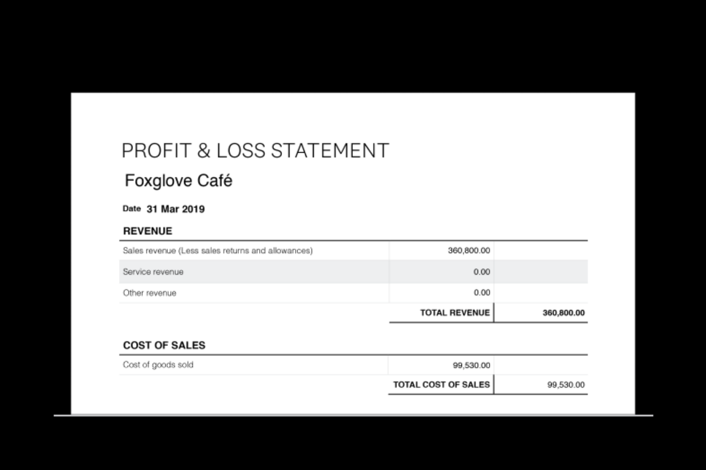  ?  [Concept of a Profit and Loss photo with a large red question mark over it (like the above)]
Now you could certainly do this, but you will likely find that it will report a very high profit on the P&L (sounds great, but unfortunately it’s a fantasy). Apart from allocation errors, there are lots of causes for overstating profit. The common reasons:  - Not including interest in the expenses  - Not including depreciation in the expenses  - Paying working Directors via drawings/loans which don’t show up in the expenses  Often P&L profit is understated. Reasons for this include:  - Stock purchases which are expensed immediately rather than put on the balance sheet  - Plant and equipment expensed right away when they should be depreciated  Then there is just plain mis-coding. Bookkeepers are used to taking short-cuts which are properly cleaned up at end of financial year when the tax returns are done.  SO it's very rare that we've even seen a P&L done correctly unless they've been properly prepared for management reports. | [concept photo of a fat elephant]    Or better below if you can find it.  
"Profit" isn't what you might think it is  Even when the P&L profit is calculated correctly, the profit it shows is accounting profit and may not align with many business owner's idea or expectations of profit. We need to understand what it means. Buying stock, assets/plant and paying down debt (such as HP loans) will all drain cash but not create a blip on the P&L profit. Plant which you bought years ago but is no longer supporting the business still being depreciated might be correct accounting, but giving you a mis-leading profit figure. | 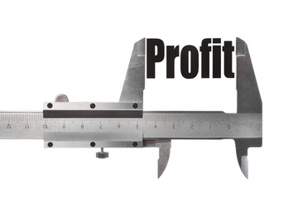  [photo very similar to this one]
The average P&L printed off without any checking/updating will be way off to the point of being misleading.

OK, so you P&L tells you what you earned in the past month (or year-to-date, or year etc). This is much more useful than just looking at the bank account transactions, but it still doesn't forecast into the near future to give you time to avoid the proverbial rocks.

The Ups and Downs of Profit  And the problems don't end there. Even in the very best businesses with the most stable trading conditions, the profit figure from month to month bounces up and down like kangaroo in a coffee shop. As you know, Profit is what you have left over when expenses are subtracted from income. Now both income and expenses vary from month to month, and they are generally much larger than the difference between them (the profit). So when you subtract one from the other, any 'noise' in those expenses and that income get magnified enormously.  Take a look at this budget from an actual company for the FY20 year. This is a plan for an ideal (but realistic) outcome. Notice that the business will be in losses in October, and very low profit in July and May - and that's if everything goes well!  Just imagine reading your P&L in October. After applying the defibrillator, you start the task of working out why you made a loss - is there something serious wrong? - are we solvent? - what does this mean for our future profitability?  Well here’s the thing, it might not mean trouble. We have clients with very profitable businesses who, due simply to timing, have some months in losses. And we don't just mean cash losses due to GST etc - we mean their P&L shows a loss. Common causes often include:  - Three fortnightly pay periods occurring in a calendar months  - Large annual insurance bills  - Income for services billed every quarter rather than every month  So what's the answer? | 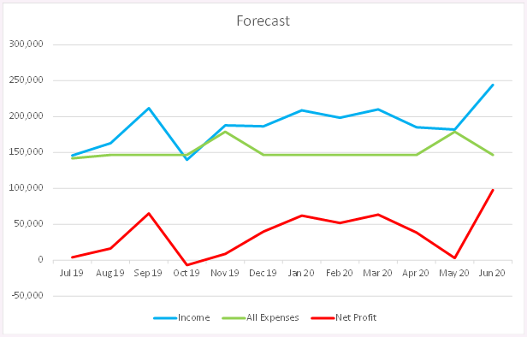  [Use this actual image, chart.png]  [Associate these words with the image}  This is a budget forecast from a client for the 19/20 financial year. Despite predicting smooth sailing and a healthy profit of $445,000, notice that in some months, their projected profit was very low or even negative.
Budget Forecasting is the answer.  Now the word budget might conjure up a tedious image of boring speeches by politicians, or might feel like a synonym for austerity,  but we'd like to convince you that, done right, a Budget Forecast is a fabulous tool to predict your future, lower your stress levels, hold your sales staff to account, and surprisingly, can motivate your staff beyond your expectations. Most importantly, you are far more likely to make the profit you want. This is not hyperbole, we are very serious. We see it working all the time. | 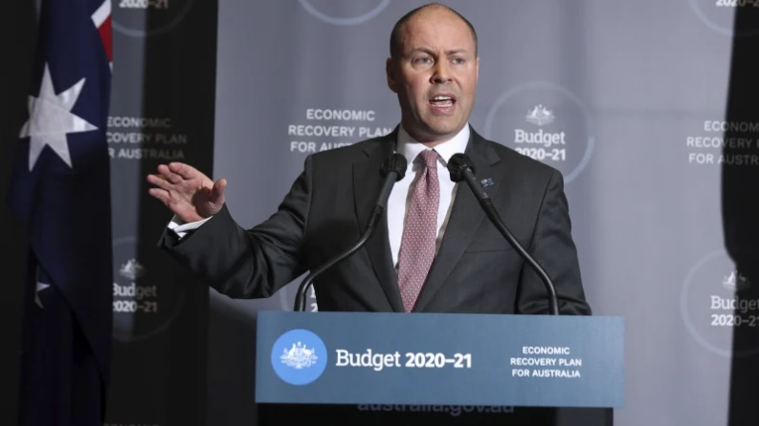  [Put a red cross over this image, or a “ghost busters” cirle and slash”]  [I have provided this exact image of Josh Frydenburg giving the budget speech]  [this image to be smaller than most as it represents a negative]
So how does it work?  At the beginning of a year (if the next financial year is a way off, don't wait, just use any 12 month period, the financial year is just a figment of the tax man's imagination, anyway) take your P&L for the past 12 months, and from that, work out what you plan to spend in the next 12 months. |   [insert a similar image of happy professional woman with laptop]
"But hold on", we hear you say, "that's just crystal ball gazing". Well yes, some things have to be guessed, but so much is accurately predictable - so much so that the guessing parts don't actually matter. |   [put a red cross or    Over this image or one very much like it]  [the visual message is :”crystal ball gazing not required”]
Most of the expenses that matter, are probably already locked in. Premises leases, staff wages, financing etc. Goods you only buy when your customers places an order, are a nice problem to have since you've just made a sale to the customer (with hopefully a good margin).  The real problems are going to be the expenses you're committed to whether or not you have income (sales). Because these expenses are very predictable you can predict with a great deal of accuracy your expenses for the coming months. You know the profit you want to make (if you don't know, use a minimum like 10% of total income). You can quickly use a spreadsheet to work out how many sales you need to make to cover your expenses and hit your profit target. Simple! You have a plan of how you'd like your year to turn out. (PS make sure you include a proper salary for you over and above the profit) | [find a concept photo of a lease like this one]    [also a large group of office workers]  
Now each month you generate a P&L (useful in itself) but which also compares what actually happened to what you planned (known as "budget vs actual"). |   [find an image similar to this one]  [on one lens write “Budget” and on the other write “actual”]
From this you can make two powerful predictions with some simple maths:  - How much profit you will make by the end of the year if  - you hit budget for the rest of the year  - things continue the way they've been going |   [image like this one]

The Benefits of Management Reporting

The benefits are huge and numerous:

Confidence in your numbers  If you are reviewing you numbers monthly (and you should be), but you're not sure just how accurate they are, and you have to do lots of checking and fixing to have some confidence in them, you're unlikely to persist with your regular reporting.  Having professional bookkeepers and accountants oversea and prepare your management reports will give you the confidence to trust the reports freeing you up to analyse your business and make decisions. |   [image which implies accuracy and confidence]
More likely to make a profit  We know that you get what you aim at. So instead of constantly monitoring you break-even point (which will result in, you guessed it, break-even), you will be monitoring your projected profit. You start to think of it as your 'break-even' point, and as a result, are far more likely to achieve it. | 
“You get what you aim at” | [put these words right across the page in a larger font or on half the page]
Early warning  If things aren't going well, you will know that your planned profit will be looking sad, so now you can take action with plenty of time on your side to make the changes you need to make. An "early warning system", if you like. As they say in aviation : "There's nothing more useless than altitude above you, or runway behind you". The earlier you know that something is wrong, the faster you fix it, the more likely you will preserve your profit. | 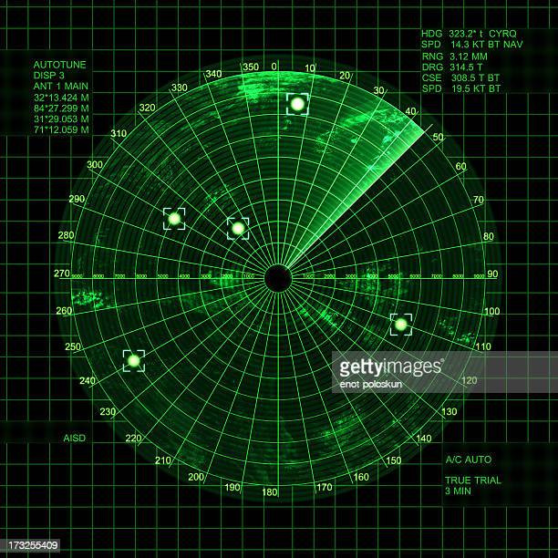
Lower Stress levels  Here's how it works. Do you know that feeling when you look at your profit figure for the month and your heart sinks, because it's low, or even negative?  Recall the real budget forecast above:  Now if you had predicted a loss for a particular month, and the Budget vs Actual report showed the expected loss (and all other numbers roughly in line with expectation), then you know that you are on track for your desired profit (at least for that month anyway). Don't you feel a whole lot better about that?  So now the management reports are focusing you on what you really need to know about, clearing away the noise you don't need to worry about. | 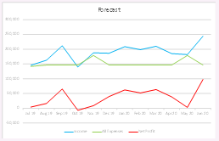  [just a small veriosn of the one we’ve already used]    [image like this one to indicate low stress levels]
[this quote can go right across the screen or in its own half] | "Budget Forecasting makes clear, what you need to focus on"
Sales Targets  When you have a Budget, you have monthly revenue targets, and that means sales targets!  Everyone loves a scoreboard and when you share the sales targets with the right team, magic happens. People get excited about achieving the targets and really excited when they exceed them. There is often a big push when the end of month is coming up and the targets have not yet been met. Your team will get a real buzz out of making the big effort to the get the month over the line. This particular benefit of budget forecasting often takes our clients by surprise - nice surprise, of course! | 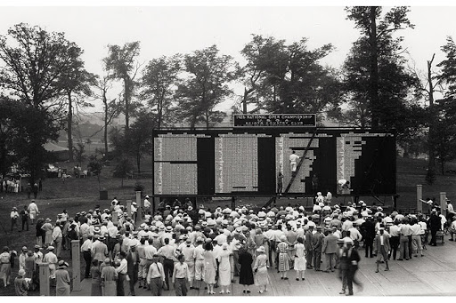  [Use this photo if you can]
Opportunistic spending and Unforeseen expenses  We all know that feeling when an unexpected bill comes in - both at home and in our businesses. But with a budget forecast, you have a little more control. You might have blown the budget on one particular expense, but chances are, you're under in another area and they cancel out. When this happens, you know your profit projection is safe.  The same applies to opportunities that suddenly come up to buy a bargain piece of equipment, or upgrade some plant which will make you more efficient. Rather than guess, you can look at your budget vs actual report and see if you can afford the unbudgeted expenditure. If you can't, then at least you can predict the impact on your end of year profit and make an informed decision. |   [or similar image of shiny new tractor or farm equipment]
What can Tactica do for you?  Tactica can provide a set of management reports for you each month. We can do your book-keeping for you, or work with your current book-keeper to ensure that transactions are coded correctly to produce management reports.  We can do this for a fixed monthly fee to give you the confidence that you will know your costs in advance (and meet your budget forecast!) | [across page]

The Tactica Management Reporting package

12 month programme
We do your bookkeeping, or we assist your existing book-keeper
We work with you to create a budget for the next 12 months
We install the budget onto you accounting system

Then, for each month, by the middle of the following month, we prepare you management accounts and meet with you to discuss them, answer questions and help you achieve your goals.

All for a fixed monthly fee

Contact us to discuss your needs | [call to action – don’t make it too high sdo as to make people think it’s the bottom of the page]
Our mission is to improve the lives of business people by giving them insights to drive their business forward. | [maybe spread this text across the page as the main mission statement]
We do this through inspiring education to show business people just how powerful their numbers can be (Knowledge is Power and we pursue growth through learning).  We give business owners confidence through competent & proactive accounting and tax services. | [Photo of the Tactica team  is provided]  

