
Enhanced Information Solutions is happy to announce eDatasheet, a product that enables Manual Data Entry into your PI System. The eDatasheet runs in HTML5 and leverages your Asset Framework for Units of Measure, Upper/ Lower Control Limits and Comments as AF attributes and PI Tags.
Once a value is saved to PI, it can optionally be edited by a user, based on eDatasheet settings. Enabling this feature allows a user to change a value (with comment) without the need of PI System Administrator tools.
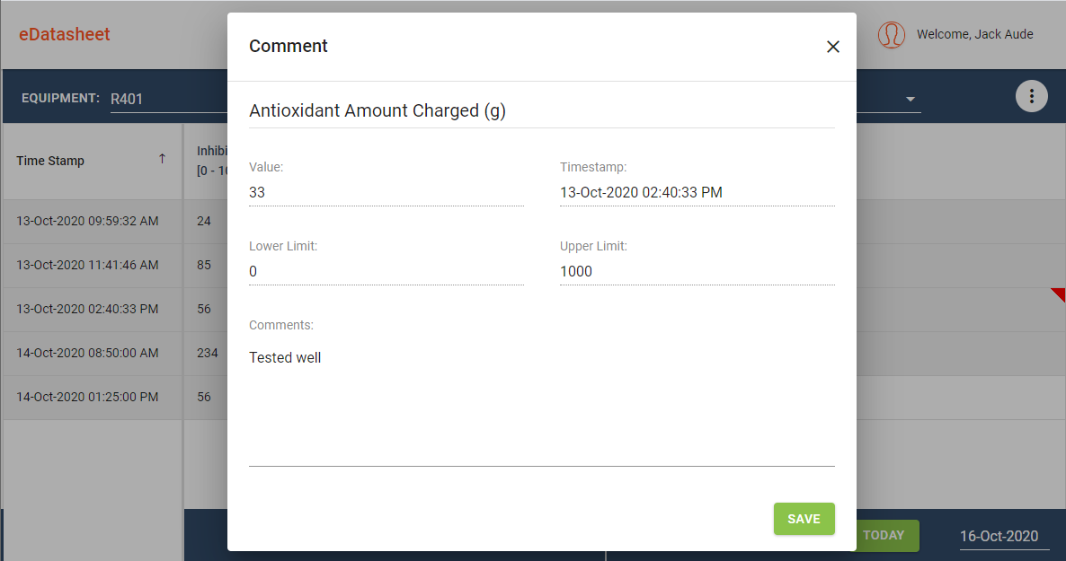

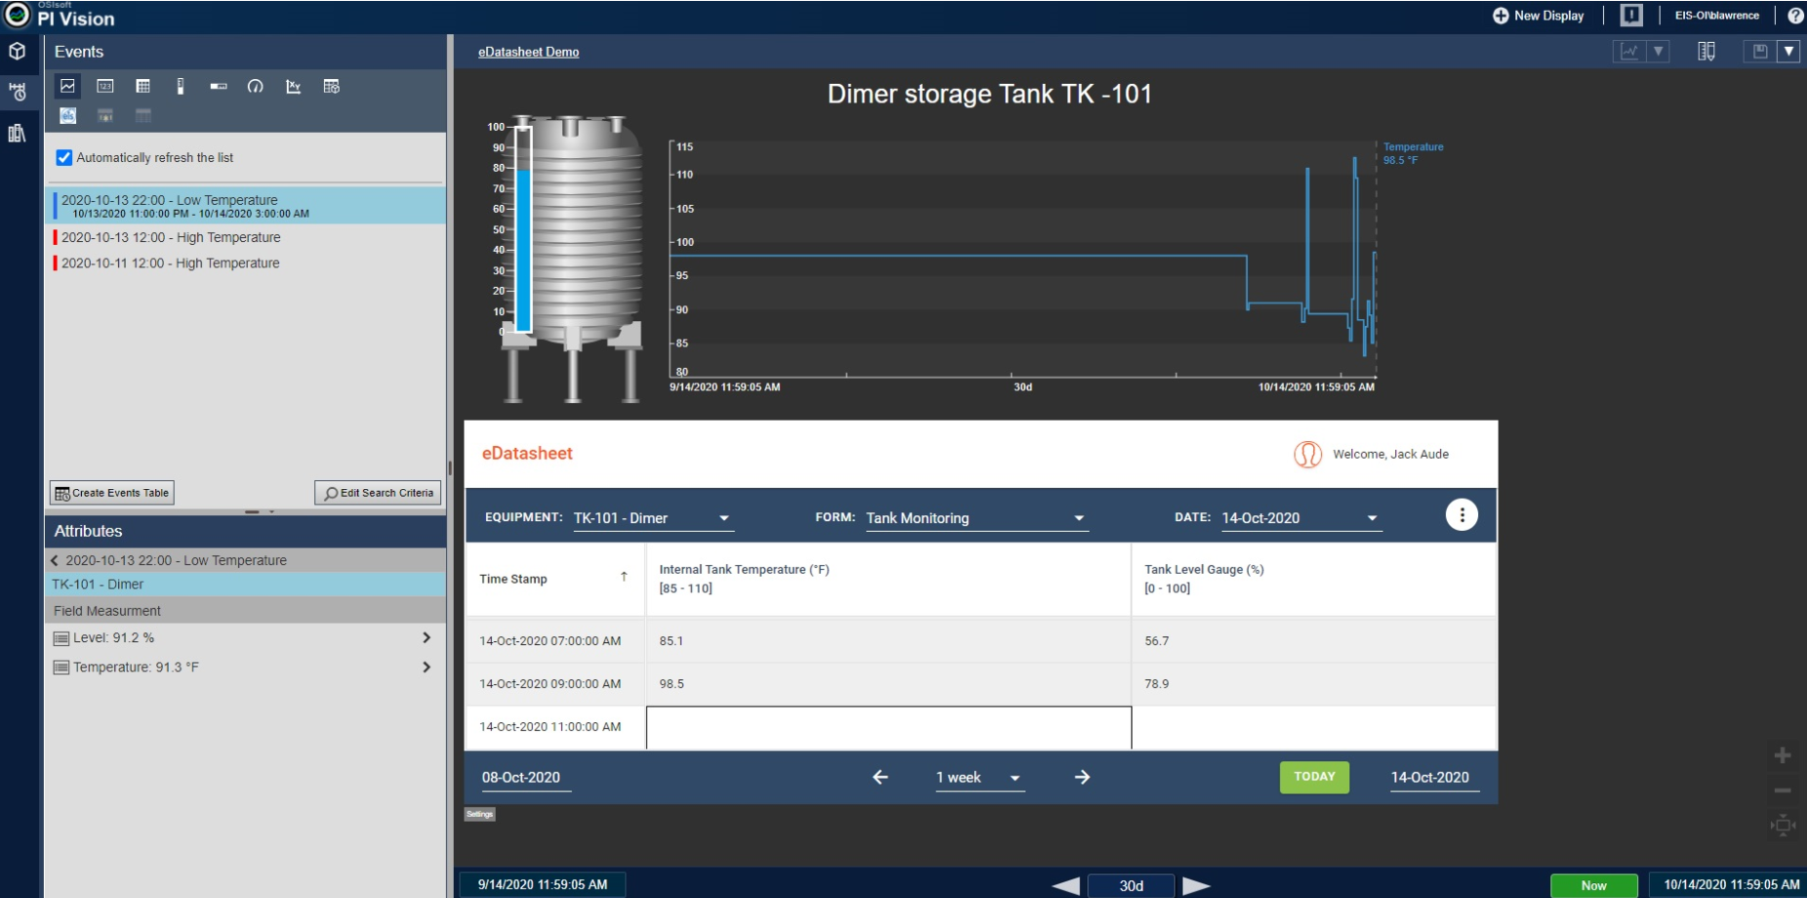
PI Vision can contain eDatasheet directly and enable users to manually input data into PI, Edge Data Store (EDS) or OSisoft Cloud Services (OCS).

Enhanced Information Solutions was founded in 1994 in Stillwater, Minnesota with offices and customers globally. Of the top Fortune 100 companies, 25 are EIS customers. To best illustrate our customer success, more than 80% of our customers are repeat customers. Additionally, EIS has up to 25 years’ experience in deploying, maintaining, upgrading and training on the OSIsoft PI System.

For additional information on eDatasheet, please visit www.EIS.com or contact Jack Aude, Jack@EISinc.com.

