Bp Alarm.com packages

One Home autoMATION Device REQUIRES A $6 a month iNCREASE per device WITH A 60 MONTH RENEWAL

Door Bell cameras

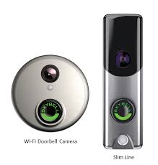

Adc Thermostat

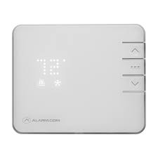

Auto Deadbolt

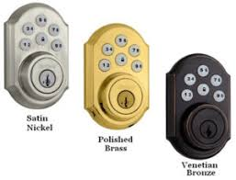

Garage Controller

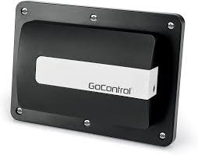

Indoor Camera
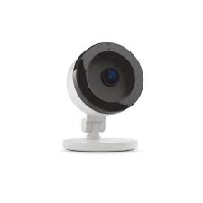

Outdoor camera REQUIRES A $12 a month INCREASE for the cAMERA PER cAMERA

outdoor CAMERAS

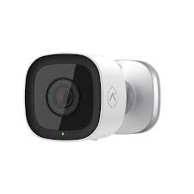

Doorbell Camera and an outdoor camera REQUIRES A $20 iNCREASE a month for BOTH theSE Devices:

1 outdoor CAMERA + one other device (Doorbell Camera)

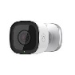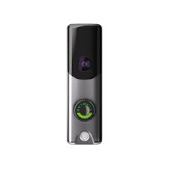

**Requirements: 60 month agreement renewal + $50 install fee per outdoor camera

Two or More Outdoor Cameras REQUIRES A $12 INCREASE per MONTH PER Outdoor camera

2-4 outdoor Cameras +12 per camera.

**Requirement: +$6 5-8 cameras due to more clips package.

1st Option: Phoneline to Cell Primary no app REQUIRES $7 INCREASE PER month, ALSO requires a 60 month renewal

2nd option: Phoneline to cell primary with app REQUIRES A $13 a MONTH INCREASE, ALSO REQUIRES a 60 month renewal

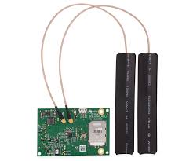

Go Control 2 panel upgrade REQUIRES A $5 INCREASE PER month WITH A 60 MONTH RENEWAL AND a one time fee $100

