SURREY RESORT LOGO

We are looking for a proposal to design a modern/contemporary logo for an up-and-coming glamping resort located 70 miles North from San Francisco, in the heart of west Sonoma county – in the middle of great redwood forests, Russian River, and wineries.

The main building houses a cafe, wine bar, a big event hall and a gym. The buildings are built in "Mediterranean style”.

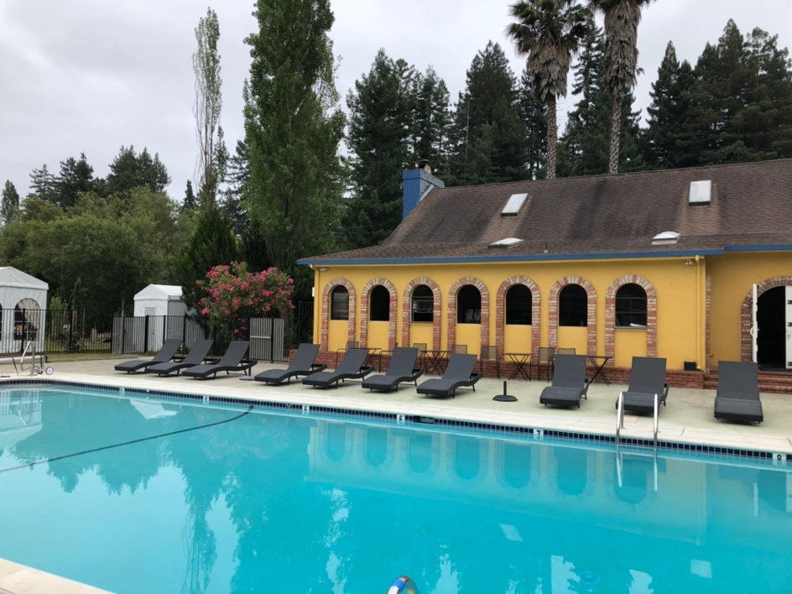

The Pool house is located behind a large pool and patio area. It has a spa room, full changing rooms (with showers/bathroom facilities) and ADA accessibility. The glamping tents are fully furnished and sit on 2 acres that back into a vineyard.

We envision a stylish contemporary logo targeting an affluent clientele ranging from “millennials” to “boomers”.

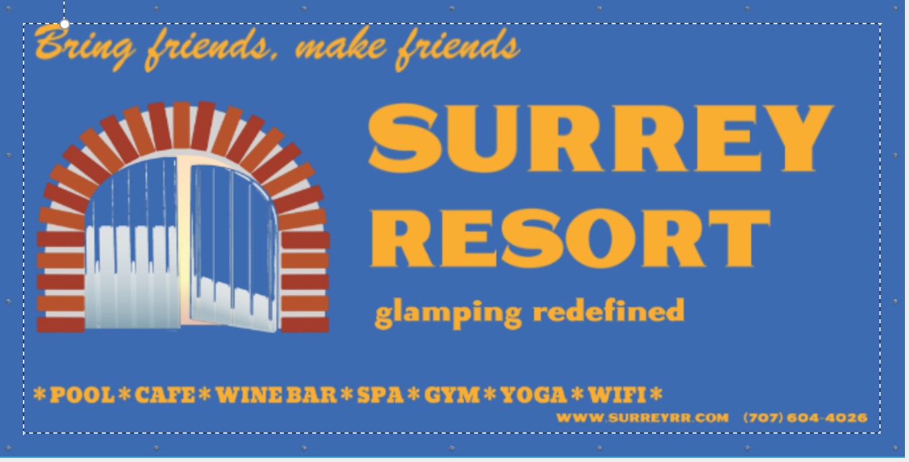
Here is a quick mock-up banner, which we would like to see significantly improved upon – cleaner/modern look.

Resort colors are blue and yellow. We don’t have to make our logo to be those colors, but perhaps black and white logo with a couple strokes of our colors?

The arched door is a very attractive feature in the main building…luring you inside the world of relaxation and connectivity with friends and the nature.

Attached below is the current letterhead of the resort utilizing a rendering of the door. Going from letterhead to a larger scale (signage for example) makes the letterhead logo too overloaded with details and takes focus away from the text and details on the signage.

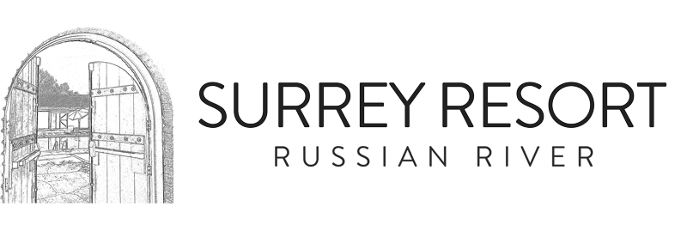

Bolder lines and fewer details would fix deficiencies of this design in our opinion, but we are open to suggestions and new ideas.

Photo of the actual door:

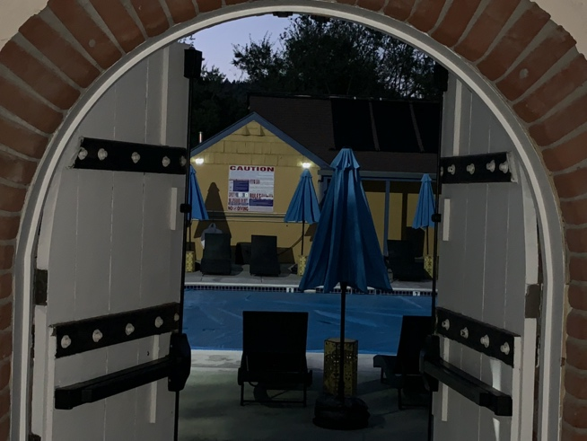

Check our website for more details: www.surreyrr.com

Contact Information:

Alex Yaroshenko

Managing Director

16590 RR LLC

(707) 604-4026

Email: laroshe@att.net

