(FOR THE DESIGNER)
Creative Brief: JESSICA PATTERSON =

INTRODUCTION
We are looking for a great designer to create a logo
For our company Jessica Patterson Law & Consultancy Pty Ltd
Logo must be the words “Jessica Patterson”.
New Legal Company owned by Jessica Patterson - experienced lawyer who advises people in the liquor, events, hospitality, events and tourism industries, in Western Australia on various aspects of their businesses. She is usually involved from the outset of projects through to dealing with management, compliance, contracts, business development and ongoing operational issues. Jessica deal with businesses and projects of all shapes and sizes, all around Western Australia.
The tag line should be something like – “Providing legal and consultancy services to all types of businesses in the liquor, hospitality, tourism and event industries in Western Australia, from start-up to trading, compliance and expansion.”
…………………………………
THIS BRIEF (OUR REQUIREMENTS)
We require different versions (iterations) of this logo. For the various applications.
Full colour, other in white (transparent) to be able to move it around, overlaying it against different colour backgrounds.

- COLOUR PALLETE

Either midnight blue + gold
Midnight Blue + White
or
Black & White
Or Gun-metal grey/charcoal + Gold

DO NOT USE ANY RED

LOGO TEXT
Jessica Patterson
Legal & Consultancy Services
Hospitality | Liquor | Tourism | Events

GO FOR IT. THINK OUTSIDE THE BOX ABOUT HOW TO RESPRESENT THIS - SOME IDEAS BELOW
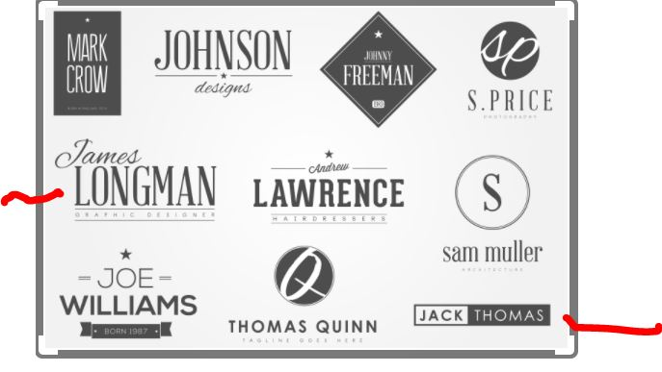

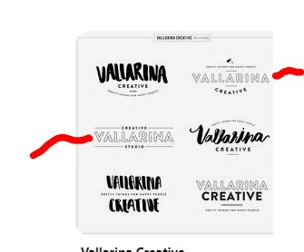

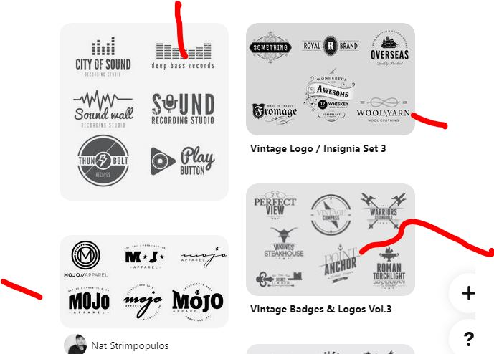

BACKGROUND ON US
So you can fully understand more about Jessica – her clients, services, industries etc) and be able to choose most compatible aesthetics / design techniques which will work well for these different aspects – we provide you with the following:
WHO ARE WE?

Jessica provides legal and consultancy services to all types of businesses in the liquor, hospitality, tourism and event industries in Western Australia, from start-up to trading, compliance and expansion.”

CORE VALUES?
Our core values include Trust, Customer-Centricity

Knowledge
Professional
Ethical
Approachable
Practical and commercial
Trust-worthy
Committed
Integrity
Client perspective focused
High standards

INDUSTRIES SHE SERVICES
Our clients come from these industries (mostly)

Liquor
Hospitality
Tourism
Events
Clubs
Hospitality precinct development
….in Western Australia

LOGO DESIGN BRIEF

Desired design style
- Modern
- Strong
- Fresh
- Looks as though we are dependable, professional experts (we are)
- Not “too busy” or complex either, logo may execute onto shirts eventually.

Font
- Something strong, clean……not flowery or too complex.
- Start off thinking about fonts like Sans serif fonts, like Helvetica – smooth edges, easy on the eye, modern look and feel – then you will be in the right zone!

Non-Negotiables:
Important things to consider with our logo please.

- SIMPLICITY - we want an identiﬁable, evocative logo – strong, visually aligned to our company’s brand qualities. Customers are drawn to logos that emphasize strength, speed, friendliness and approachability - lets inject our OWN PERSONALITY into logo design elements, which reflect us.
- Don’t produce a logo that will “DATE” early either – must have a TIMELESSNESS about it so can go ahead, doing its thing, affording Jessica long-term brand recognition as the business grows.
- Avoid hot trends – logo must ENDURE FOR DECADES telling a story of us, our company AUTHENTICALLY and honestly.

- Has to be VERSATILE. Easily RECOGNISABLE. TRANSFERRABLE ONTO ANY MEDIUM bearing our brand, incl. merch, vehicle, social media, packaging, advertising.

- Has to work across full block colour as well, so whatever logo is designed, we will need a png. Version (wihte??) that can easily sit agains a full block colour background.

- Do not rip anything off from other existing designs either! Be aware of COPYRIGHT issues This logo will be for a LAW FIRM!

COMPETITOR LOGOS

Some of our Competitors bellow. Do not design using same colours or symbols. Please STAY AWAY FROM THE COMPETITOR COLOURS, SHAPES wherever possible

Lavan (not a true competitor but important to distinguish from)
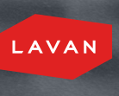

Dwyer Durack (NICE LOGO)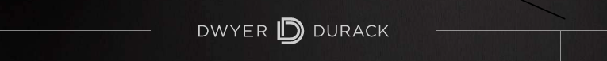

Cullen Macleod (BORING LOGO)
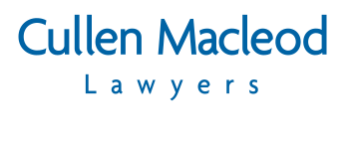
Ryan & Durey


Australian Travel and Tourism Lawyers


Frichot & Frichot


Murfett Legal


Canford Hospitality Consultants
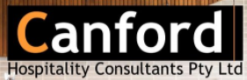

Hospitality Total Services


DESIGN BRIEF - LOGO cont.

PROJECT TIMING” DUE BY DATE
- We will begin to review your designs as they come through choose one that really resonates with us, but generally we’d like to have all logo options submitted to us to make a decision by this Thursday….18 March 2021

BUDGET
- $150 AUD on completed job

DELIVERABLES
- Logos in various file formats will be required please:
  - Several different high-res versions - EPS, PDF, Web version, .png (White)

- We will also in step two – give you more work direct, and ask you to design some
  - business cards
  - official company documentation
  - email signature
  - socials
  - letterhead

PROJECT OWNER DETAILS
Jo Woodfield
Owner, Director THE HIGHER MIX
jo@thehighermix.com

FOR DESIGNERS
NB WE’RE NOT ACCEPTING CALLS OR ANY INPUTS FROM YOU ALL, UNTIL WE AWARD THE CONTRACT
So, please do not try and get in touch with Jo via email or Whatsapp or any other way until we have awarded you the contract. Thank you.

