CLIENT: Le Funnel Cake

Brief: We want to create a logo for our business focused on funnel cakes, sweets & desserts, where people can customize their desserts. Our business is family oriented, warm, inviting and friendly and people stop by because they have a craving or they saw our delicious looking desserts. Our customers live in Boyle Heights/ East LA, but are not limited to these areas as we have serious funnel cake aficionados who will drive long distances just for our treats.

Who we are:
- We sell Funnel Cakes, Sweets/ Dessert
- Customization/ Build your own
- Visually Appealing
  - Craving * senses
- We are about Flavor
- Funnel cakes with a little bit of French in there

Who is our customer?
- Funnel Cake aficionados

Who is your Competition?
- Churro bros
- Street vendor
- Churroholic
- Crepes gone wild

Here are some logos we like:
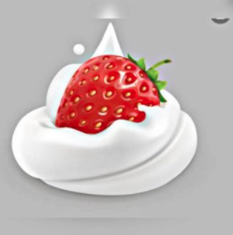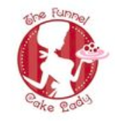

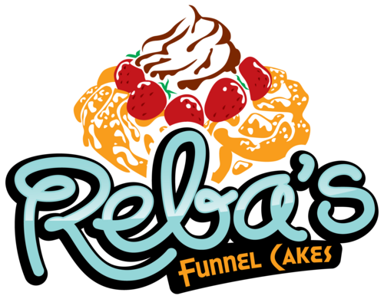

Logo must haves:
- Include image (can be illustrated) of a funnel cake.
- Include business name: “Le Funnel Cake” (without quotation marks)
- Slogan: A bite of happiness
- Must be more on the playful side. A playful vibe
- Colorful (see examples)
- to be used on all print collateral

Nice to have:
- The font is creative and somehow look like dessert.

Here are some photos of our desserts!

