T4L Logo Design

Purpose: Create a new logo for T4L.

Current Logo: Created initially to get project started.
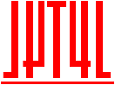

What is T4L: An All-Inclusive Membership for Subscribing to an Electric Vehicle.

T4L Website: https://www.t4l.me/

Primary Colors:
- Red: 255, 0, 0
- White
- Gray or Light Gray

Style:
- T4L word with emblem
- Sleek
- Clean

Uses:
- Logo will be used on Website, Stationery, etc.
- Logo as an Emblem, Used on T4L Buildings
- Eched version of logo will be placed on Electric Vehicles that are within T4L Fleet

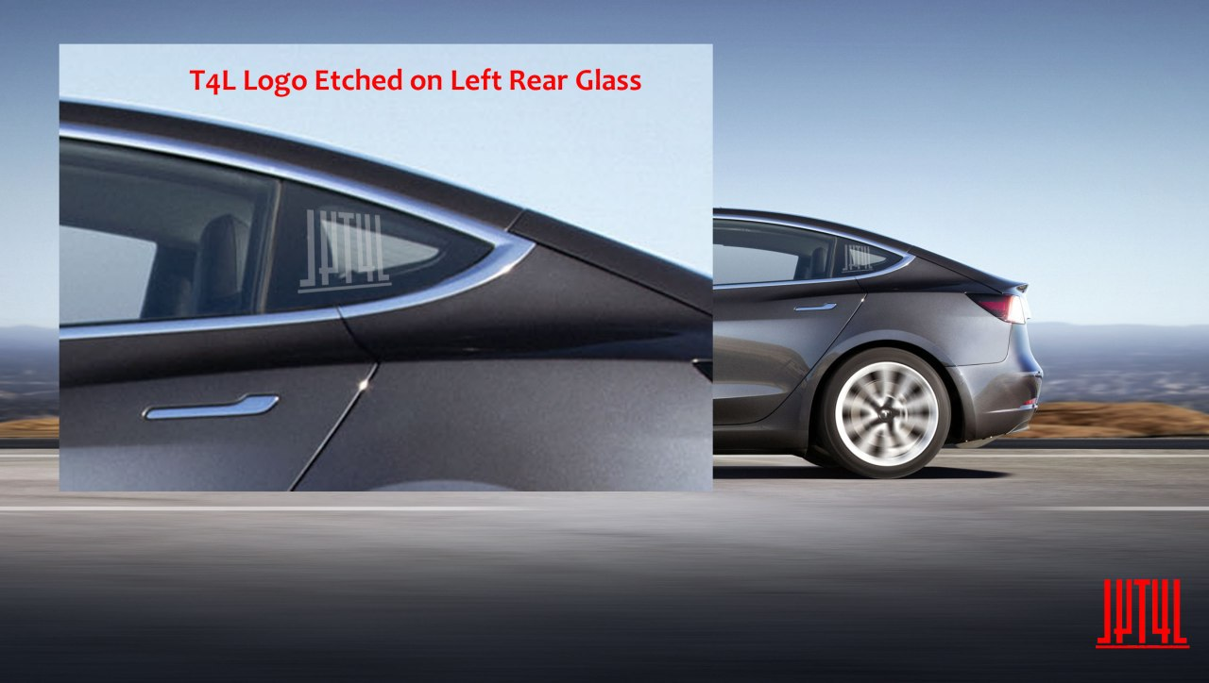

References For Logo Ideas:
- Tesla Motors Logo
- Lucid Motors Logo
- Audi Logo

