Yard 99
What is Yard 99: A family friendly community/common area with restaurants, green space, and stage overlooking a nature preserve. The perfect place to bring the whole family. Bring your friends, enjoy a variety of food, American Bistro, Mexican Food, Cajun Seafood, Barbeque, and more. There will be outdoor dining and patio seating and space to play on the green. There will be weekend entertainment on the stage, a big screen that can show sporting games. The green space made of turf for kids to run and play on while parents eat and have a beer or wine. This will also be a Pet friendly space.
Yard 99 will be located within the Valley Ranch, a master-planned mixed-use development, consisting of shopping, dining, entertainment, residential communities (single family homes and apartment communities) medical district, office, and hospitality.
Key Words: urban, rustic, industrial
Target: “Something for Everyone”: Families, Friends, Couples, pets. Lots of seating and space to run around. Fun, Family Orientated, Outdoors.
Logo should be/have: Contrasting textures, vibrant, eclectic, urban/rustic
Emphasis on: Community, intimate setting, lifestyle imagery, artisan/local artist/muralists, local appeal/hometown
Similar Concepts: https://www.yardtx.com/, https://chickennpickle.com/san-antonio/
Inspiration Photos:
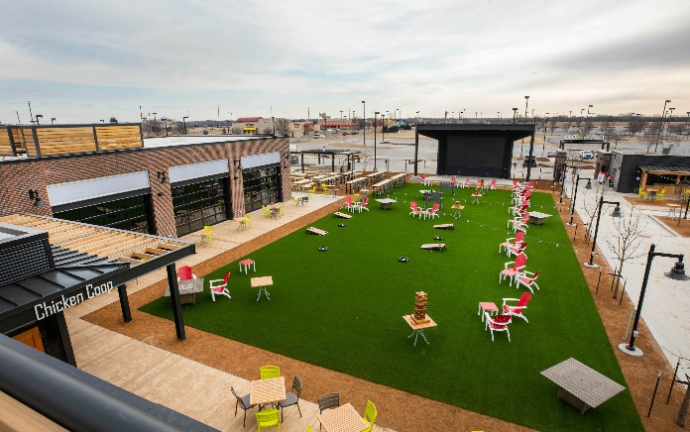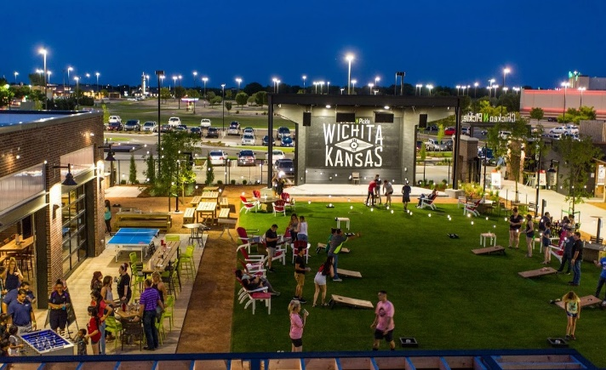
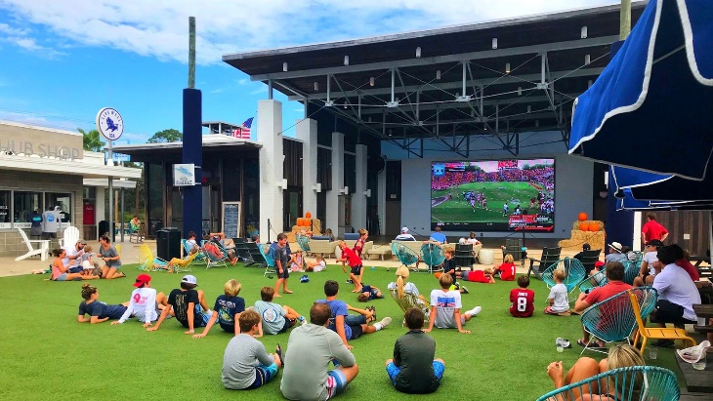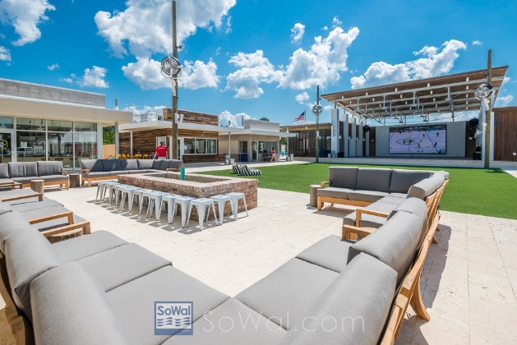

Inspiration:
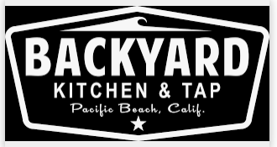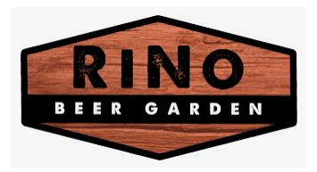
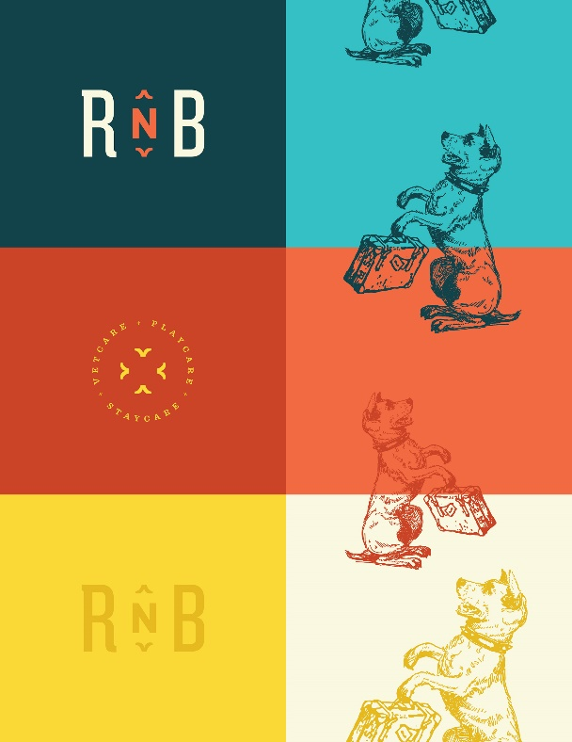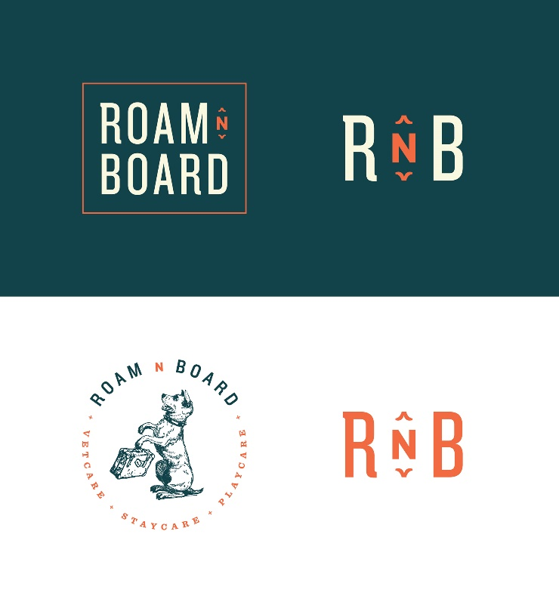
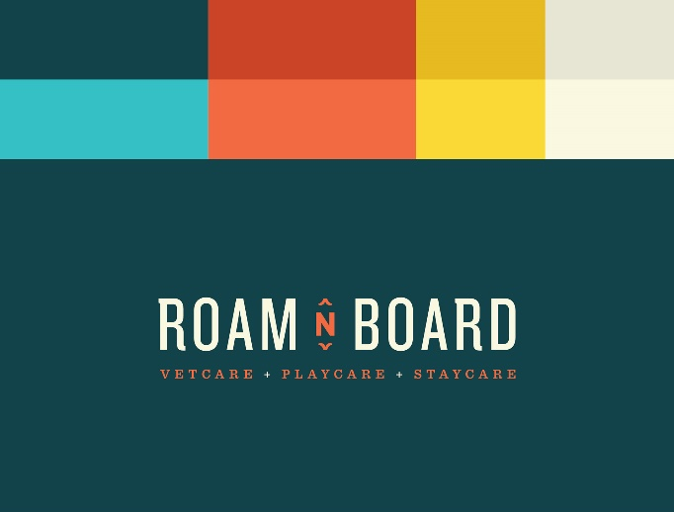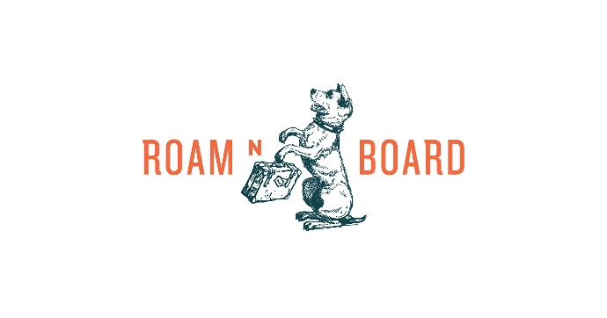
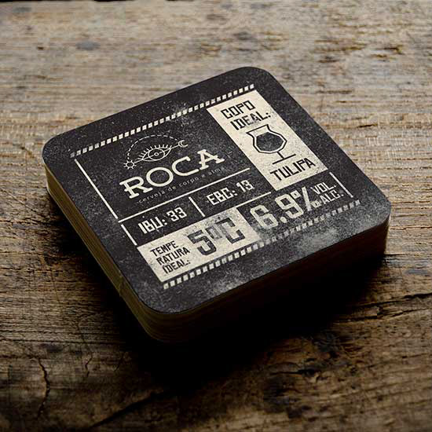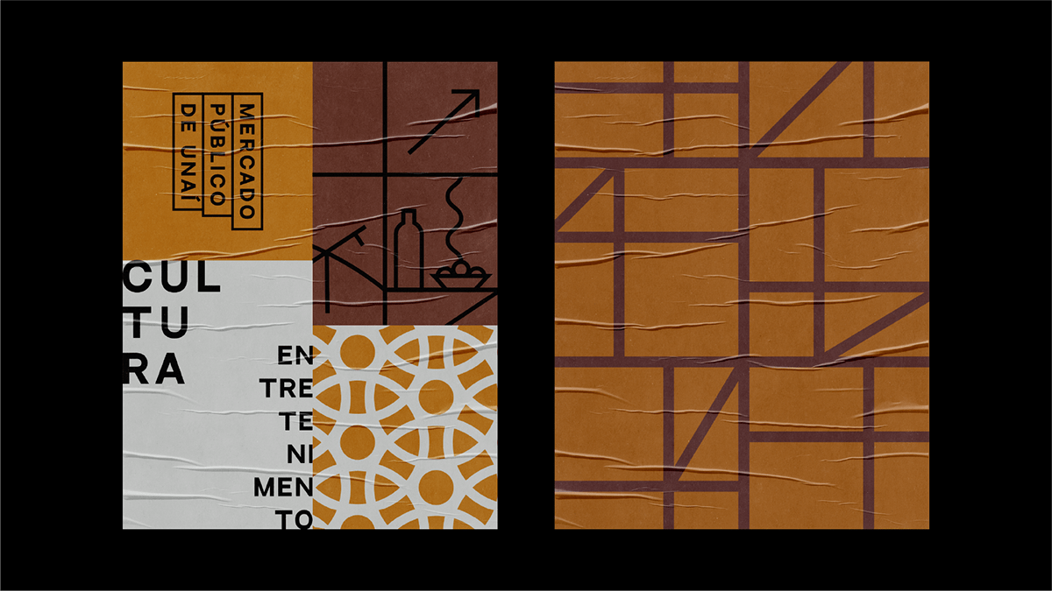
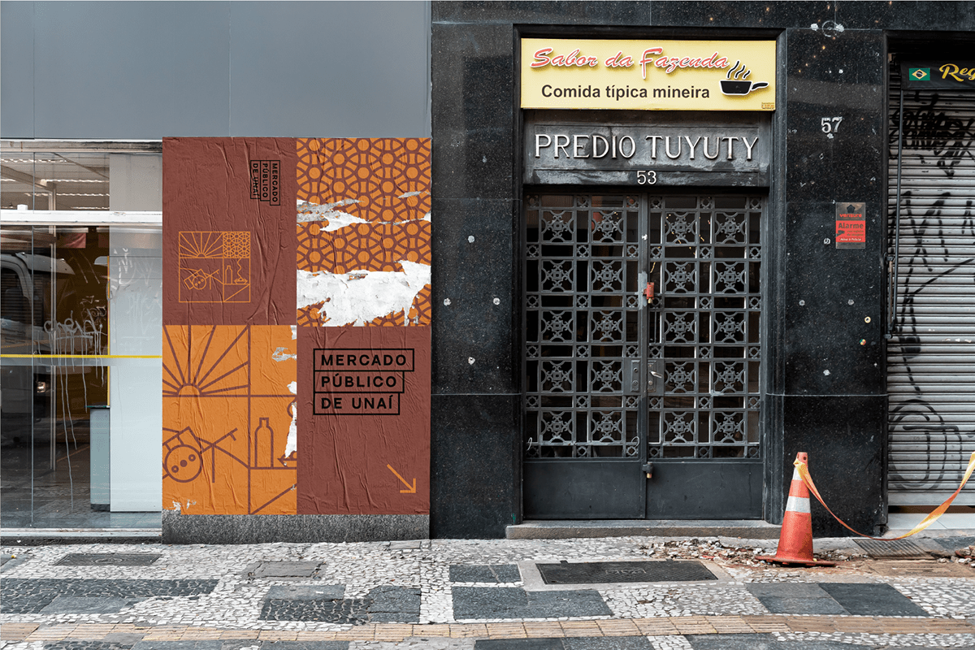

Other concepts located in Valley Ranch include:

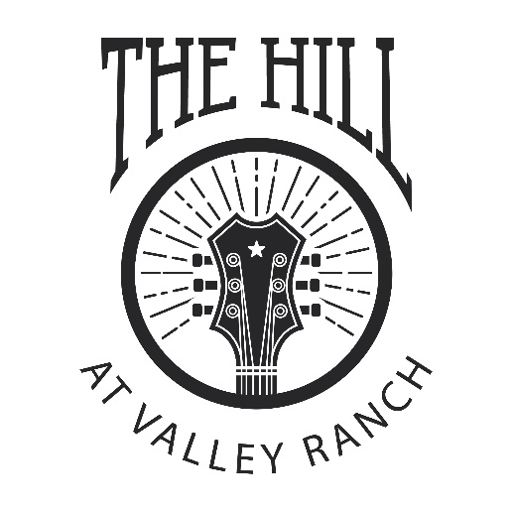
The Hill at Valley Ranch is a 14-acre multi-purpose live event space. The perfect destination for beer, wine, and food festivals, carnivals, cultural events, live music and entertainment.

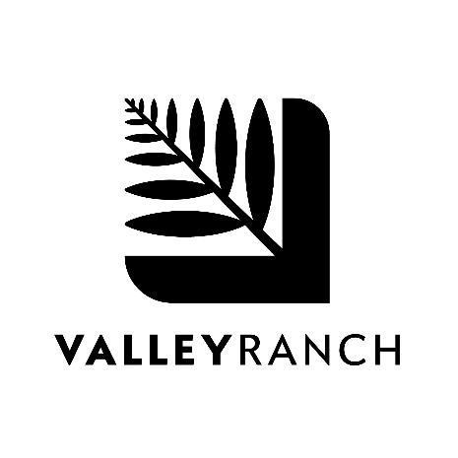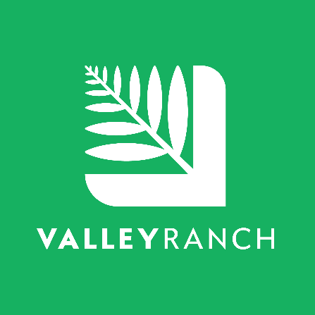
Valley Ranch, a 1,400-acre master planned development that includes all aspects of a modern, connect community. Valley Ranch offers a variety of residential options with shopping, dining, entertainment and work options nearby.

