The View at Wayne National
Marketing Materials Creative Brief
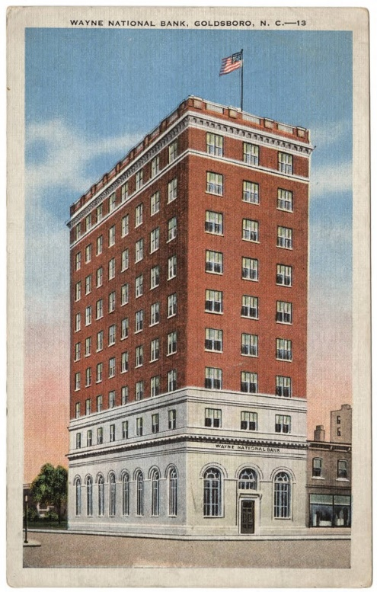
Materials required:
- Logo for the building
- Logotype for building signage, apartment number plaques, website, etc.

Project Description: The View at Wayne National is a restoration of a 1920's historic bank into luxury apartments and ground floor retail. Goldsboro, NC, like many southern towns that saw decades of economic decay, is enjoying a renaissance in its downtown area. The Wayne National Bank, the grand dame of decades past, was vacant for years. Sitting in the heart of Goldsboro, the Bank was a symbol of decay.
The current restoration of the Bank is the crown jewel of recent revitalization efforts in Goldsboro. The town’s residents eagerly await its completion. The building will contain 63 luxury apartment homes that speak to the grand yet simple past of the Bank and the town. 44 of the units will be located in the old Bank and 19 will be located in the surrounding County Buildings. The project will also incorporate approximately 10,955 total square feet of retail divided between the ground floor of the Bank and the County Buildings. Panoramic views of downtown Goldsboro and a green tree canopy stretch out in all directions.
The logo and logotype should speak to the Bank’s rich history and classic design, yet also incorporate the revitalization and the modernization that our redevelopment is bringing to the town and to the building.

Building Details:
- Originally built in early 1920s
- Began renovation Month Year, delivers Month Year
- 63 luxury apartments ranging from studios to 2-BRs, and 10,955 square feet of retail located in the base of the buildings
- Historic yet refreshed exterior preserving key architectural features, such as the arched windows
- Full gutting and renovation of interior units and common areas
- Downtown, Class-A location

Images
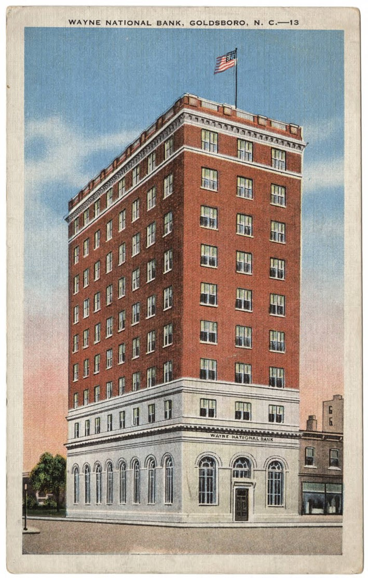
A postcard of Wayne National Bank in its heyday in the 1920s
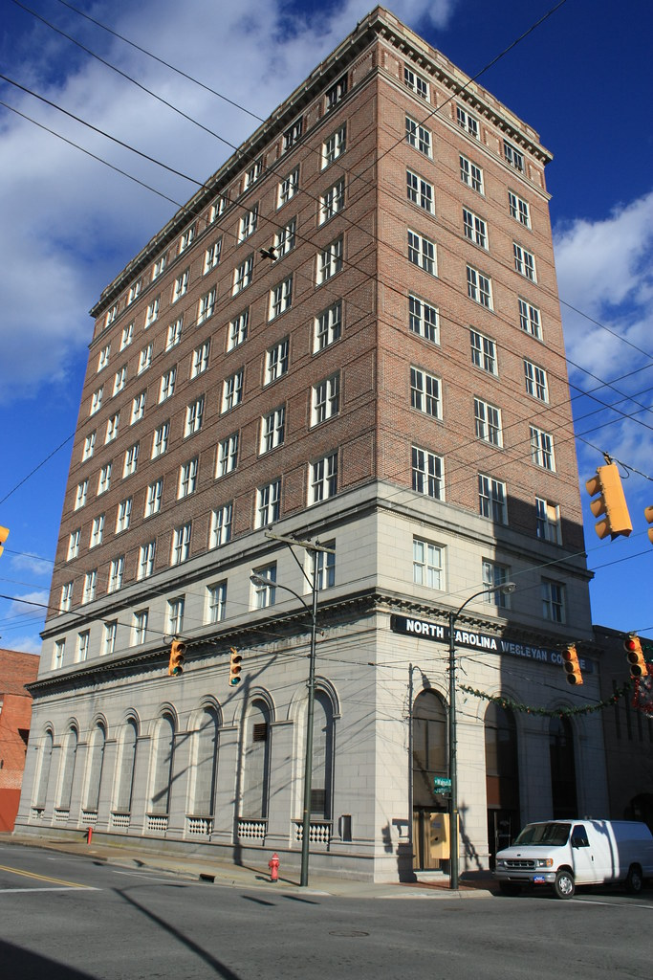
Wayne National Bank prior to Redevelopment
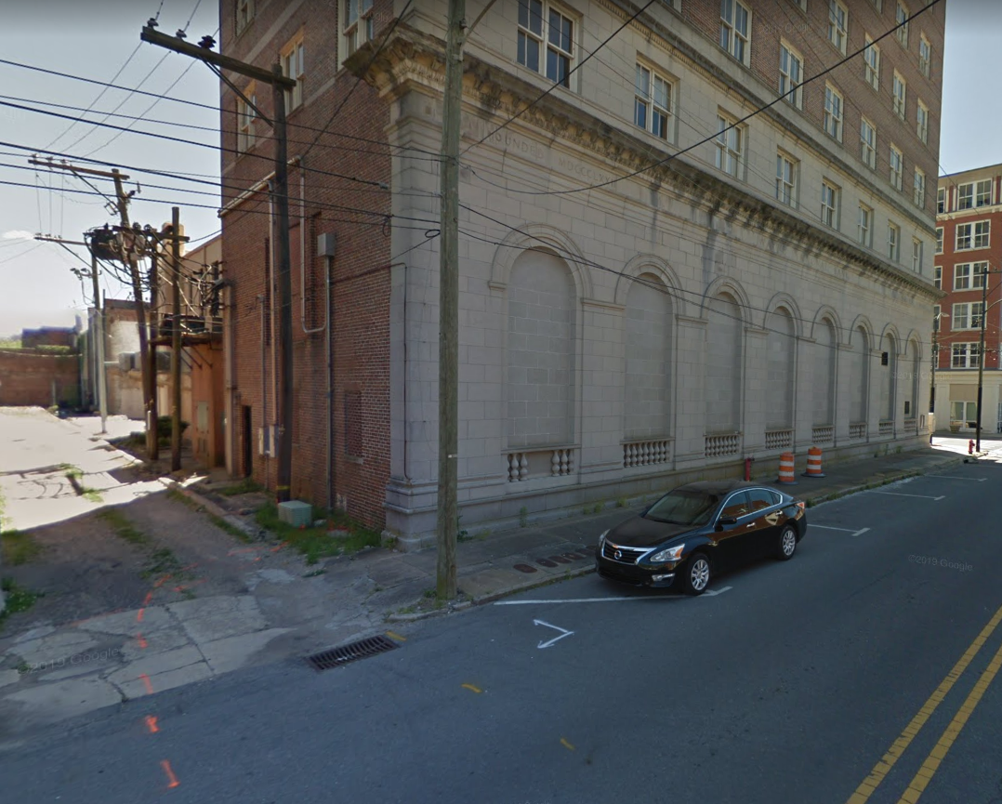
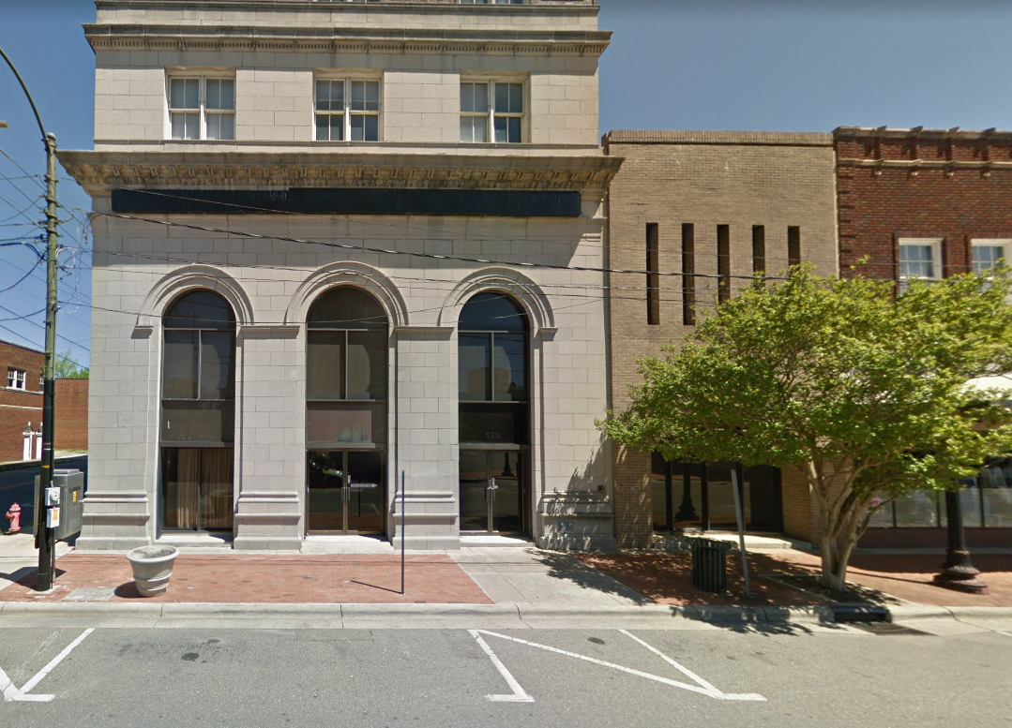
Photos of the Bank’s arched windows, which will be remain after renovation

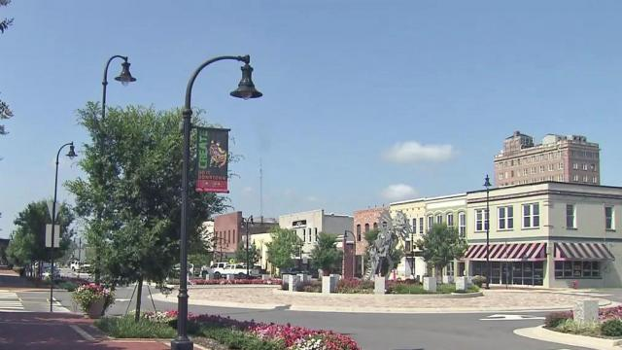
Downtown Goldsboro, NC

