Remote Planning and Scheduling Logo Pantones

Part of logo | Font | Color
RPS | SF Fourche (all caps) | 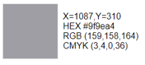
Remote Symbol
REMOTE PLANNING AND SCHEDULING | Airstrike Regular (all caps)



Part of logo | Font | Color
RPS | SF Fourche (all caps) | 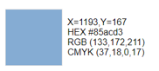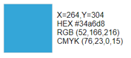
Remote Symbol
REMOTE PLANNING AND SCHEDULING | Airstrike Regular (all caps)


