Finishes:

Exterior:
Roof, gutters, downpipes: Coloursteel – Sandstone Grey
Window joinery: Powdercoated – Sandstone Grey
Cedar weatherboard: Stained, Wood-X Avalanche
Plaster: Resene Half Cloud

Interior:
Flooring: Godfrey Hirst timber laminate flooring – Elegant oak
Carpet: Godfrey Hirst – Cockle
Tiles: 600x600, grey matte finish
Ceiling: Resene Alabaster
Trims, doors & windows: Resene Alabaster
Walls: Resene Sea Fog

Kitchen:
Benchtop: Granite stone, white polished
Joinery: Timberland, premium oak
Splashback: Tiled, white, gloss
Appliances: Fisher & Paykel stainless steel
Tapware: Methven

Exterior:




Interior:
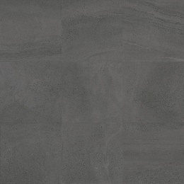
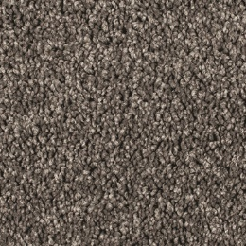
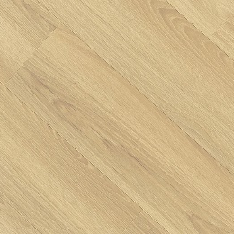




Kitchen:
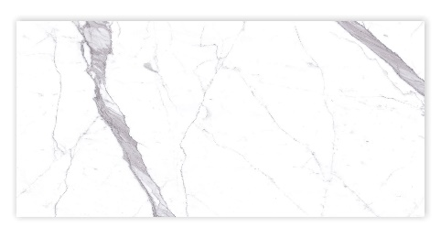
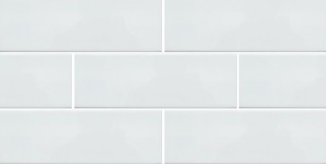

Specifications:

Construction:
Foundation: Engineered concrete waffle slab over gravel raft
Framing: 90mm kiln dried SG8 framing
Intertenancy wall: Gib Intertenancy Barrier system
Exterior wall insulation: R2.6 glass wool batts
Ceiling insulation: R4.0 glass wool batts
Midfloor insulation: R2.2 glass wool batts
Intertenancy wall insulation R2.2 glass wool batts

Exterior:
Roof: Coloursteel tray profile
Fascia & gutter: Coloursteel
Exterior Cladding: Vertical cedar weatherboard and Rockcote Integra panel & plaster on ventilated cavity system
Window & door joinery: Double glazed, powder coated aluminium
Front door: Aluminium
Garage door: Sectional door with automatic opener and remotes

Internal:
Ceiling height: 2.4m
Linings: Painted gib, level 4 finish, aqualine to wet areas
Flooring: Nylon died carpet with 11mm foam underlay
Internal doors: Painted, flush finish, hollowcore
Door hardware: Lever action handles, Satin Chrome
Wardrobe joinery: Prefinished 16mm white melamine carcass
Landry joinery: Prefinished 16mm white melamine carcass and laminate benchtop

Bathroom:
Shower base & walls: Tiled
Shower door: Glazed
Vanity: VCBC wall hung, in timberland oak
WC: VCBC, back to wall
Tapware: Methven, chrome
Heated towel rail: Chrome
Wall heater: Stainless steel
Mirror: Wall hung mirror above vanity

Electrical:
Lighting : Recessed LED down lights
Heating: Heat pump high wall mounted, Daikin or Mitsubishi, sized to meet Healthy Homes Regulations
Appliances: Fisher & Paykel, induction hob, oven, rangehood & dishwasher
Water heater: Electric 250L cylinder
Power: Double outlets throughout
Smoke alarms: To each floor

External works:
Driveway: Concrete, exposed aggregate and sponge finish
Patio: Concrete, sponge finish
Soft landscaping: Plantings as per landscaping plan
Fencing: To perimeter
Other chattels: Letterbox, washing line

