My Colours and Combinations, i would like to have

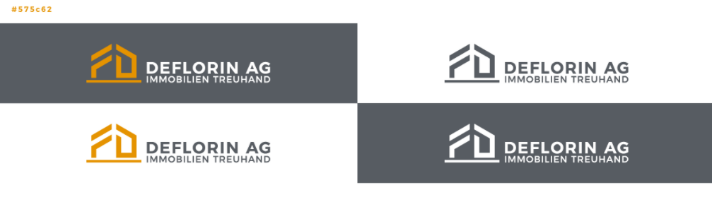
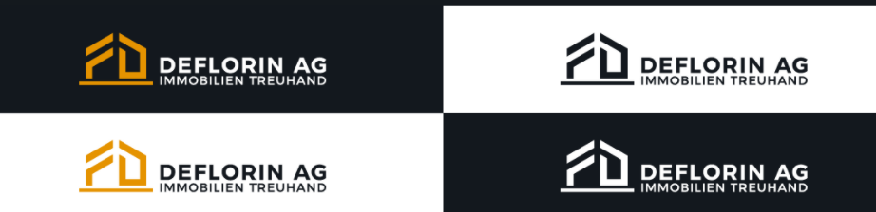

The different variations I want

- Once just the brand FD.
The other things should be transparant.
The white brand FD is possible to have it in white and transparent.

- The 8 Variations at the top with the background.
The white words is possible to have it in white and transparent

- The 8 Variations at the top without the background.
The other things should be transparent.
The white words is possible to have it in white and transparent.

- I need also the last two things i explained (green marked) with this different namings:
- DEFLORIN AG (without IMMOBILIEN TREUHAND)
- DEFLORIN AG and under this only IMMOBILIEN
- DEFLORIN AG and under this only TREUHAND

- I need the colour you used and the Font and size.

- I need different Formats I can use as a beginner without special programms for different things and later maybe a advertising office can use.

Did i booked also ?
- I thought I booked also carddesign and the icons for socialmedia, ist this correct?

