End-User Quick Start Guide

Step 1: Set-Up Your Voicemail

Setting Up Your Mailbox
The first time you log in to your mailbox, you are walked through recording your name for the directory and recording your personal greeting. The name recording is for the dial-by-name directory, so when someone enters the first three letters of your last name, it will playback your name recording.
The greeting plays when your mailbox is reached. It is essential to make a custom message, as many callers will not leave messages at mailboxes that have generic greetings.

Accessing Voicemail from your Desk Phone
- Press the Messages button  on your phone to access your voicemail box, or dial 5001 if you can not identify the voicemail button.
- When prompted, enter your default voicemail pin 2323, and then press #.
Note: If you subscribe to multiple mailboxes, press the left or right arrows on the directional pad to select the extension of the voicemail you want to access. Then follow the steps above.

- To access another person’s mailbox
- Dial 5000.
- When prompted, enter the other person’s extension number.
- Enter the voicemail PIN of the other person’s mailbox, followed by #.

Accessing Voicemail from the user portal
- Start a web browser.
- Go to phone.miswitchcommunications.com

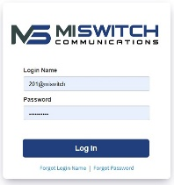
Click in the Login name field and type your user name ___________________ (ext@customerdomain). Your customerdomain typically is the same as your email address domain.
Click in the Password field and enter your user password. (default password is ___________

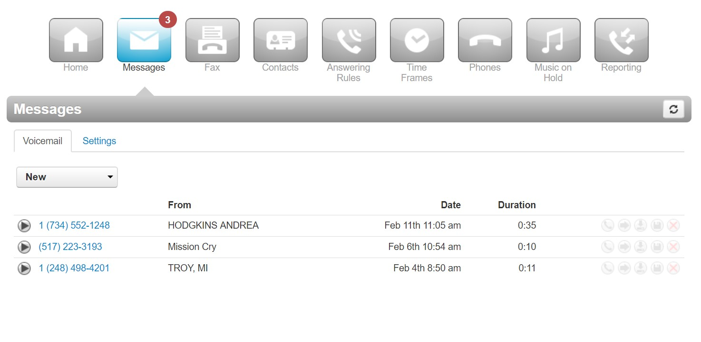
Record your greeting
- From the Settings tab of the Messages page, click the speaker icon .
- Next to New Greeting, click Record and the system will call you, or upload an existing greeting.

Step 2: Setting up the mobile application

Installing Mobile Application
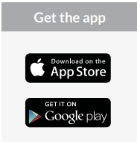
- Search ReachUC and click install. 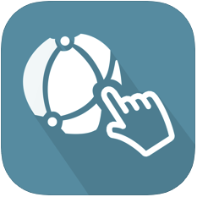

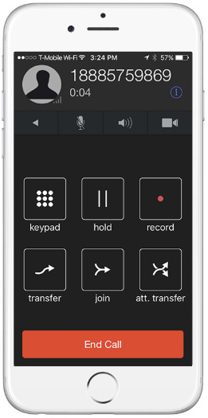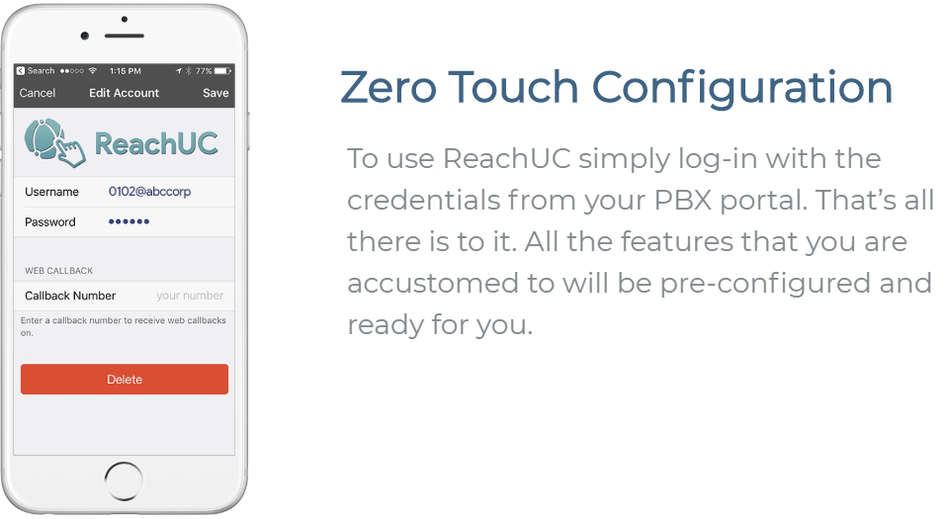

Step 3: Using your desk phone
Making Calls
Making a call with your phone does not require a leading 9. You can dial on-hook or off-hook.
To dial on-hook
Dial the phone number.
Pick up the handset, headset, or speaker.

To dial off-hook
Pick up the handset, headset, or speaker.
Dial the phone number.
Calls to the US and Canada are all dialed using 10 or 11 digits.

Receiving Calls
When a call comes in, you can answer it via a headset, speakerphone, or handset.
- To answer a call using a handset
- Lift the handset off-hook.
- To answer a call using a speakerphone
- Press the Speaker button.
- To answer a call using a headset
Usage depends on how the headset is connected. Often, you'll press the button on the headset or press the headset button on the phone.

Handling Calls
Your cloud PBX features various ways to move calls around, including attended transfer, unattended (blind) transfer, voicemail transfer, park, and more. In this section, references to BLFs are the 1-touch buttons to extensions common at front-desk phones.

Attended Transfer
Attended transfer allows you to speak to the transfer recipient prior to completing the transfer while the caller is on hold.
- To perform an attended transfer using Polycom and Yealink phones
- Press the Transfer key/softkey on your phone.
- Dial the recipient’s extension or press their BLF.
- Speak to the recipient, and then either press Transfer again to complete or cancel if the recipient cannot take the call.

Blind Transfer
- To blind transfer using Yealink phones
- Press Transfer.
- Dial the extension of the recipient.
Press Transfer

Transfers to External Numbers
A transfer can also go to an external number such as a cell phone. Follow the transfer directions above but instead of dialing an extension, dial a 10-digit phone number.

Park and Hold
On your phone system, hold is a local function. This means a call held on your phone cannot be picked up at another station. Park is a system-wide function. This means a call parked at one phone may be picked up by any phone.
- To park a call
- Dial *** in an active call from any phone. The system says, “The call is parked at 7xx.”
- Hang up.
To retrieve the parked call, dial 7xx where xx is the number stated by the system.

Emergency 911 Calls

- When you dial 911 from ReachUC running on a mobile phone, the application will automatically dial out using your existing cellular service. 911 calls from your mobile phone will not be routed through your UCaaS service provider.
- 911 calls dialed from the desktop (WebRTC) app will be routed through your UCaaS service provider (the same as any other softphone).

