Packaging Brief

Client: Creative Hampers

www.creativehampers.com.au

Our Company | We are a Gift Hamper website and curate a range of hampers for all occasions, celebrations, care, birthdays, thank yous, staff and client thank yous. Hampers include champagne and alcohol with gourmet treats, pamper hampers, beer hampers, Hampers for men, women, families, children, newborns and corporate clients.  The company has changed hands and we are looking at many aspects of the business. We want to keep some of the heritage of the business as it has been around for some years and has awareness in the marketplace. The website will change in future but other than some enhancements it will not radically change.
The Brief | We want to revamp our packaging to make it more contemporary and exude luxury.  Our design should be modern luxury  The design should relate to some of the existing livery.  Hampers tend to be a special gift and we want the recipient to be wowed from the moment they receive the gift. Firstly when they see the box and then continue to be wowed when they open it up. The whole experience should be a feeling of being special.  Packaging design is crucial
Hamper box specifics | All hampers are produced off shore and arrive flat for ease of storage and transport. We have a range of hamper sizes but for initial design purpose you can work with this size box  Finished size. 36cm (l) x 24cm (w) x 12cm (d)  The packaging design should be self sufficient with a ribbon attached to the front as per the reference photo that follows (ref 1). We would like this ribbon to have our logo on it  The design however will need to carry over to other box sizes (large and small). The smallest box being 36cm (l) x 12.5cm (w) x 11cm (d)
Must haves | Fixed ribbon to front of box design with our logo (photo ref 1)  The word ‘’Happiness’’ to be printed in a script typeface across the front of the box as per photo ref 2. Feel free to choose a different typeface, I don’t particularly like this one on the reference  Box colour  grey box please do a light and dark grey version  Brand colours are orange, grey & cream. The orange colour can not be changed but we are happy to consider alternatives to the greys and crea,  Orange PMS 151.  Grey 888888  Grey 716E6E  Grey D4D5D6  Cream FFFCF5 (this one we haven’t use that much so happy to consider others)  Typeface for logo Rylan Regular. No other typefaces are defined. Happy to consider other for script and non script for inside box  inside box to also be included in the design please look at a different colour for inside box which gives that luxurious feel (see ref 3)  wording on the inside to say ‘’A Box of Happiness by Creative Hampers”

Ref 1
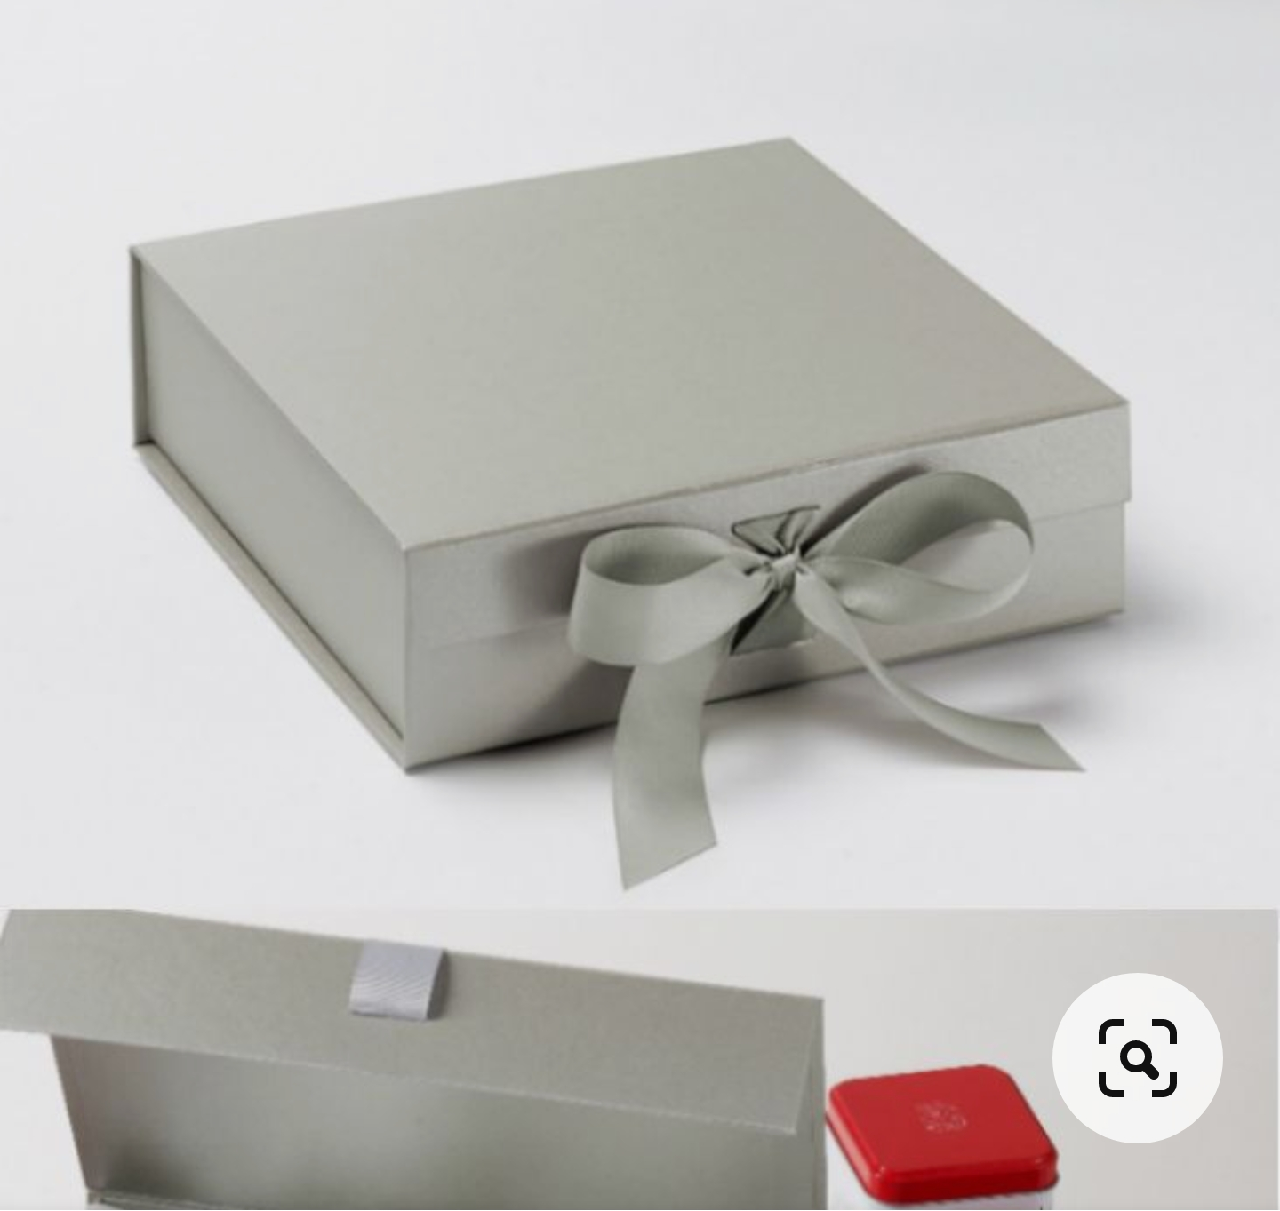

Ref 2
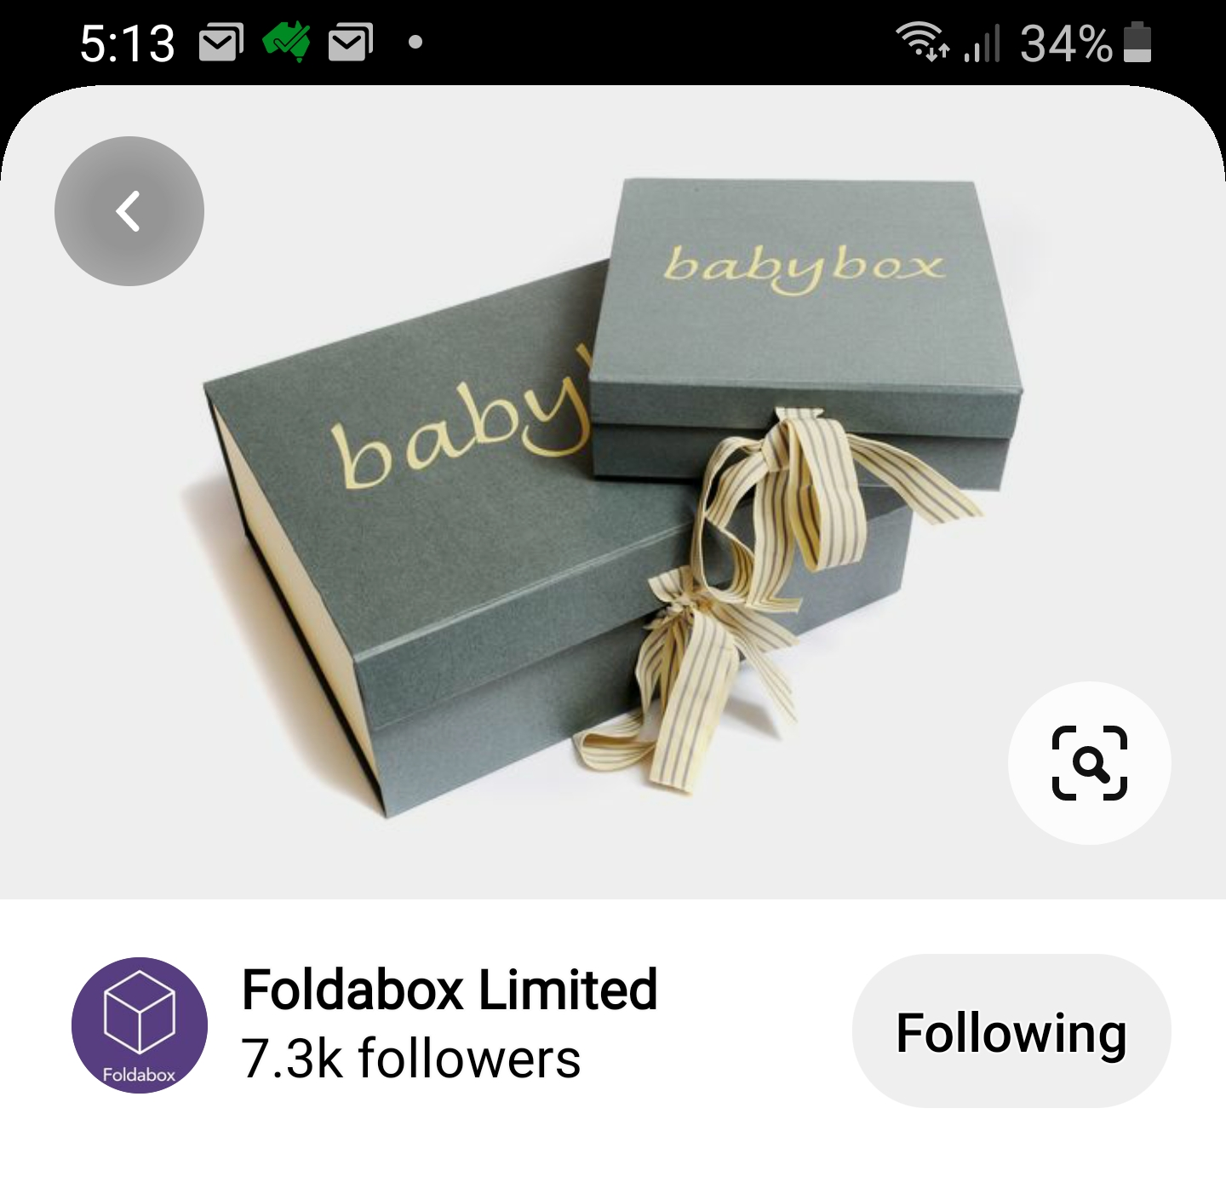

Ref 3

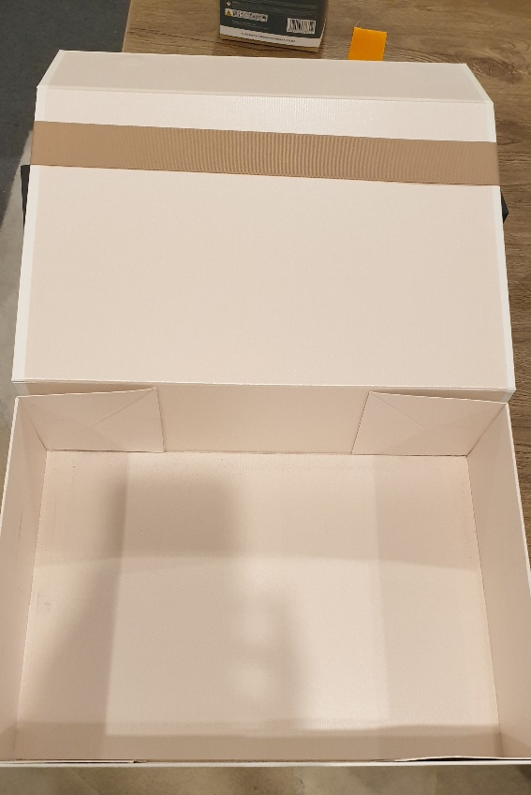

Box size to be used for designed (measurements in brief)
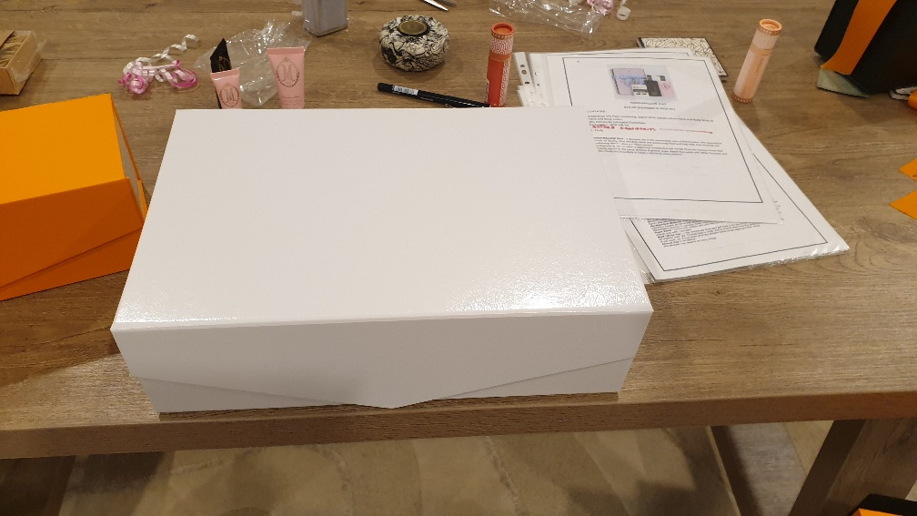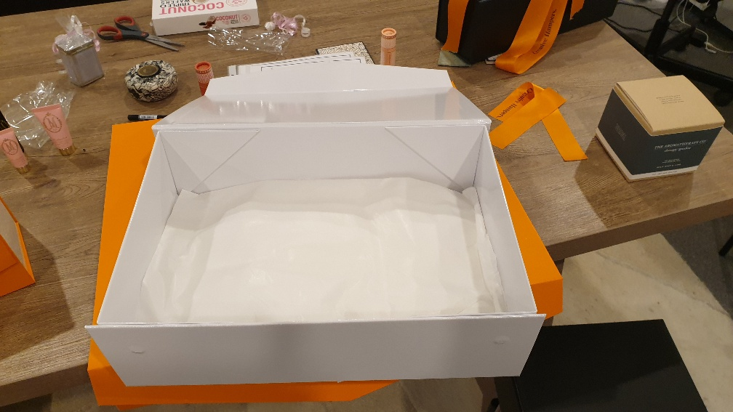

Current box example
