Attack Vector Web Site



Prepared by
Paul Ford

I am looking at offering a website for parents that will look at popular apps and games a produce a attack vector for them.
There would be a introduction/overview on what the attack vector of an app or game in the context of this site is.
The attack vector will look at various features within an app or game and inform a parent how easy it is for a child to be exposed to inappropriate content or what the risk of online grooming is.
For each app we would look at the following

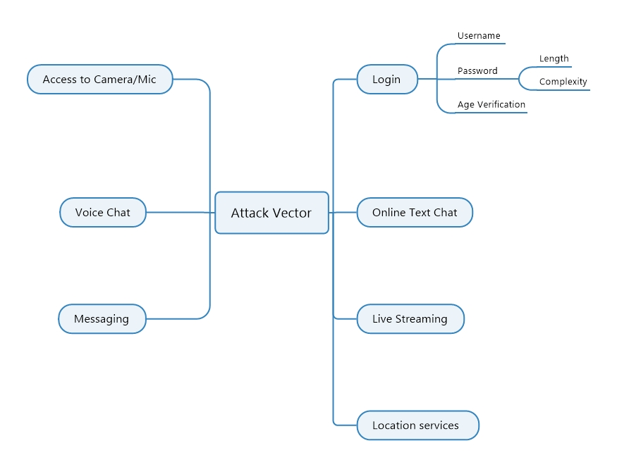

We would take into consideration –
Does the game or app have access to the camera and mic and does the game/app have the ability to send pics or video within the app itself ?
Does the game or app have voice chat and can voice changing software interface into the game or app ?
Does the game or app have an inbuilt messaging service and what types of messages and content can be sent over this ?
Does it have any constraints on username such as length or whether you can use profanity on the user name ?
What are the password requirements in terms of length, complexity, does it allow you to use a recently used password ?
What age verification does the app or game have ?
Is there online text chat and of so does it have a profanity filter, does it block urls and web links ?
Does the game or app allow live streaming ?
Does it have location services enabled ?

So the areas we could break this down into on the website are
- Login
- Chat/Messaging
- Camera/Microphone Access
- Location Services
- Live Streaming
Each of these would have a rating and an explanation of the rating. Then there would be an overall rating for the app/game.

This should be easy for a parent to take a look at and understand.

