Looking for logo and matching banners for a medieval castle. I would like to incorporate a 4-legged dragon standing on its back legs. I need it in multiple color backgrounds to match room decors. deep red, blue, and purple backgrounds with gold dragon. Dragon should look like he is a king or regal. Dragon is gold with shades of blue against a blue background or gold and red gainst a red background.

This dragon is close but don’t like the face / head. https://www.pinterest.com/pin/492722015465071215/
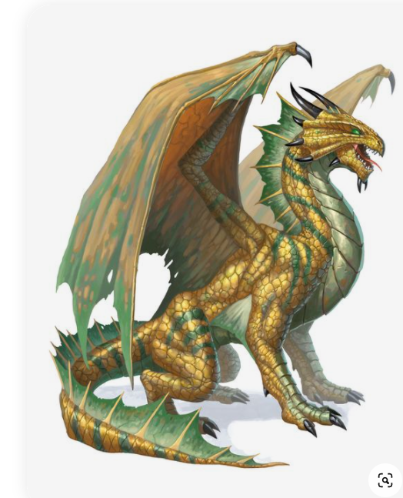

This one is good but want him sitting or standing on back legs.
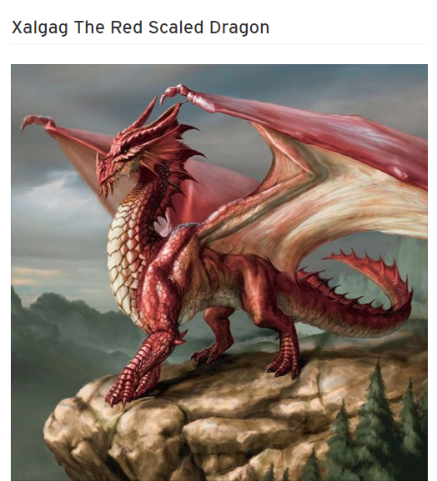
https://soundcloud.com/rlfhog3/xalgag-the-red-scaled-dragon-1 i

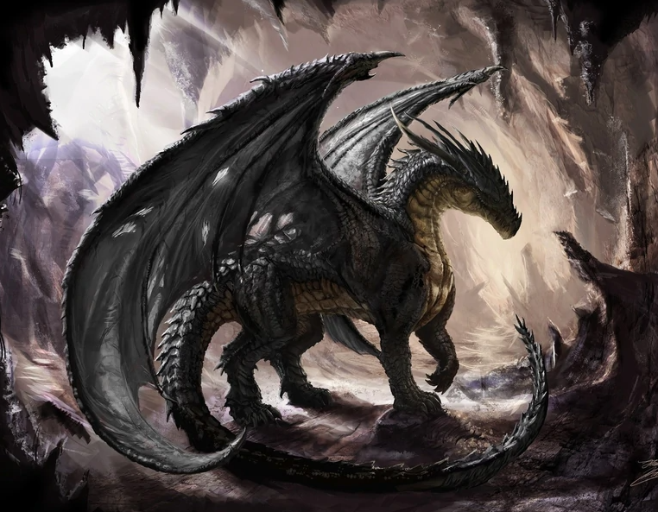
https://my-hero-academia-fanon.fandom.com/wiki/Black_Dragon
I like the head and the circular fashion of this one as it would fit on a logo as a square. Another versions with his tail going down long would be good for the banner.
