(company name) PETER EDWARDS T/A AMPUTEEHUB PTY LTD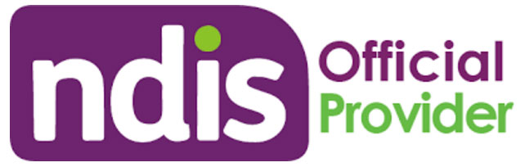This logo to be smaller than the company logo.
Disability Care Provider (smaller font)
“Changing Perspectives” (smaller font)

Who are we?
Amputeehub’s goal is to empower you to live the life you want to without any limitations. We are committed to providing the highest level of client focused care, we serve individuals with a broad range of disabilities. We are here to make a difference in your lives, your family’s lives and communities. As an organization we embed our values of Reliability, Respect, Excellence and Resilience. We value Diversity and Encourage individualism.
Amputeehub provides a comprehensive range of services, programs, and general support for people with disabilities.

SERVICES:
Support Coordination
- Support coordination will assist you in achieving your goals our Support Coordinators will assist you in choosing and coordinating providers, they will develop service agreements. Support Coordination also assists with assistive technology and home modification.
Supported independent living.
- A support delivering independent living arrangements, to make the client independent within their capacity and their own care.
Assistance with self-care activities
- including assistance and supervision of personal and oral hygiene tasks, getting dressed.
Personal domestic assistance including
- Meal preparation, medications, linen services.
- House cleaning
- Yard Maintenance/Lawn Mowing
Participation in social and community activities, individual and group-based access/activities
- Social and community day programs
- Transport assistance
Assist Access/Maintain Employ
- Assistance, access and maintain employment including supports in employment, career counselling and finding open market employment.
Short term accommodation including respite,
- To live out of home for a short period.
Life skills development in individual and group-based settings.

Enjoy what you love doing let us take care of the rest!

“Amputeehub is your guide to live the life you want to without any limitations”!

Are you or anyone you know disabled?
Not connected to the NDIS? (a whole Page)

We can help! What is the NDIS?
If you are aged under 65 years and have a permanent and significant disability, you may be eligible for NDIS services. The NDIS is a government organisation that provides supports to people with disabilities to achieve their goals.
Contact us for more information!
Find out how we can help you!

(I want to address to be of the smallest font and the last thing) use icons of phones and @ icons)
CALL US TODAY!
0484194476
0411481510

amputeehub@outlook.com -(bigger font)
Wedsite: www.amputeehub.com
anna.amputeehub@outlook.com (smaller font)

Address: 43-47 Cross St Baulkham Hills NSW 2153

