Brand Values
1. Company mission statement: This is a sentence or two that explains your company’s goals. It should also weave in some information about what your organization is and why it exists.
- To become empowered by being the best version of yourself.
- Promote health and wellness of mind, body and soul
- Look for life, Live life, LOVE life and learn how to make choices for your highest good
- Find healing in food
2. Product/services positioning statement: This is like your company mission statement, only more specific to your offerings. Here’s Volvo’s for an example:
“For upscale American families, Volvo is the family automobile that offers maximum safety.”
- Individualized health coaching through the concept of Bioindividuality (when I complete my certification which will be end of 2021 but sharing my journey along the way)
- Theta Meditation (I am certified but don’t practice. In a mentorship program for this modality and would like to have a section on it)
- Material products: arbonne, essential oils and eventually some of my own products
- Section on various health and beauty regimens and spiritual practices

3. Benefit of your product/service: Does it save your customers money? Does it help them increase ROI? Think about how exactly you’re helping your target audience.
- Improving quality of life by becoming the best versions of themselves by discovering new avenues of fitness, nutrition, yoga, meditation

4. Five words that represent your brand: Think about your brand’s personality. How would you describe it?
Holistic, wellness, zen, love, fun, adventure, positivity, fitness, strength, confidence and self-love. (oopps went over 5)

5. Three messages your brand needs to communicate: Why does your brand matter? These messages should be relevant to your target audience.
- Optimize and prioritize your physical and mental health.
- Nourish the mind, body and spirit through healthy choices
- Mental Health support through self-care

6. Value proposition: How do you solve your customers’ problems? This should summarize why someone should buy your product or invest in your services.
Improve quality of life
Feel better
Look better
Nourish body and soul to become the best you can
Teach people to explore new methods of wellness
Save them time through recommending products and clothing reviews (idea?)

Brand Attributes
The following questions will dive into the essence and identity of your brand.
7. How does your brand’s image fall between these opposing characteristics?
- Masculine/Feminine
- Simple/Intricate
- Grey/Colorful
- Conservative/Extravagant
- Approachable/Authoritative
- Necessity/Luxury
- Fun/Serious
- Professional/Casual
- Modern/Classic
- Sporty/Elegant
- Extreme/Safe

8. What colors represent your brand?
Earthy, light blue, silver, light pink, peach, black white

9. What colors would you not like to see?
Red, Bright Harsh Colors

10. What words would you use to describe your brand’s image?
Fun, modern, zen, fitness, active, adventurous, evolution, strength, energetic, healthy, relatable information from an approachable and normal person not a celebrity

11. What words would you not want used to describe your brand’s image?
Treat, prevent, cure, reduce, fast

12. What attributes and/or emotions do you want associated with your brand?
Positive, happy, fun, trustworthy, love, motivation, creative, intention, support, journey, kindness

13. What attributes and/or emotions would you not want associated with your brand?
Negative, push sales, ego, intimidation, stress, angry

Abstract Values
To answer the following questions, use your imagination to think of your brand in unique situations.
14. How would you describe your brand to a friend?
360-degree approach to improving overall mind, body, soul offering a variety of products and guidance and ideas customized to individual needs

15. How would you describe its style?
Clean, focused, approachable, classy but not presumptuous, hip, modern

16. What other brands would be its friends?
Lululemon, gymshark, spiritual gangster
Example of a graduate from my school program and I like her style
https://www.integrativenutrition.com (this is my school)
https://clairepthomas.com/

17. Where would your brand hang out?
Beach, Yosemite, gym, hot yoga, home enjoying private space (I love nesting and getting in a cocoon to enjoy my spiritual home space.

18. Age? Gender?
All ages and genders…probably middle-aged women will relate most to me I would think but I want to approach all

19. What actor/actress would be perfect to play your brand? Why?
Kate Hudson: she is fun, engaging, light and positive energy, wellness focused with her company

20. What kind of car would your brand be?
An SUV – functional, resilient, versatile, adventurous

21. What animal would represent your brand?

My spirit animals: Dragonfly and dolphin

Dragonfly

Evolution/Transformation

Adaptation

Change

Joy

Light

Connection with spiritual realm

Dolphin

Playful (humor and joy)

Inner strength

Intelligent

In tune with instincts

Spread love

Design
Now we’re getting into the look and feel of your brand. The following questions will help you narrow down your visual preferences.
22. Which one of these logo formats do you believe best represents your brand?

Logotype
This format includes your company’s name in stylized typeface and/or your company initials in a simple shape.
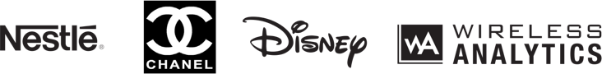

Pictorial Mark
This mark includes literal or representative imagery to symbolize your brand.
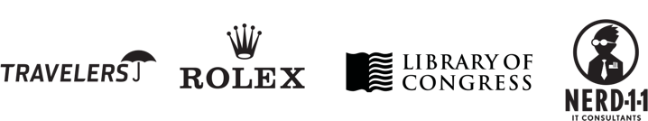

Abstract Mark
This format includes abstract shapes and symbols that convey a specific idea or attribute. These types of logos are very unique and identifiable often without the company name.
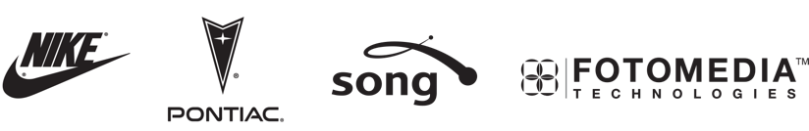

Emblem or Enclosure
This features the name or initials of the company, usually as part of a pictorial element or shape.
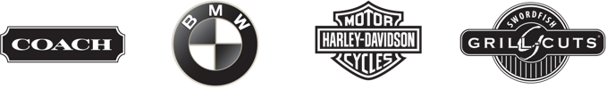
23. Which one of these logo styles do you feel best represents your brand?

Web 2.0
Common elements typically include vibrant colors, a subtle 3D feel, bold type, color transitions, shadows, gloss and reflection.


Contemporary
Common elements include fresh colors, stylized imagery and clean type.


Classic
Common elements include timeless colors, literal imagery and traditional type.

Detailed/Stylized
Common elements include detail, textures, flowing lines and distinctive type.


Complex illustration
These include a hand-drawn feel depicting a scene or character.

24. What style of font do you feel best represents your brand?
- Serif
- Slab Serif
- Sans Serif
- Script
- Blackletter
Remember: There’s no need to rush through answering all of these questions! Your responses will ultimately determine your brand’s positioning, so this exercise should take you some time.

