Gardens on Millenia POA & Retail Month of November
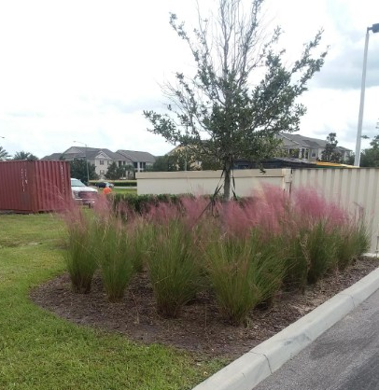

- Grasses Throughout:
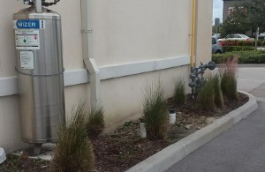
Right now the Muhly grass is blooming and looks great. The crew went around and trimmed them all up so they look fresh and clean. There were some of the types that were not blooming, that we trimmed back farther.

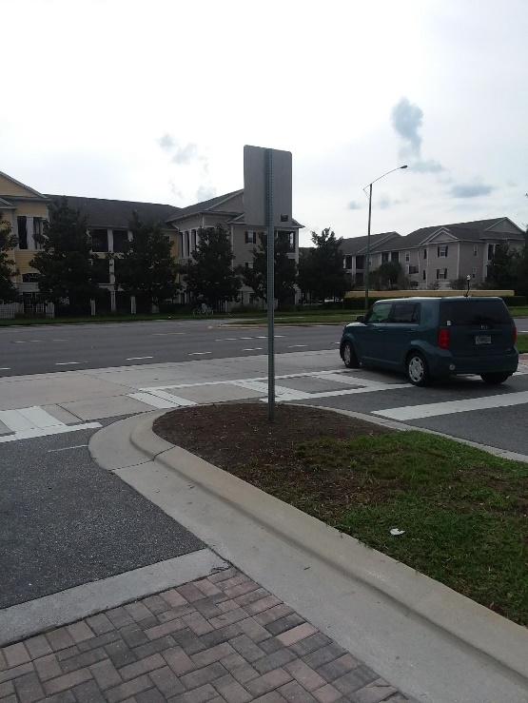

- Flowers:
Both main entrances are in need of fresh flowers.

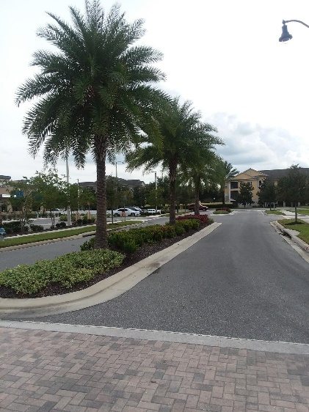

- Palms Need Trimming:
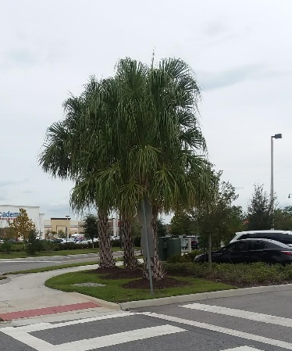
All the Palms could use a trimming, there are dead frons and some hanging seed pods and boots. Let us know if and when you would like to get this scheduled.

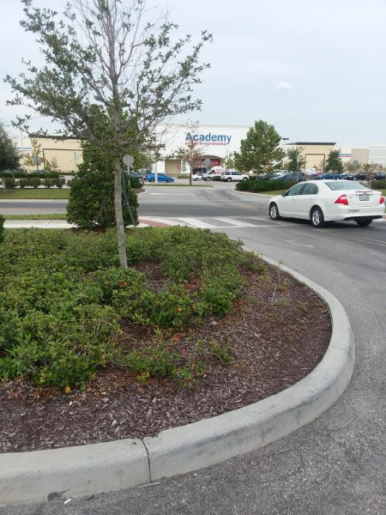

- Fill In:
We should fill this corner in where truck run over the corner with additional plants.

Gardens on Millenia POA…cont
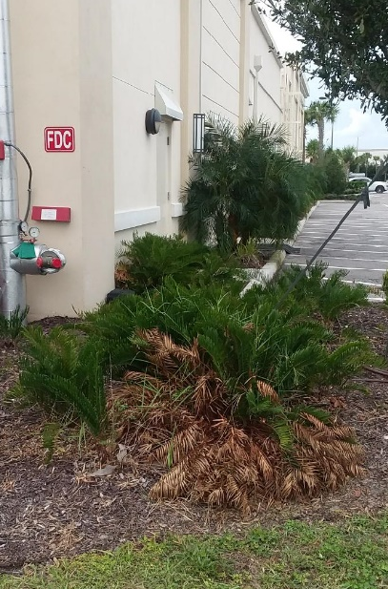
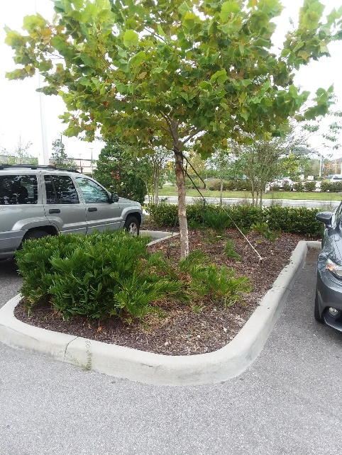

- Fill in Coonties:
Coonties need to be filled in here. As well as side of 5 guys.

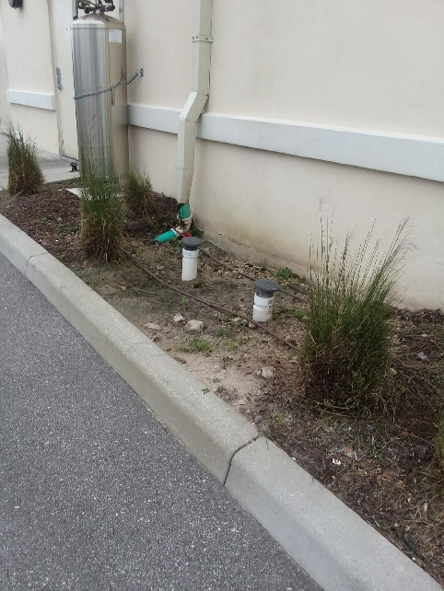

- Mulch:
Overall the place could use fresh mulch, or we could just mulch these washed out areas that are an eye sore.
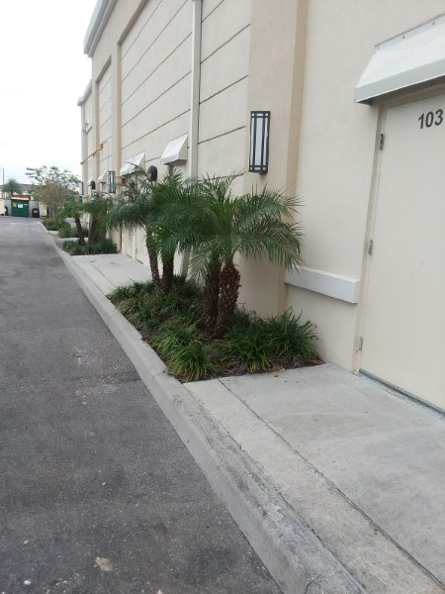

- Pruning:
All the little palms have been pruned up to look clean

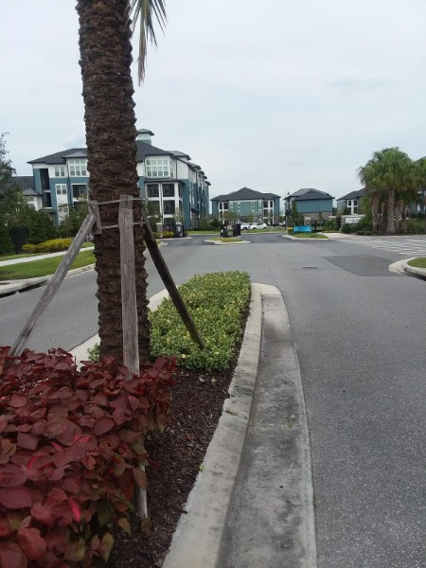
- Plants filling in:
The copper plants and Jasmine are all filling in nicely
